**Supplementary Materials for “Network regression analysis for binary and ordinal categorical phenotypes in transcriptome-wide association studies”**

Liye Zhang1,2†, Tao Ju1,2†, Xiuyuan Jin1,2, Jiadong Ji3, Jiayi Han1,2, Xiang Zhou4, Zhongshang Yuan1,2*

1 Department of Biostatistics, School of Public Health, Cheeloo College of Medicine, Shandong University, Jinan, Shandong, 250012, China

2 Institute for Medical Dataology, Shandong University, Jinan, Shandong, 250003, China

3 Institute for Financial Studies, Shandong University, Jinan, Shandong, 250100, China

4 Department of Biostatistics, The University of Michigan,1420 Washington Heights, Ann Arbor, MI, 48109, USA

†Liye Zhang and Tao Ju contributed equally to this work.

* Corresponding author.

Email addresses: [yuanzhongshang@sdu.edu.cn](%20yuanzhongshang@sdu.edu.cn) (Zhongshang Yuan)

**Supplementary Figures S1-S51:**

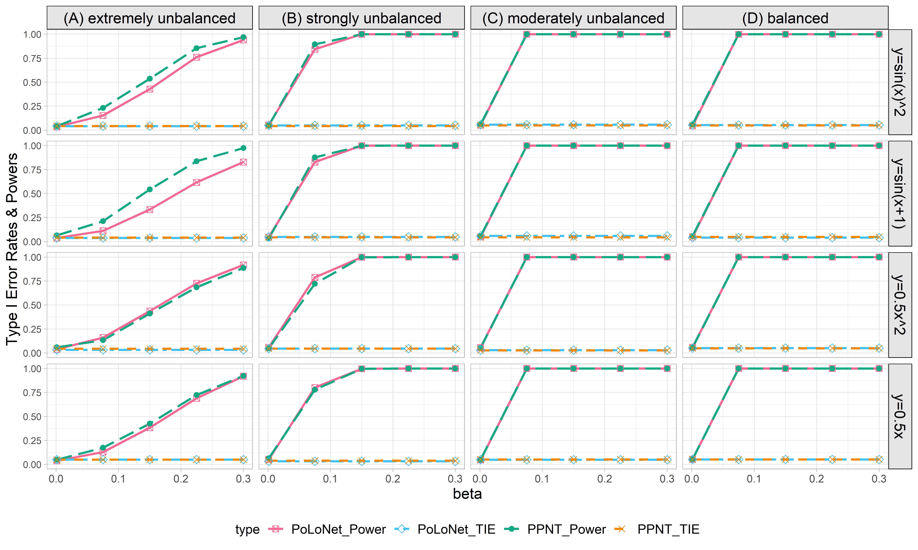

**Figure S1. Empirical type I error rates and powers for detecting the effect of the node for the binary trait under the setting that both node and edge have effects, with the node hanging on the edge (n=10000), with DPR as gene expression prediction model in TWAS.** The significance level is α=0.05. Simulations are conducted with 4 different between-node correlation patterns (the recombination of quadratic and sine, sine, quadratic, linear) and 5 different effect sizes (0.001, 0.075, 0.15, 0.225, 0.3). **(A)** extremely unbalanced (1:999) ; **(B)** strongly unbalanced (99:1); **(C)**moderately unbalanced (1:9); **(D)** balanced (1:1))

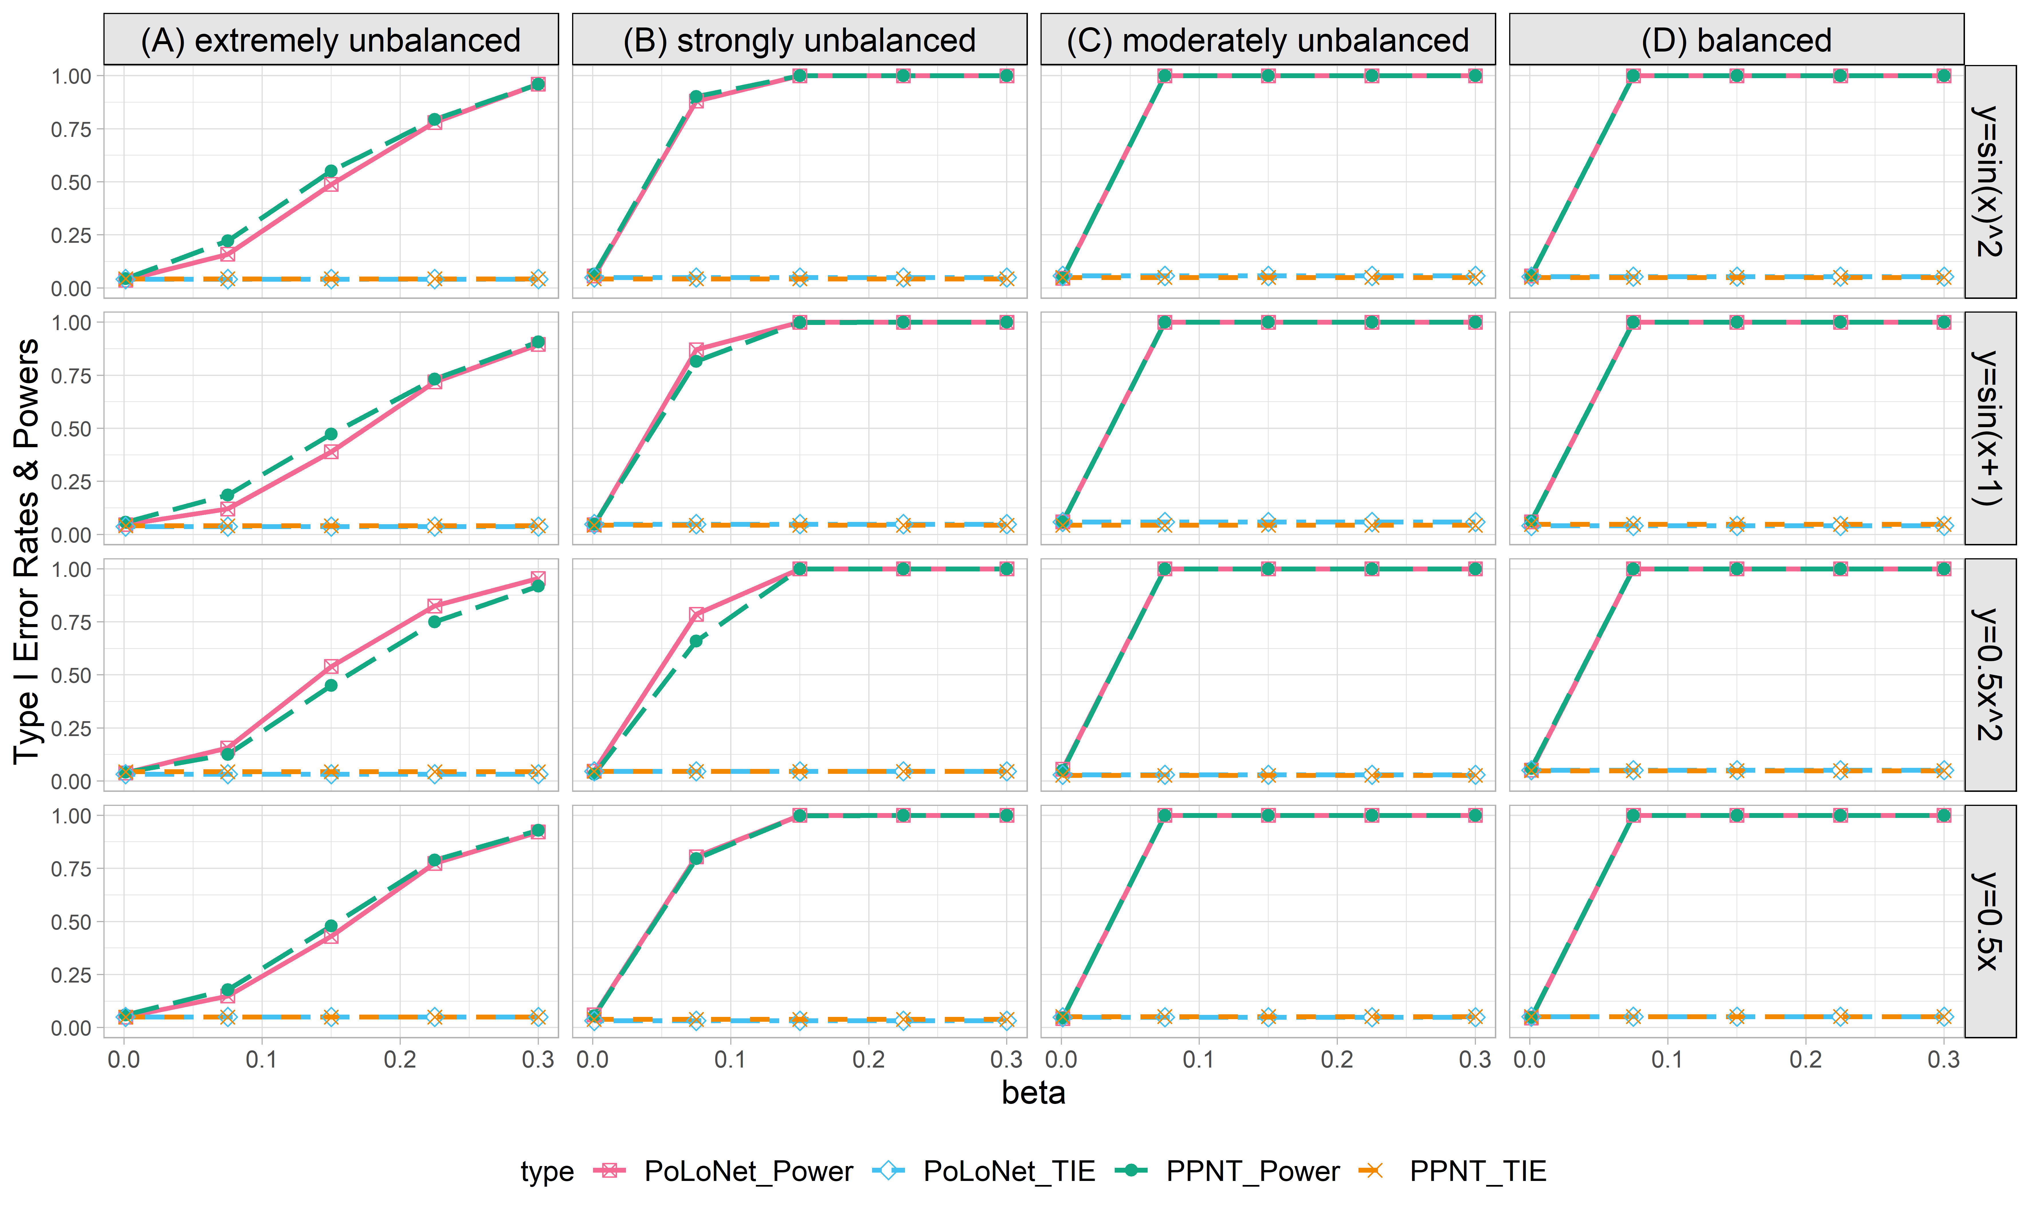

**Figure S2. Empirical type I error rates and powers for detecting the effect of the node for the binary trait under the setting that both node and edge have effects, with the node not hanging on the edge (n=10000), with DPR as gene expression prediction model in TWAS.** The significance level is α=0.05. Simulations are conducted with 4 different between-node correlation patterns (the recombination of quadratic and sine, sine, quadratic, linear) and 5 different effect sizes (0.001, 0.075, 0.15, 0.225, 0.3). **(A)** extremely unbalanced (1:999) ; **(B)** strongly unbalanced (99:1); **(C)** moderately unbalanced (1:9); **(D)** balanced (1:1)).

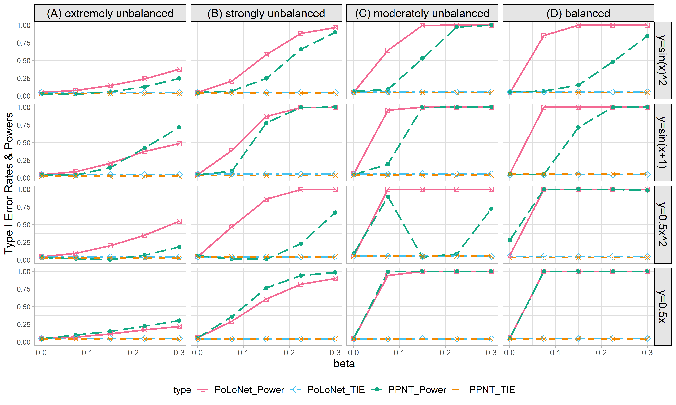

**Figure S3. Empirical type I error rates and powers for detecting the effect of the edge for the binary trait under the setting that both node and edge have effects, with the node hanging on the edge (n=10000), with DPR as gene expression prediction model in TWAS.** The significance level is α=0.05. Simulations are conducted with 4 different between-node correlation patterns (the recombination of quadratic and sine, sine, quadratic, linear) and 5 different effect sizes (0.001, 0.075, 0.15, 0.225, 0.3). **(A)** extremely unbalanced (1:999) ; **(B)** strongly unbalanced (99:1); **(C)** moderately unbalanced (1:9); **(D)** balanced (1:1)).

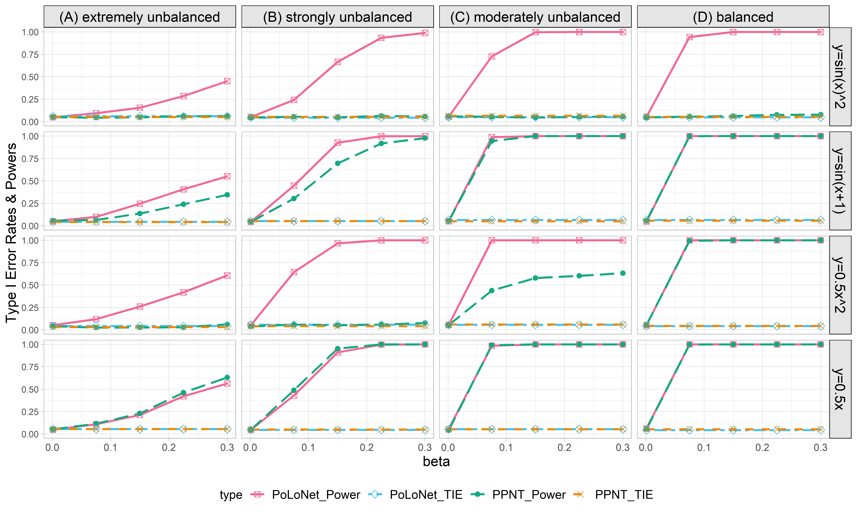

**Figure S4. Empirical type I error rates and powers for detecting the effect of the edge for the binary trait under the setting that both node and edge have effects, with the node not hanging on the edge (n=10000), with DPR as gene expression prediction model in TWAS.** The significance level is α=0.05. Simulations are conducted with 4 different between-node correlation patterns (the recombination of quadratic and sine, sine, quadratic, linear) and 5 different effect sizestt (0.001, 0.075, 0.15, 0.225, 0.3). **(A)** extremely unbalanced (1:999) ; **(B)** strongly unbalanced (99:1); **(C)** moderately unbalanced (1:9); **(D)** balanced (1:1)).

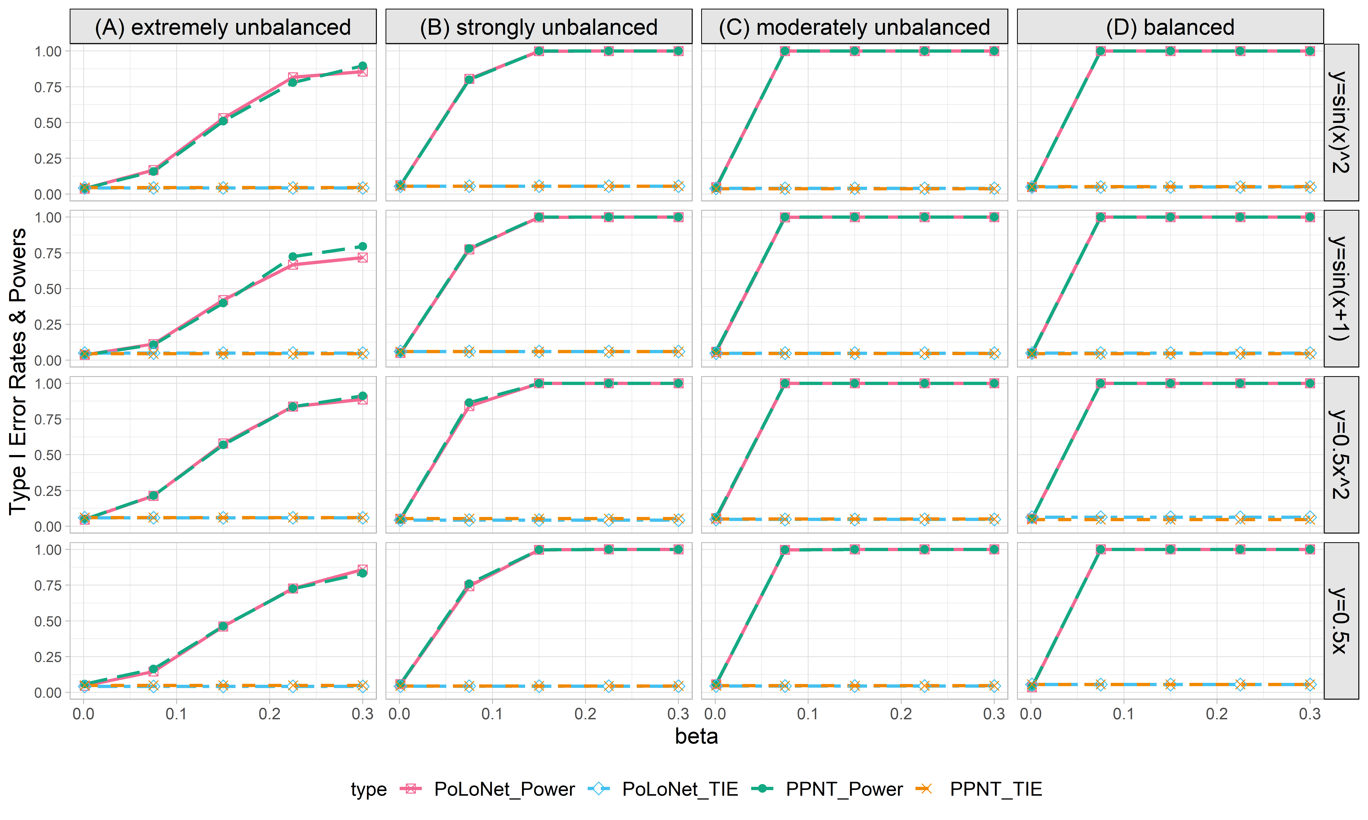

**Figure S5. Empirical type I error rates and powers for detecting the effect of the node for the binary trait under the setting that only node has effects (n=5000), with DPR as gene expression prediction model in TWAS.** The significance level is α=0.05. Simulations are conducted with 4 different between-node correlation patterns (the recombination of quadratic and sine, sine, quadratic, linear) and 5 different effect sizes (0.001, 0.075, 0.15, 0.225, 0.3). **(A)** extremely unbalanced (1:999) ; **(B)** strongly unbalanced (99:1); **(C)** moderately unbalanced (1:9); **(D)** balanced (1:1)).

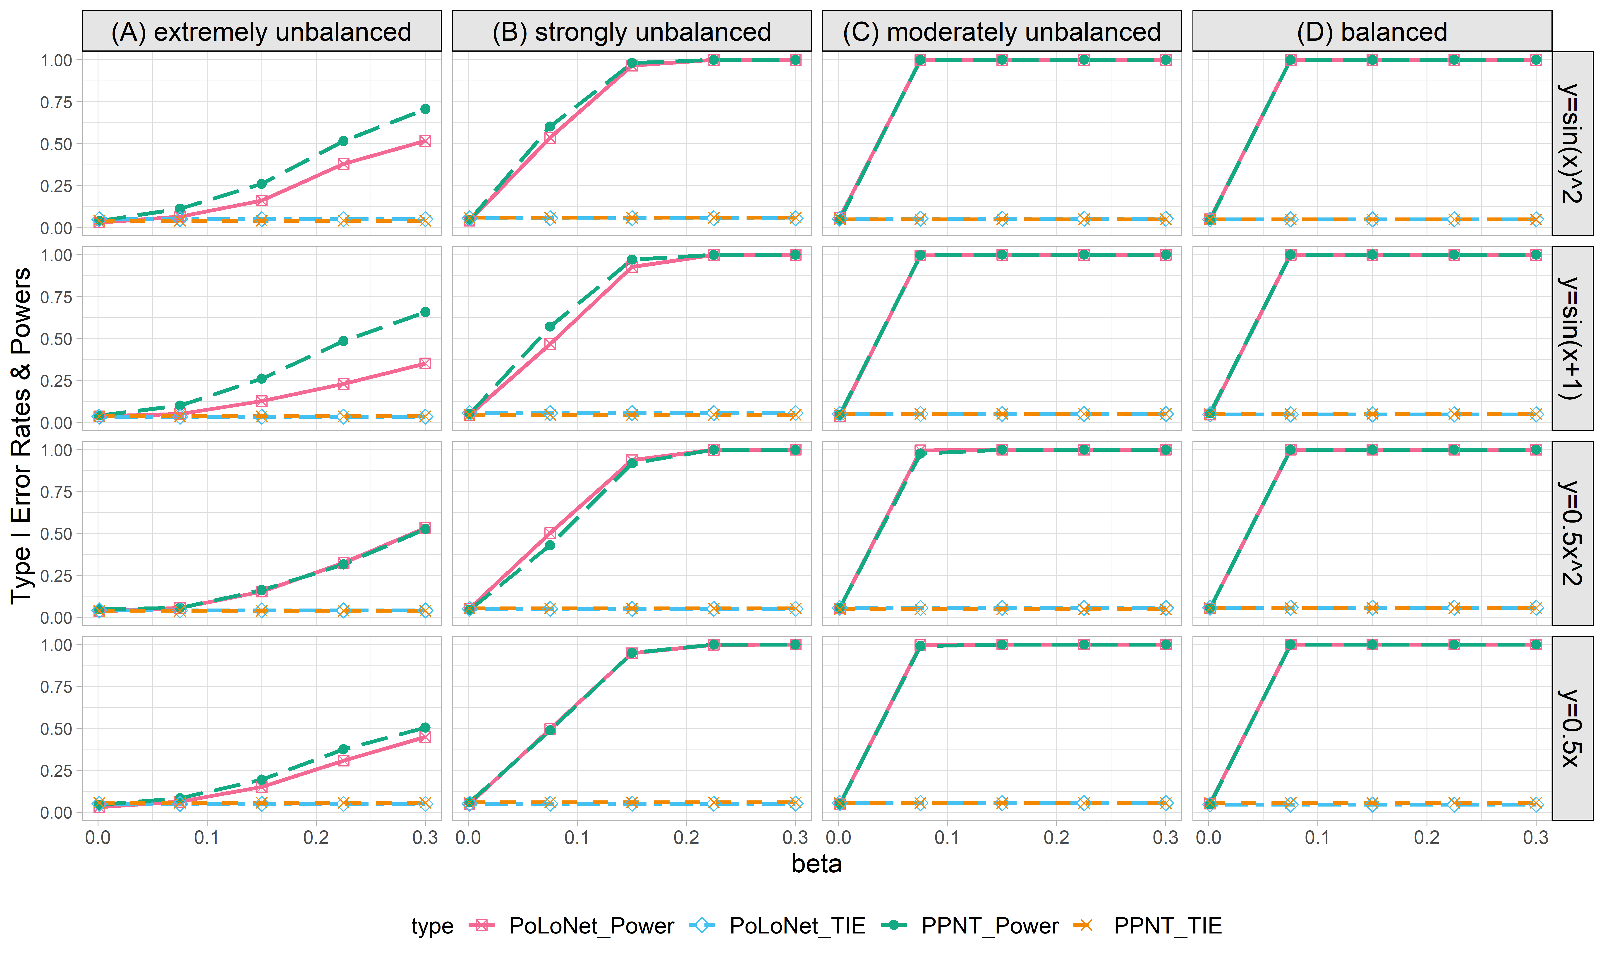

**Figure S6. Empirical type I error rates and powers for detecting the effect of the node for the binary trait under the setting that both node and edge has effects, with the node hanging on the edge (n=5000), with DPR as gene expression prediction model in TWAS.** The significance level is α=0.05. Simulations are conducted with 4 different between-node correlation patterns (the recombination of quadratic and sine, sine, quadratic, linear) and 5 different effect sizes (0.001, 0.075, 0.15, 0.225, 0.3). **(A)** extremely unbalanced (1:999); **(B)** strongly unbalanced (99:1); **(C)** moderately unbalanced (1:9); **(D)** balanced (1:1)).

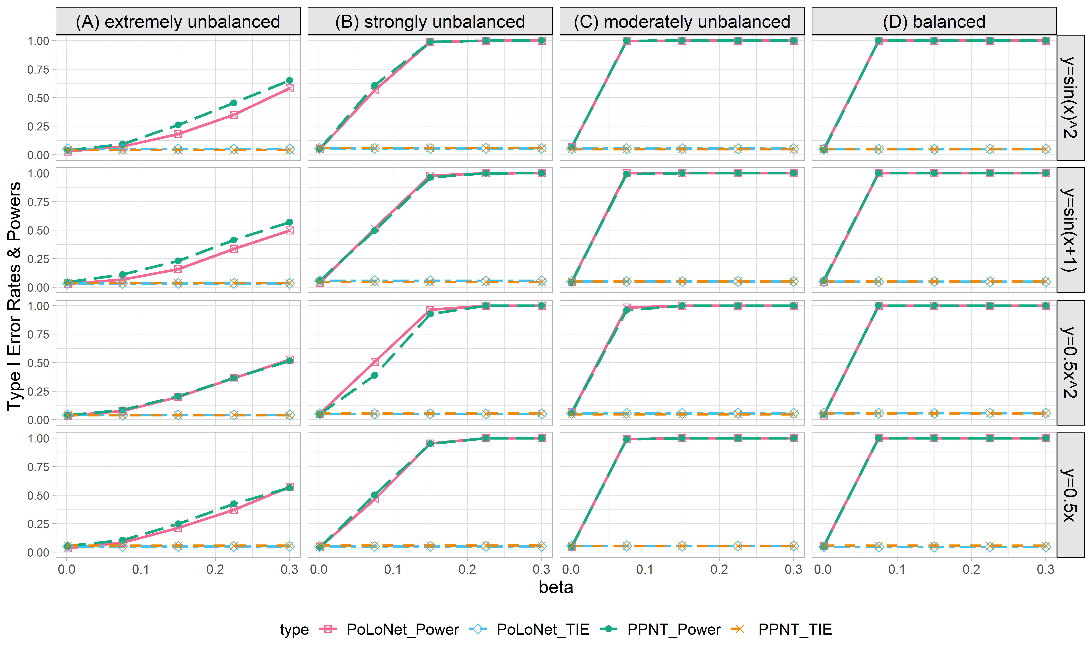

**Figure S7. Empirical type I error rates and powers for detecting the effect of the node for the binary trait under the setting that both node and edge have effects, with the node not hanging on the edge (n=5000), with DPR as gene expression prediction model in TWAS.** The significance level is α=0.05. Simulations are conducted with 4 different between-node correlation patterns (the recombination of quadratic and sine, sine, quadratic, linear) and 5 different effect sizes (0.001, 0.075, 0.15, 0.225, 0.3). **(A)** extremely unbalanced (1:999); **(B)** strongly unbalanced (99:1); **(C)** moderately unbalanced (1:9); **(D)** balanced (1:1)).

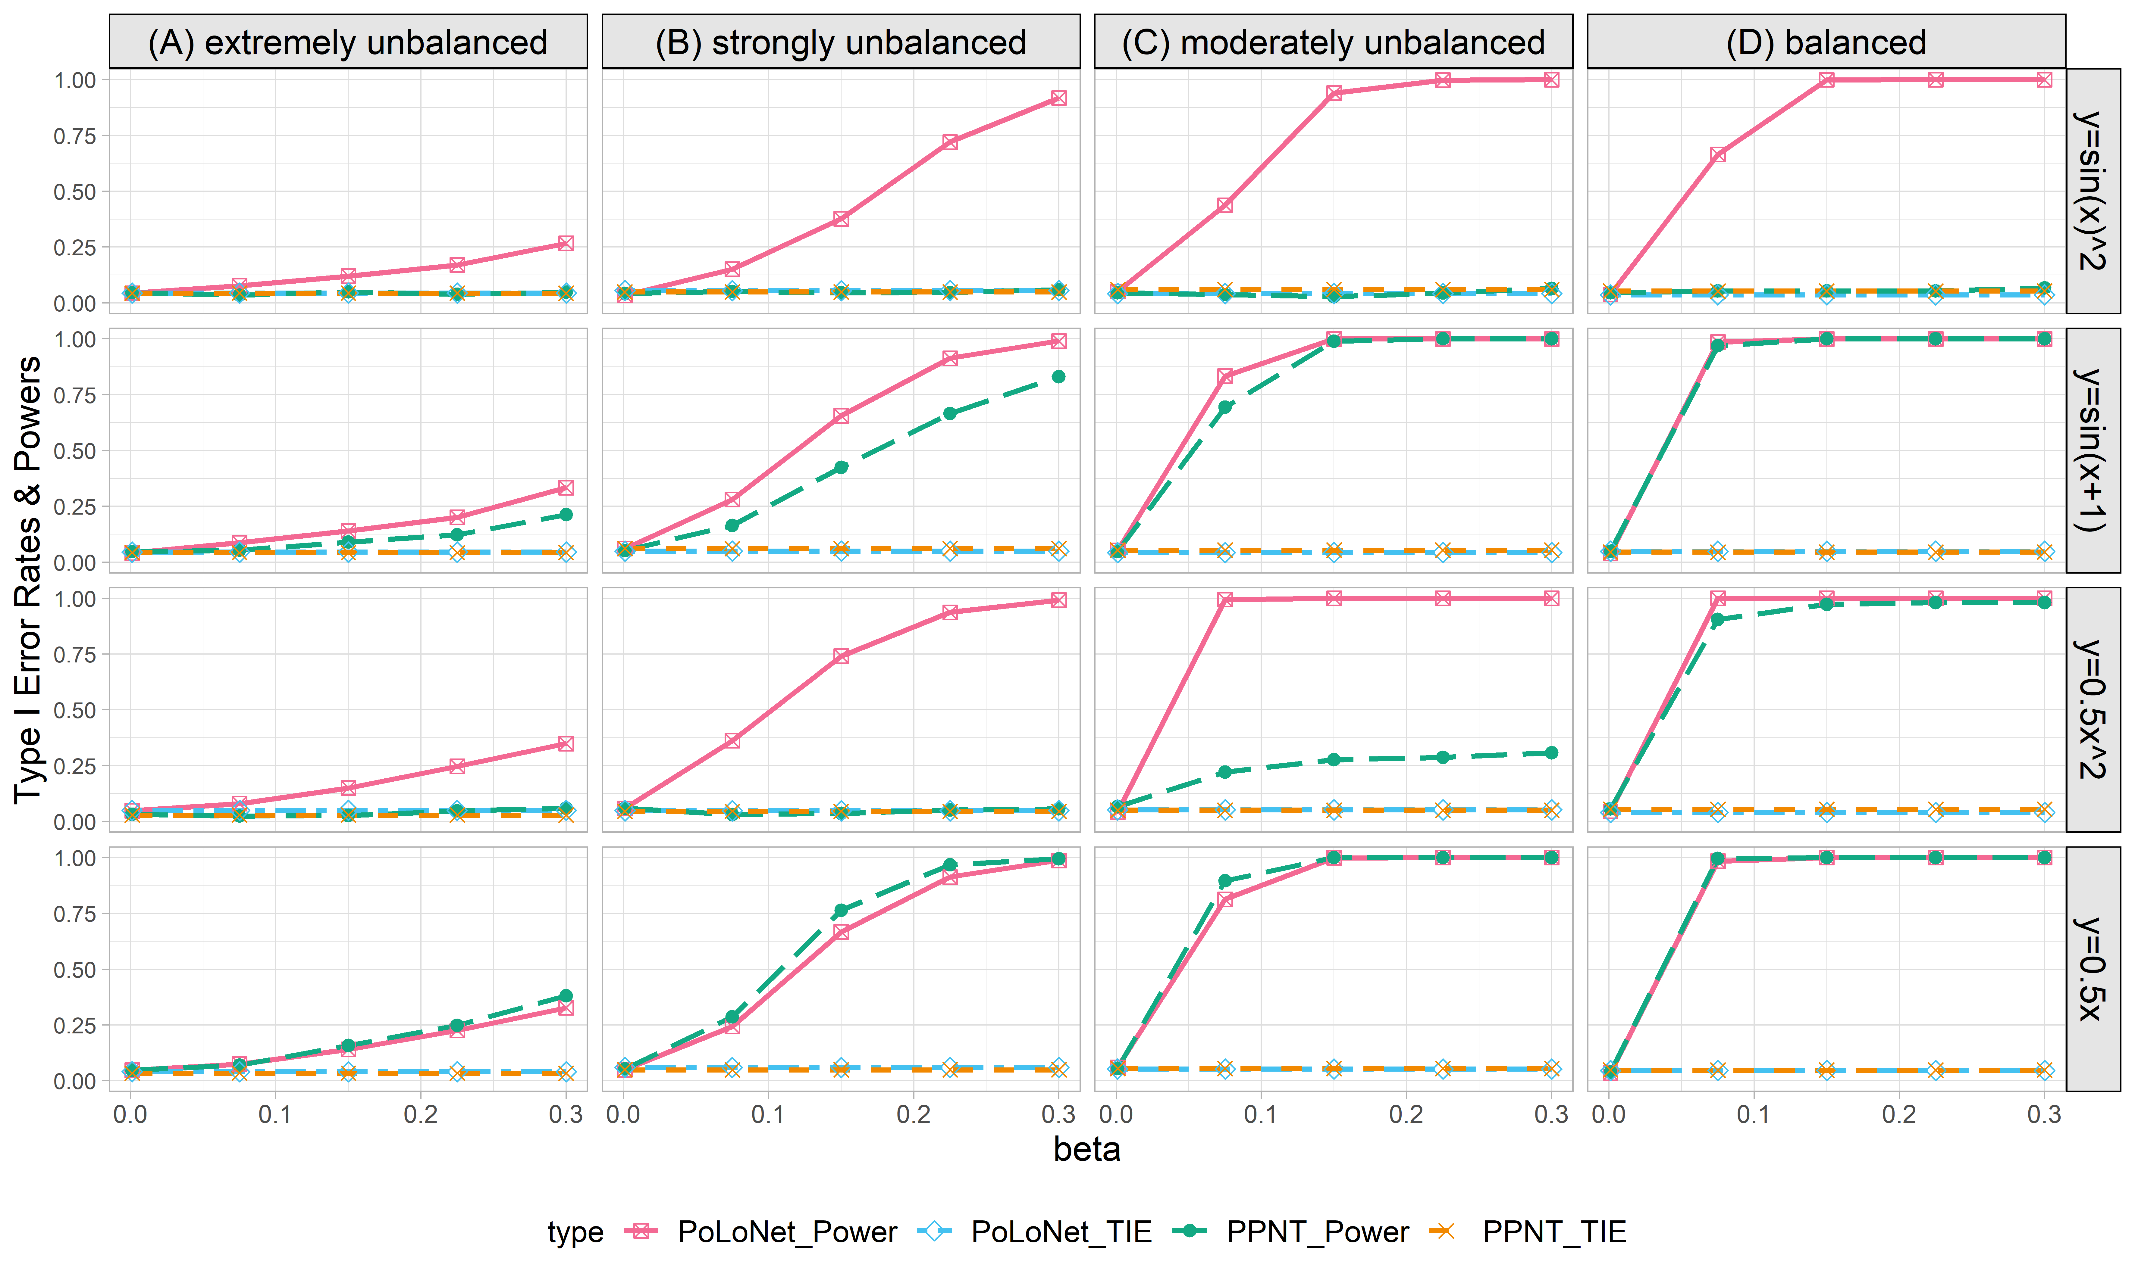

**Figure S8. Empirical type I error rates and powers for detecting the effect of the edge for the binary trait under the setting that only the edge has an effect (n=5000), with DPR as gene expression prediction model in TWAS.** The significance level is α=0.05. Simulations are conducted with 4 different between-node correlation patterns (the recombination of quadratic and sine, sine, quadratic, linear) and 5 different effect sizes (0.001, 0.075, 0.15, 0.225, 0.3). **(A)** extremely unbalanced (1:999) ; **(B)** strongly unbalanced (99:1); **(C)** moderately unbalanced (1:9); **(D)** balanced (1:1)).

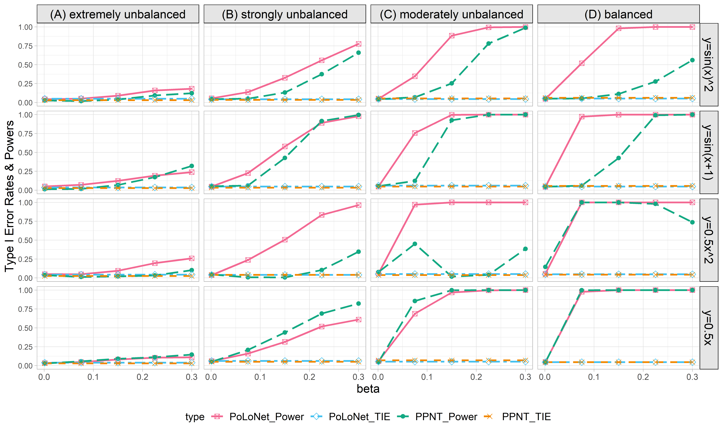

**Figure S9. Empirical type I error rates and powers for detecting the effect of the edge for the binary trait under the setting that both node and edge have effects, with the node hanging on the edge (n=5000), with DPR as gene expression prediction model in TWAS.** The significance level is α=0.05. Simulations are conducted with 4 different between-node correlation patterns (the recombination of quadratic and sine, sine, quadratic, linear) and 5 different effect sizes (0.001, 0.075, 0.15, 0.225, 0.3). **(A)** extremely unbalanced (1:999); **(B)** strongly unbalanced (99:1); **(C)** moderately unbalanced (1:9); **(D)** balanced (1:1)).

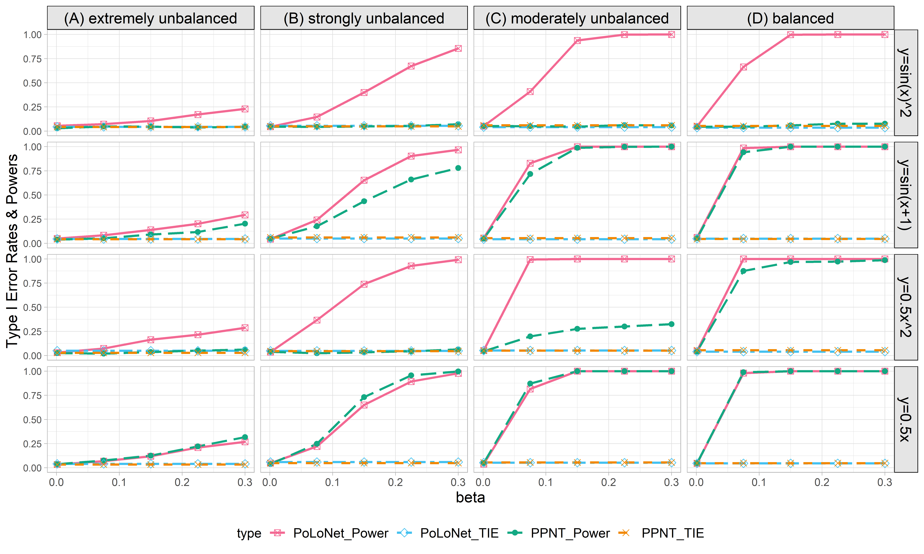

**Figure S10. Empirical type I error rates and powers for detecting the effect of the edge for the binary trait under the setting that both node and edge have effects, with the node not hanging on the edge (n=5000), with DPR as gene expression prediction model in TWAS.** The significance level is α=0.05. Simulations are conducted with 4 different between-node correlation patterns (the recombination of quadratic and sine, sine, quadratic, linear) and 5 different effect sizes (0.001, 0.075, 0.15, 0.225, 0.3). **(A)** extremely unbalanced (1:999); **(B)** strongly unbalanced (99:1); **(C)** moderately unbalanced (1:9); **(D)** balanced (1:1)).

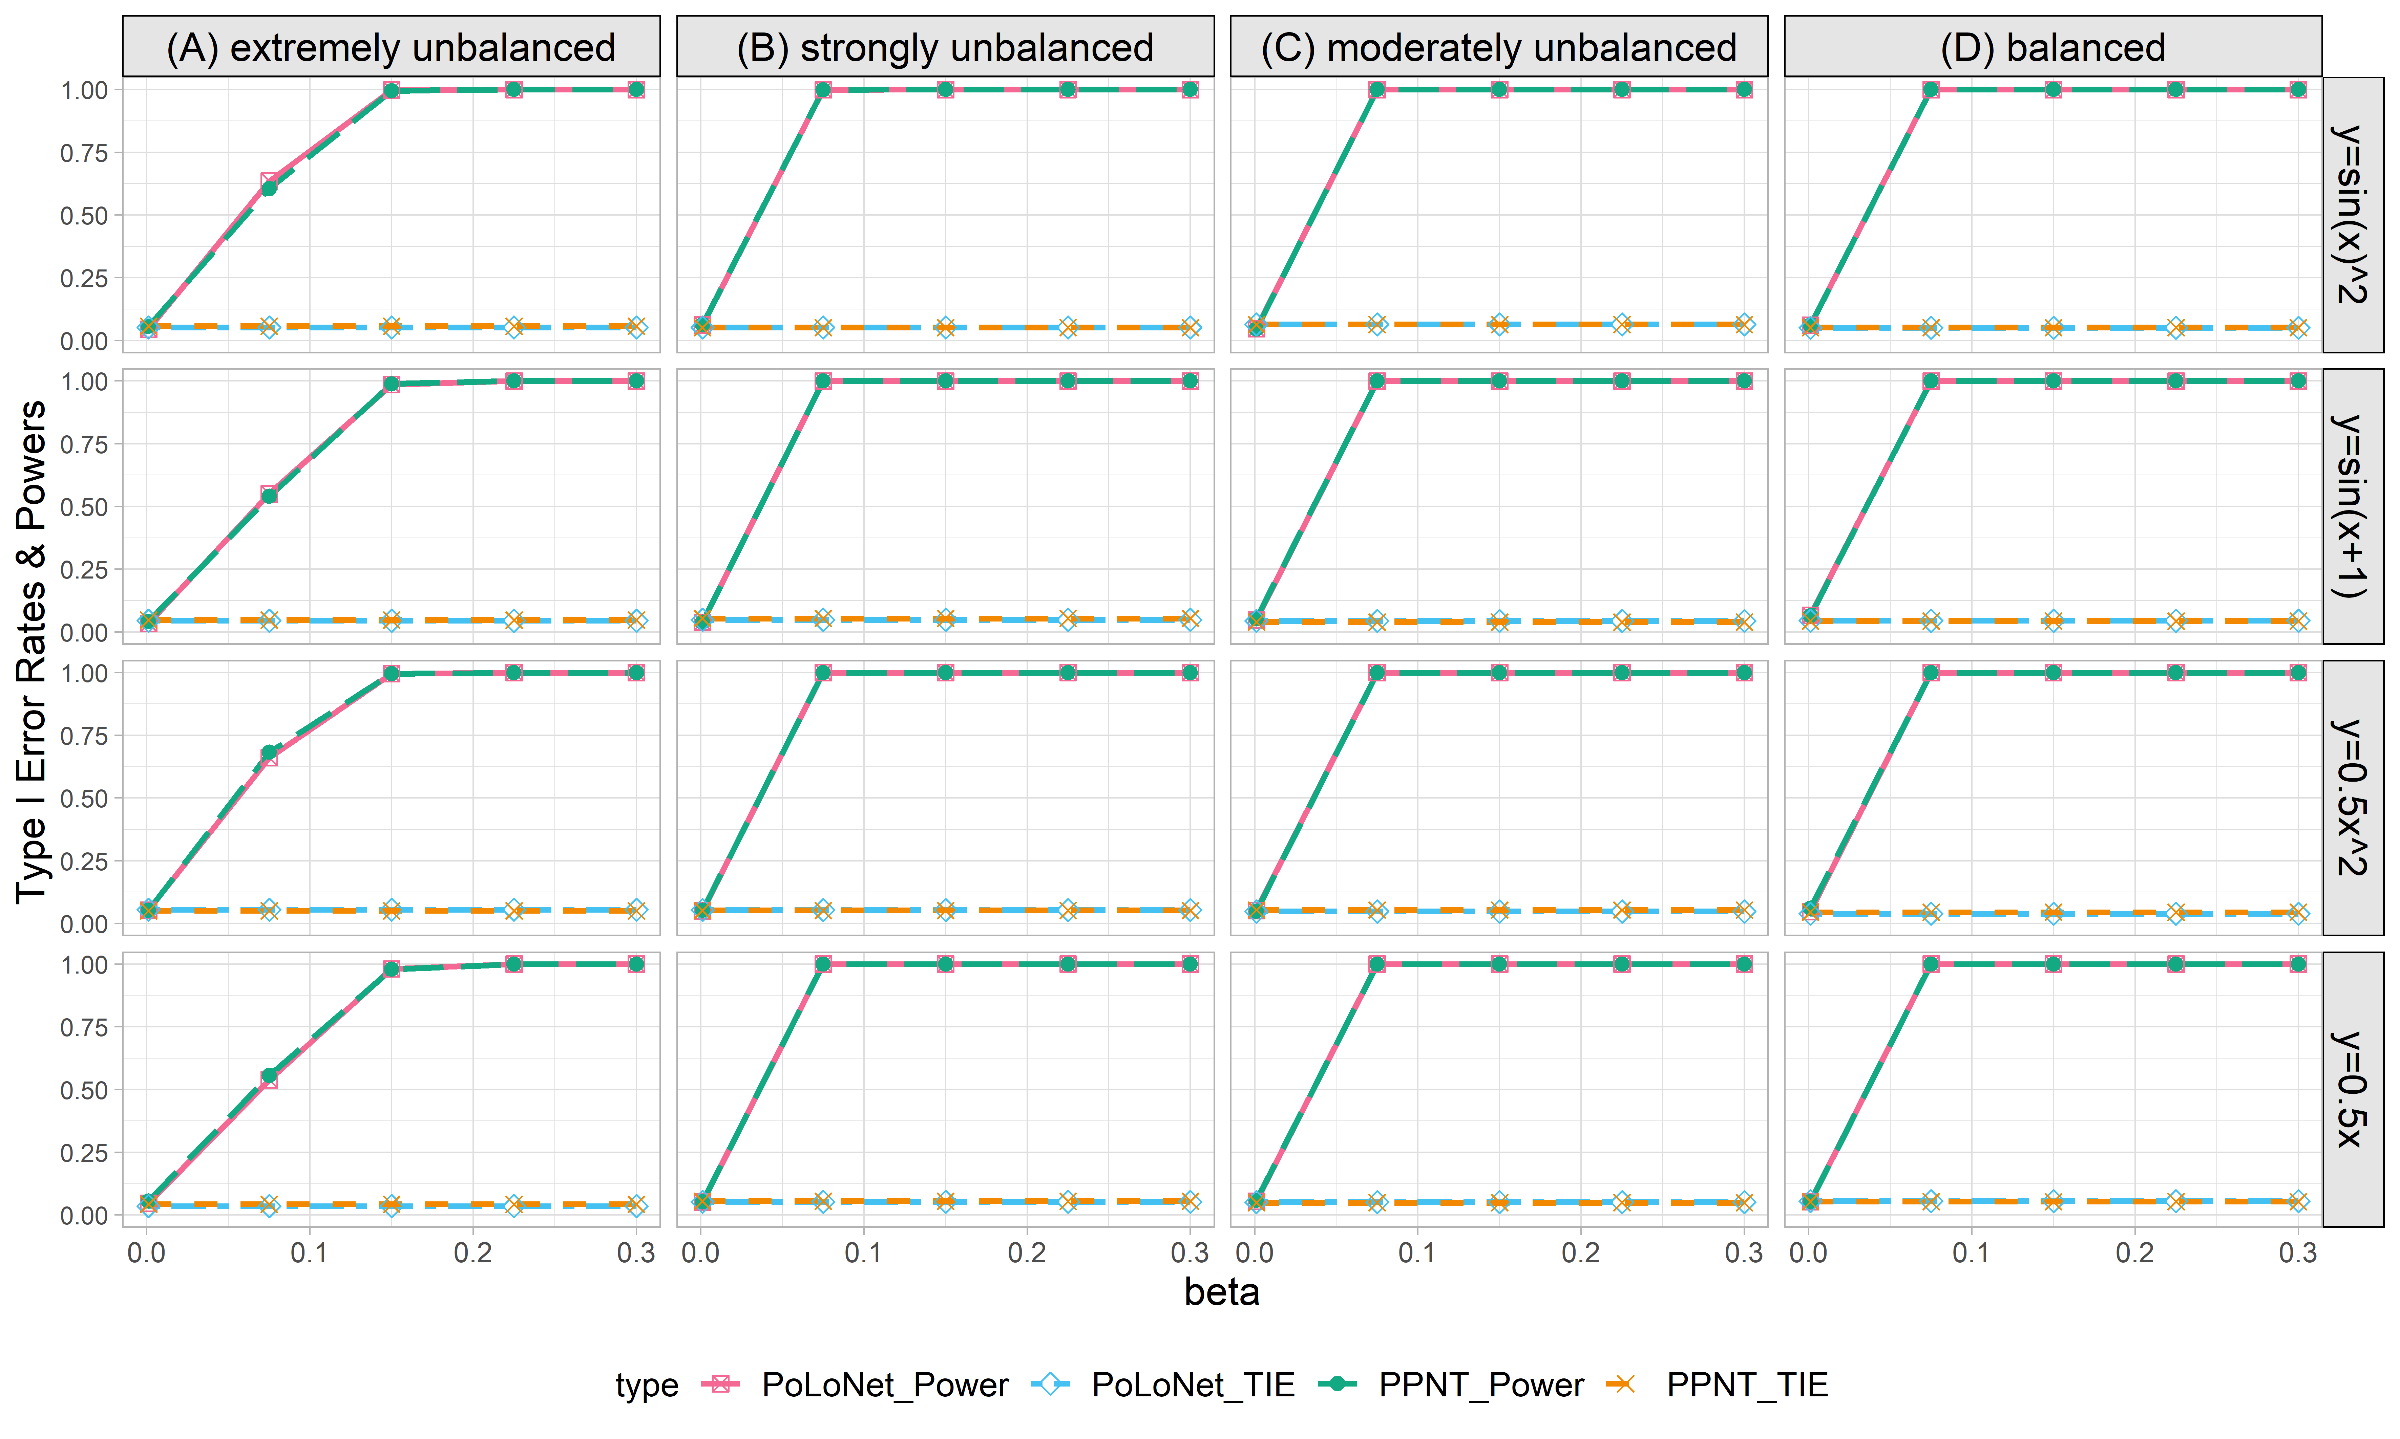

**Figure S11. Empirical type I error rates and powers for detecting the effect of the node for the binary trait under the setting that only node has an effect (n=20000), with DPR as gene expression prediction model in TWAS.** The significance level is α=0.05. Simulations are conducted with 4 different between-node correlation patterns (the recombination of quadratic and sine, sine, quadratic, linear) and 5 different effect sizes (0.001, 0.075, 0.15, 0.225, 0.3). **(A)** extremely unbalanced (1:999); **(B)** strongly unbalanced (99:1); **(C)** moderately unbalanced (1:9); **(D)** balanced (1:1)).

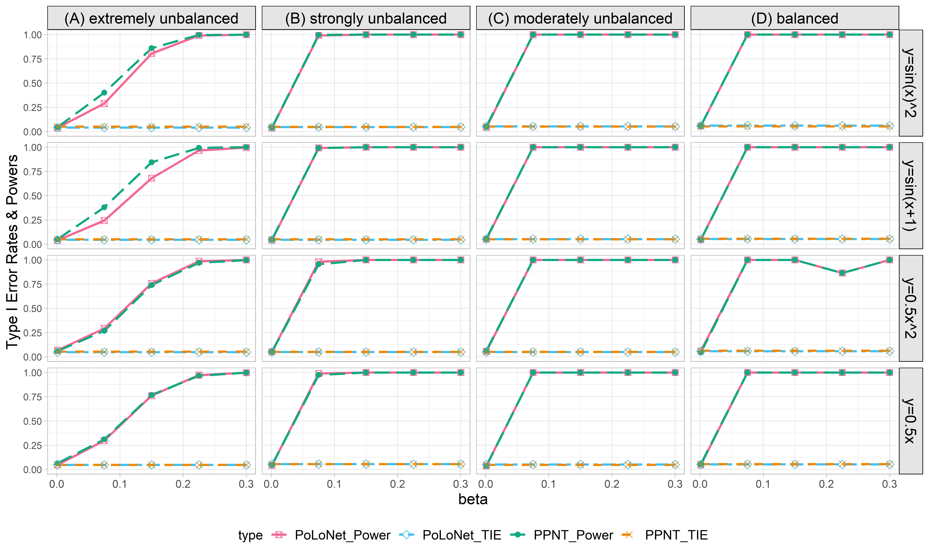

**Figure S12. Empirical type I error rates and powers for detecting the effect of the node for the binary trait under the setting that both node and edge have effects, with the node hanging on the edge (n=20000), with DPR as gene expression prediction model in TWAS.** The significance level is α=0.05. Simulations are conducted with 4 different between-node correlation patterns (the recombination of quadratic and sine, sine, quadratic, linear) and 5 different effect sizes (0.001, 0.075, 0.15, 0.225, 0.3). **(A)** extremely unbalanced (1:999); **(B)** strongly unbalanced (99:1); **(C)** moderately unbalanced (1:9); **(D)** balanced (1:1)).

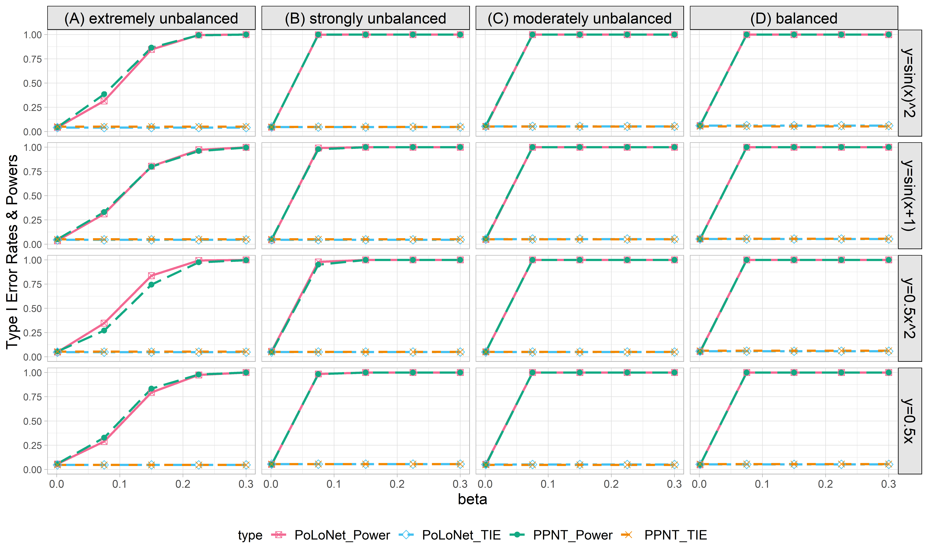

**Figure S13. Empirical type I error rates and powers for detecting the effect of the node for the binary trait under the setting that both node and edge have effects, with the node not hanging on the edge (n=20000), with DPR as gene expression prediction model in TWAS.** The significance level is α=0.05. Simulations are conducted with 4 different between-node correlation patterns (the recombination of quadratic and sine, sine, quadratic, linear) and 5 different effect sizes (0.001, 0.075, 0.15, 0.225, 0.3). **(A)** extremely unbalanced (1:999); **(B)** strongly unbalanced (99:1); **(C)** moderately unbalanced (1:9); **(D)** balanced (1:1)).

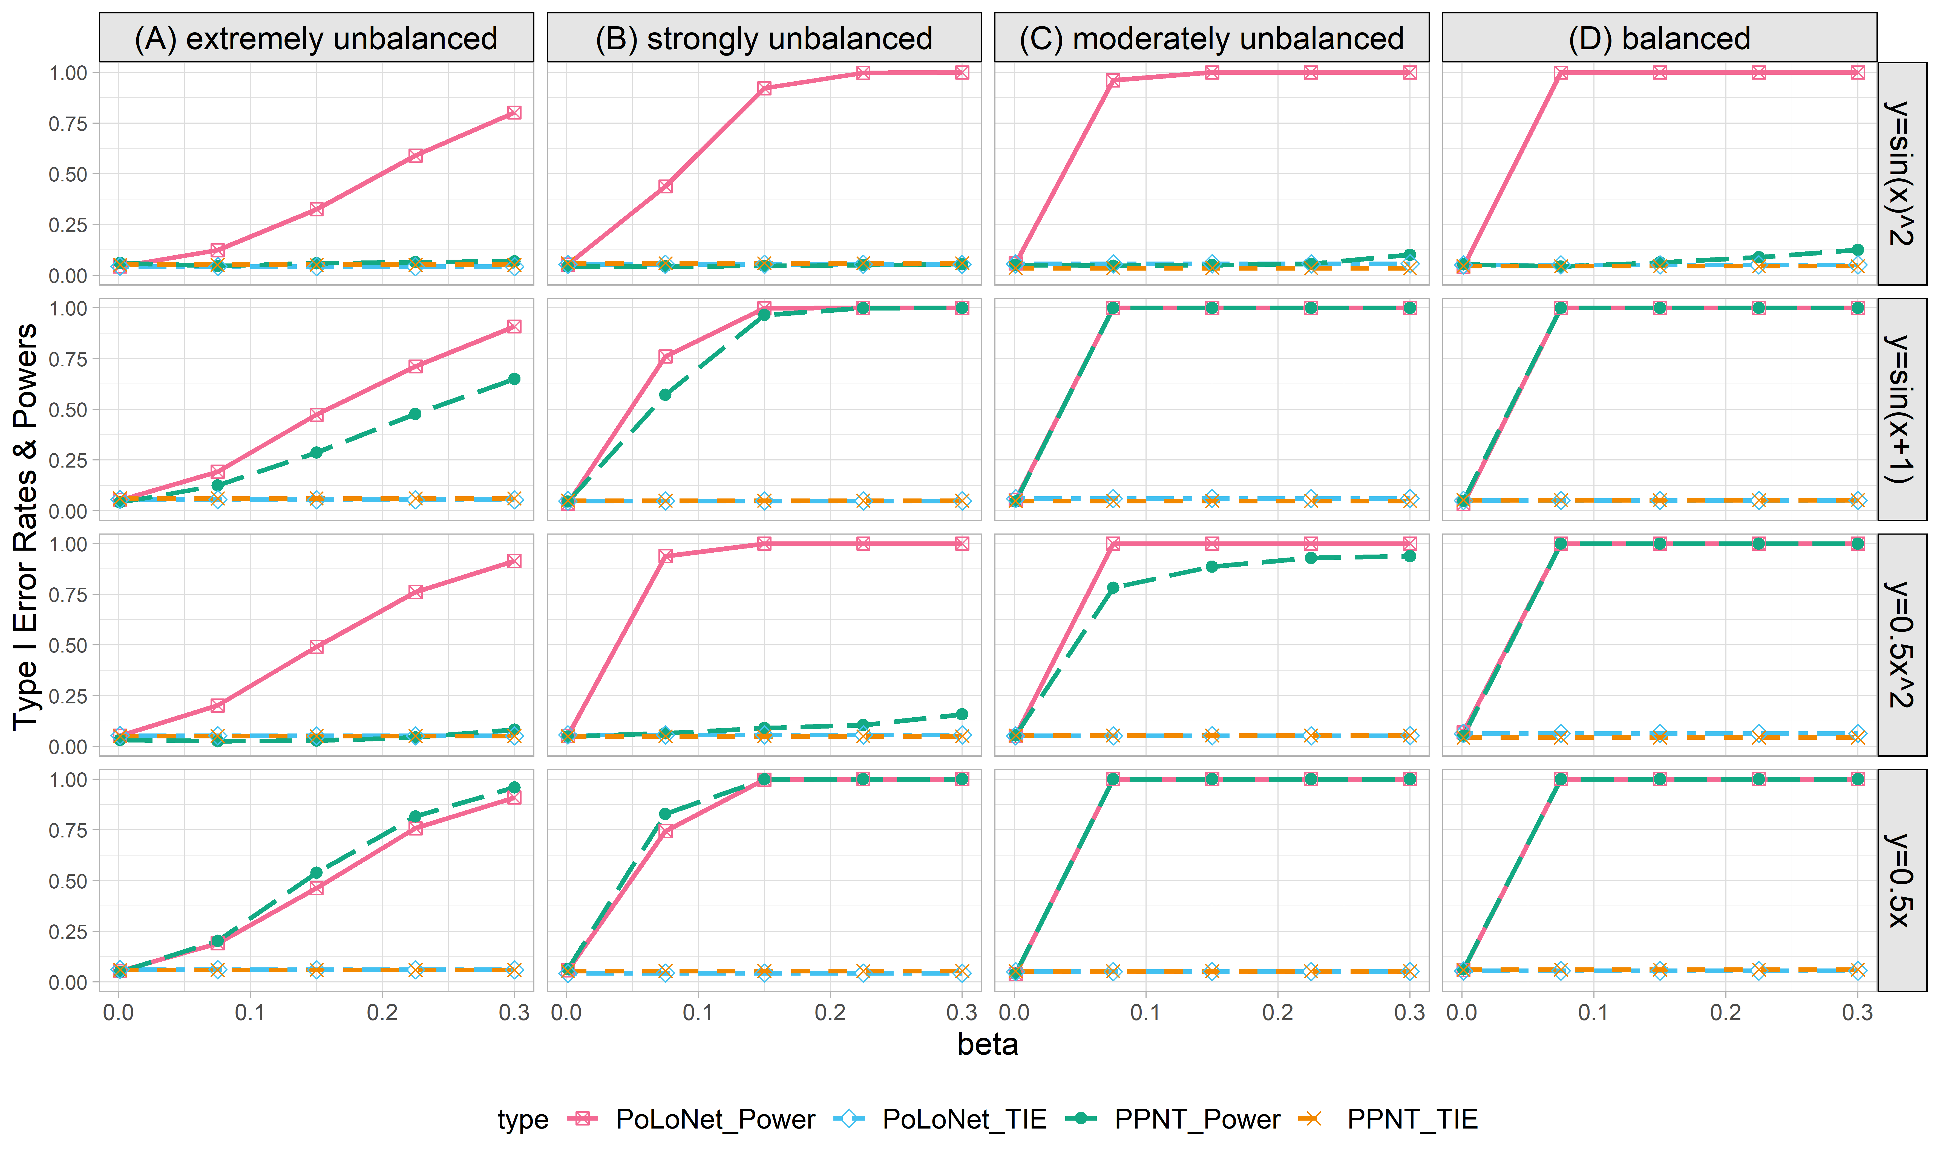

**Figure S14. Empirical type I error rates and powers for detecting the effect of the edge for the binary trait under the setting that only the edge has an effect (n=20000), with DPR as the gene expression prediction model in TWAS.** The significance level is α=0.05. Simulations are conducted with 4 different between-node correlation patterns (the recombination of quadratic and sine, sine, quadratic, linear) and 5 different effect sizes (0.001, 0.075, 0.15, 0.225, 0.3). **(A)** extremely unbalanced (1:999); **(B)** strongly unbalanced (99:1); **(C)** moderately unbalanced (1:9); **(D)** balanced (1:1)).

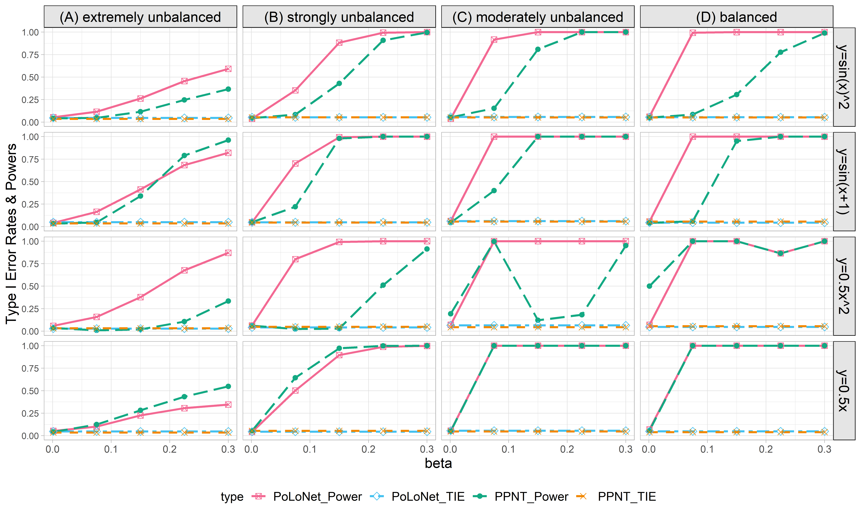

**Figure S15. Empirical type I error rates and powers for detecting the effect of the edge for the binary trait under the setting that both node and edge have effects, with the node hanging on the edge (n=20000), with DPR as gene expression prediction model in TWAS.** The significance level is α=0.05. Simulations are conducted with 4 different between-node correlation patterns (the recombination of quadratic and sine, sine, quadratic, linear) and 5 different effect sizes (0.001, 0.075, 0.15, 0.225, 0.3). **(A)** extremely unbalanced (1:999); **(B)** strongly unbalanced (99:1); **(C)** moderately unbalanced (1:9); **(D)** balanced (1:1)).

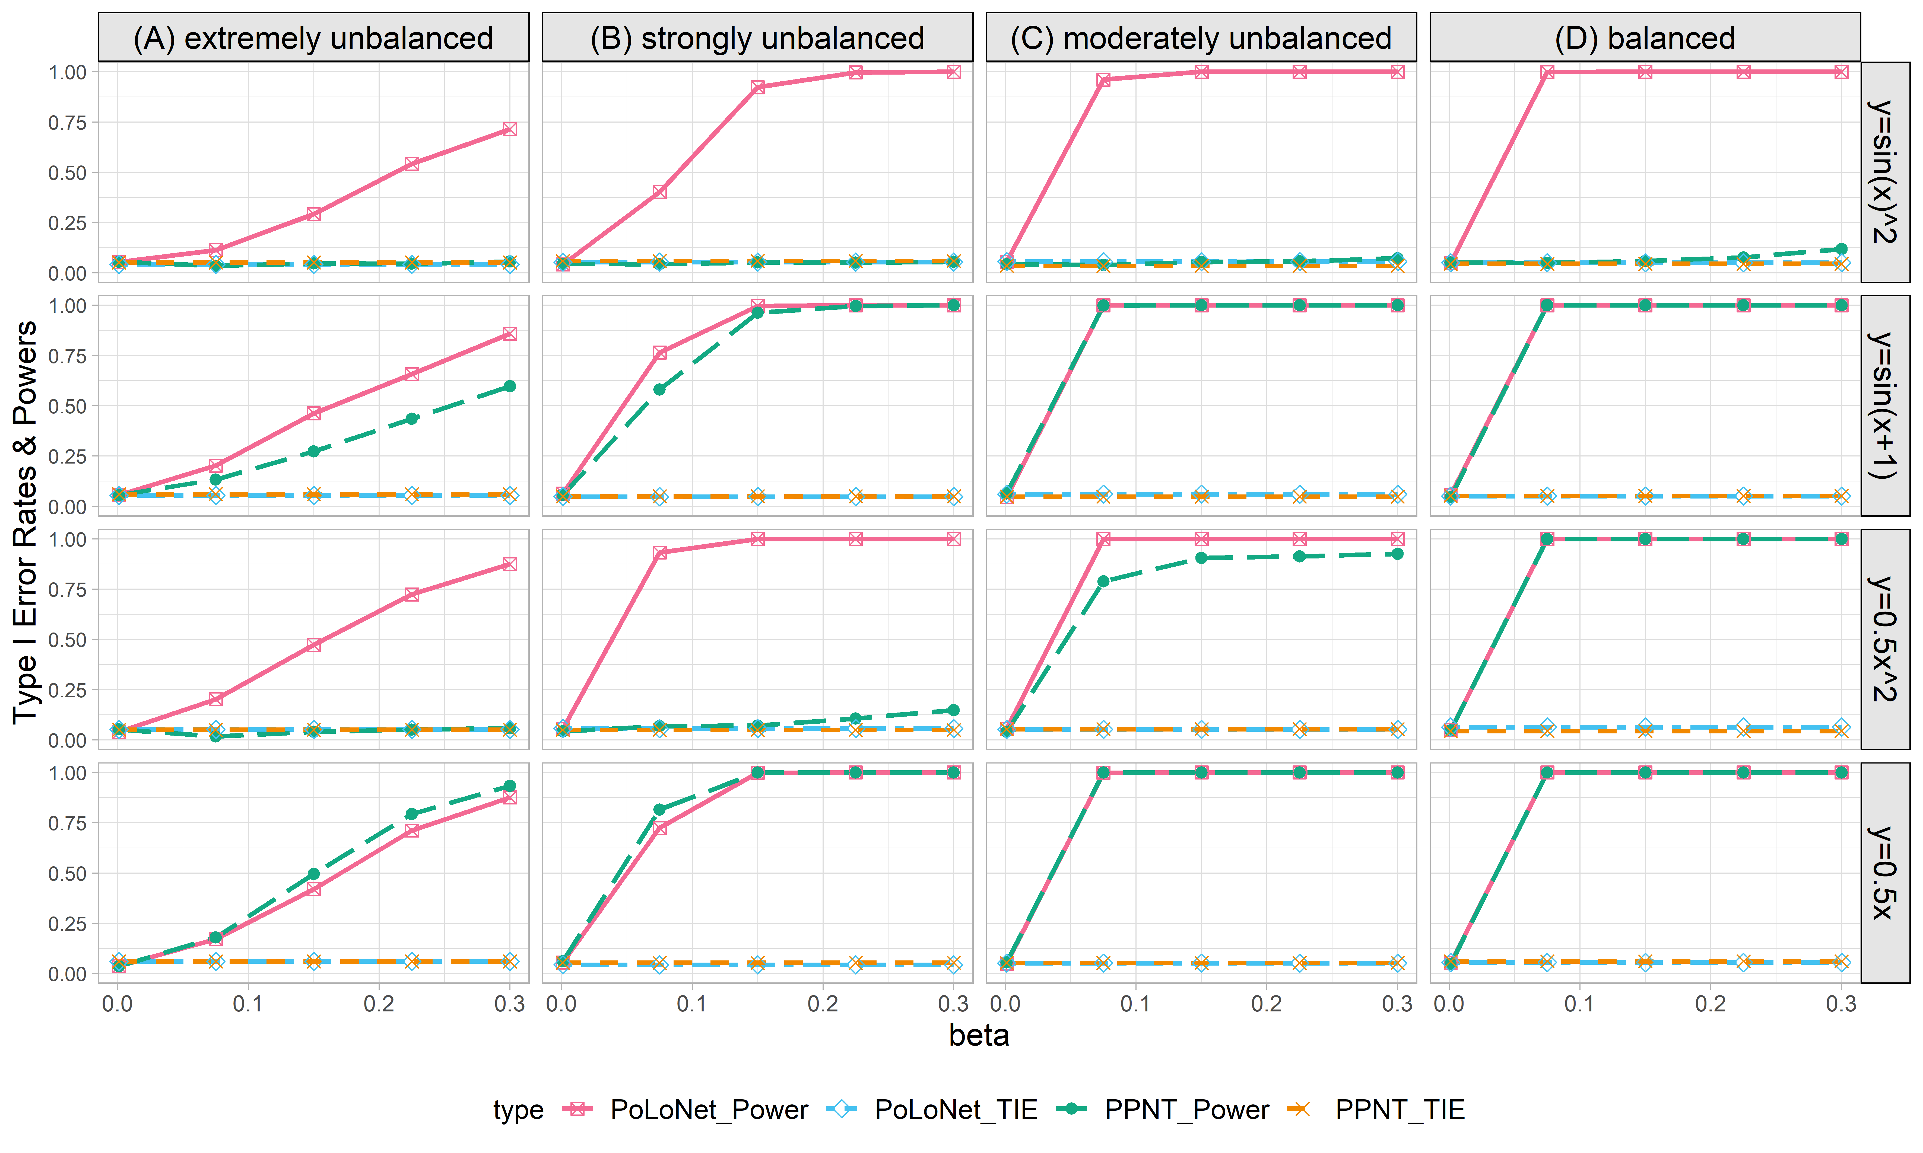

**Figure S16. Empirical type I error rates and powers for detecting the effect of the edge for the binary trait under the setting that both node and edge have effects, with the node not hanging on the edge (n=20000), with DPR as gene expression prediction model in TWAS.** The significance level is α=0.05. Simulations are conducted with 4 different between-node correlation patterns (the recombination of quadratic and sine, sine, quadratic, linear) and 5 different effect sizes (0.001, 0.075, 0.15, 0.225, 0.3). **(A)** extremely unbalanced (1:999); **(B)** strongly unbalanced (99:1); **(C)** moderately unbalanced (1:9); **(D)** balanced (1:1)).

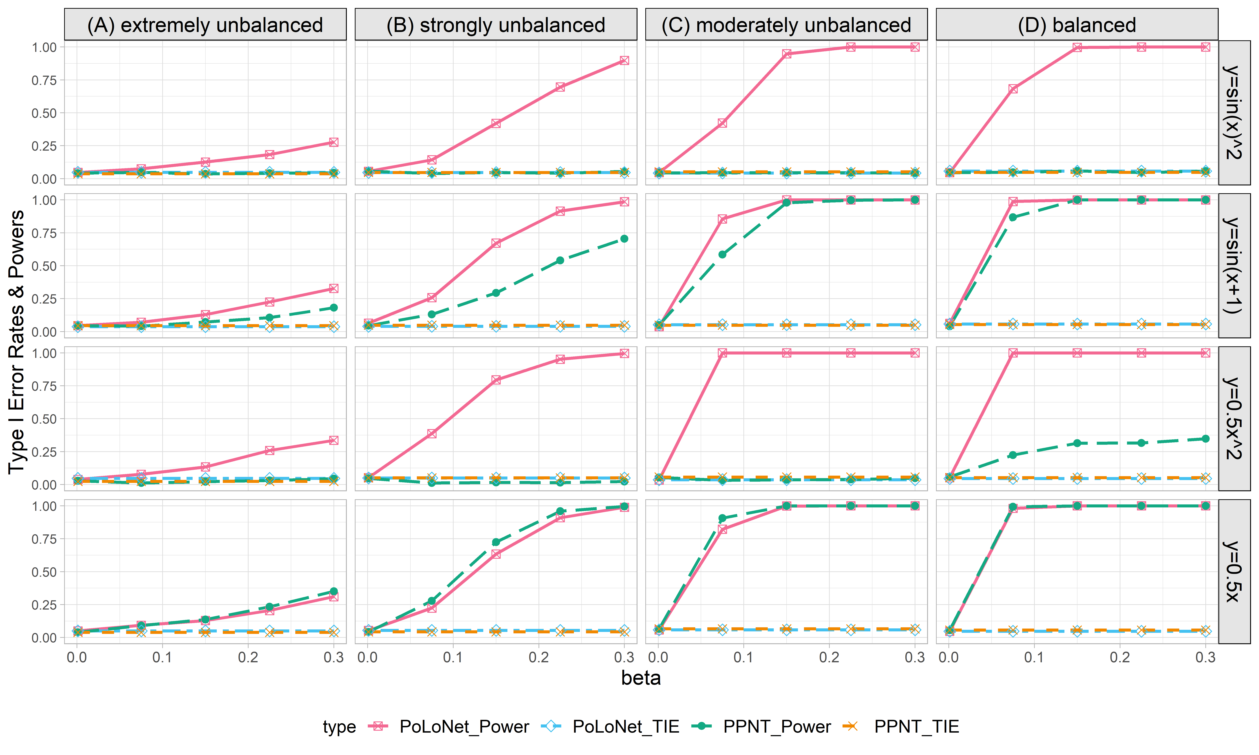

**Figure S17. Empirical type I error rates and powers for detecting the effect of the edge for the binary trait under the setting that only edge has an effect (n=5000), with BSLMM as gene expression prediction model in TWAS.** The significance level is α=0.05. Simulations are conducted with 4 different between-node correlation patterns (the recombination of quadratic and sine, sine, quadratic, linear) and 5 different effect sizes (0.001, 0.075, 0.15, 0.225, 0.3). **(A)** extremely unbalanced (1:999); **(B)** strongly unbalanced (99:1); **(C)** moderately unbalanced (1:9); **(D)** balanced (1:1)).

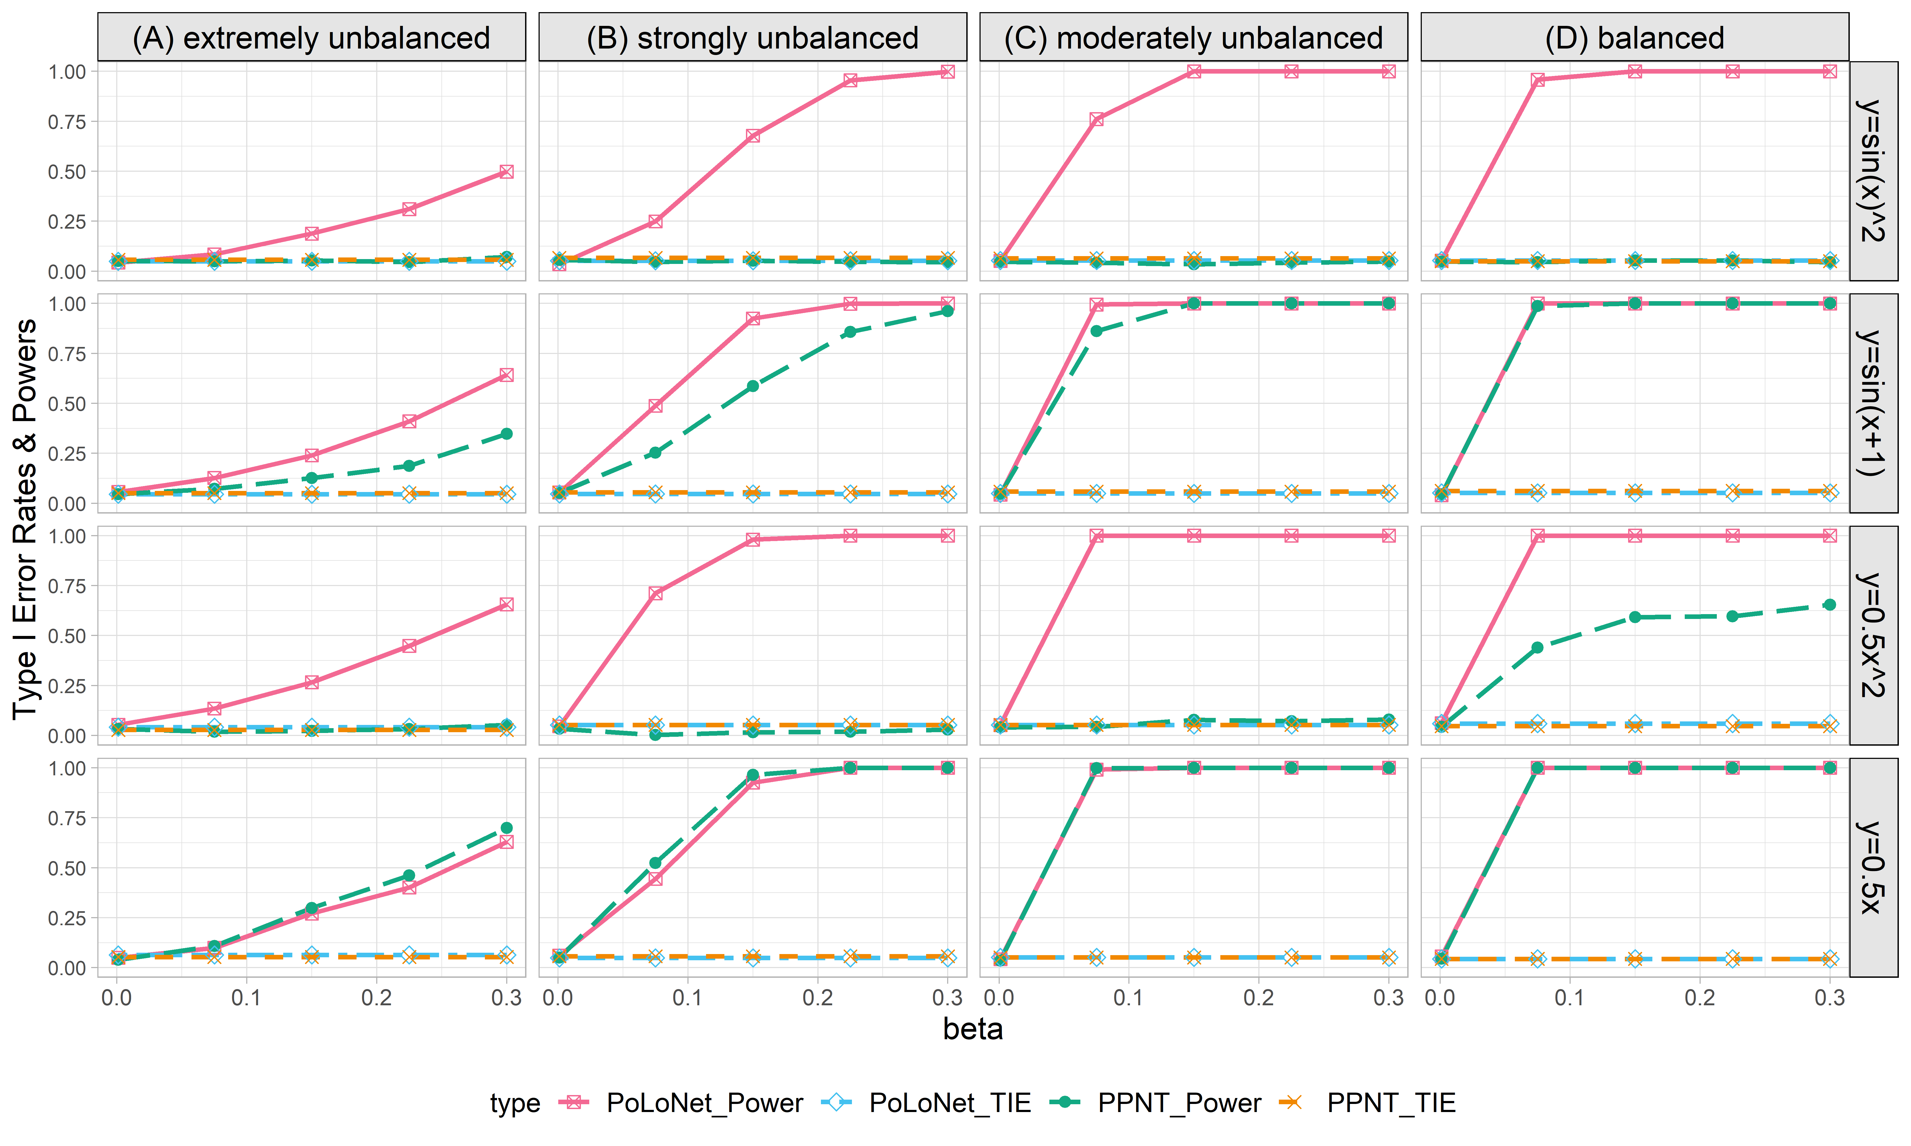

**Figure S18. Empirical type I error rates and powers for detecting the effect of the edge for the binary trait under the setting that only the edge has an effect (n=10000), with BSLMM as gene expression prediction model in TWAS.** The significance level is α=0.05. Simulations are conducted with 4 different between-node correlation patterns (the recombination of quadratic and sine, sine, quadratic, linear) and 5 different effect sizes (0.001, 0.075, 0.15, 0.225, 0.3). **(A)** extremely unbalanced (1:999); **(B)** strongly unbalanced (99:1); **(C)** moderately unbalanced (1:9); **(D)** balanced (1:1)).

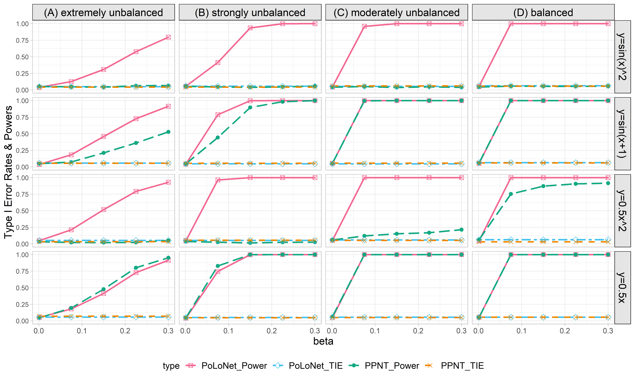

**Figure S19. Empirical type I error rates and powers for detecting the effect of the edge for the binary trait under the setting that only the edge has an effect (n=20000), with BSLMM as gene expression prediction model in TWAS.** The significance level is α=0.05. Simulations are conducted with 4 different between-node correlation patterns (the recombination of quadratic and sine, sine, quadratic, linear) and 5 different effect sizes (0.001, 0.075, 0.15, 0.225, 0.3). **(A)** extremely unbalanced (1:999); **(B)** strongly unbalanced (99:1); **(C)** moderately unbalanced (1:9); **(D)** balanced (1:1)).

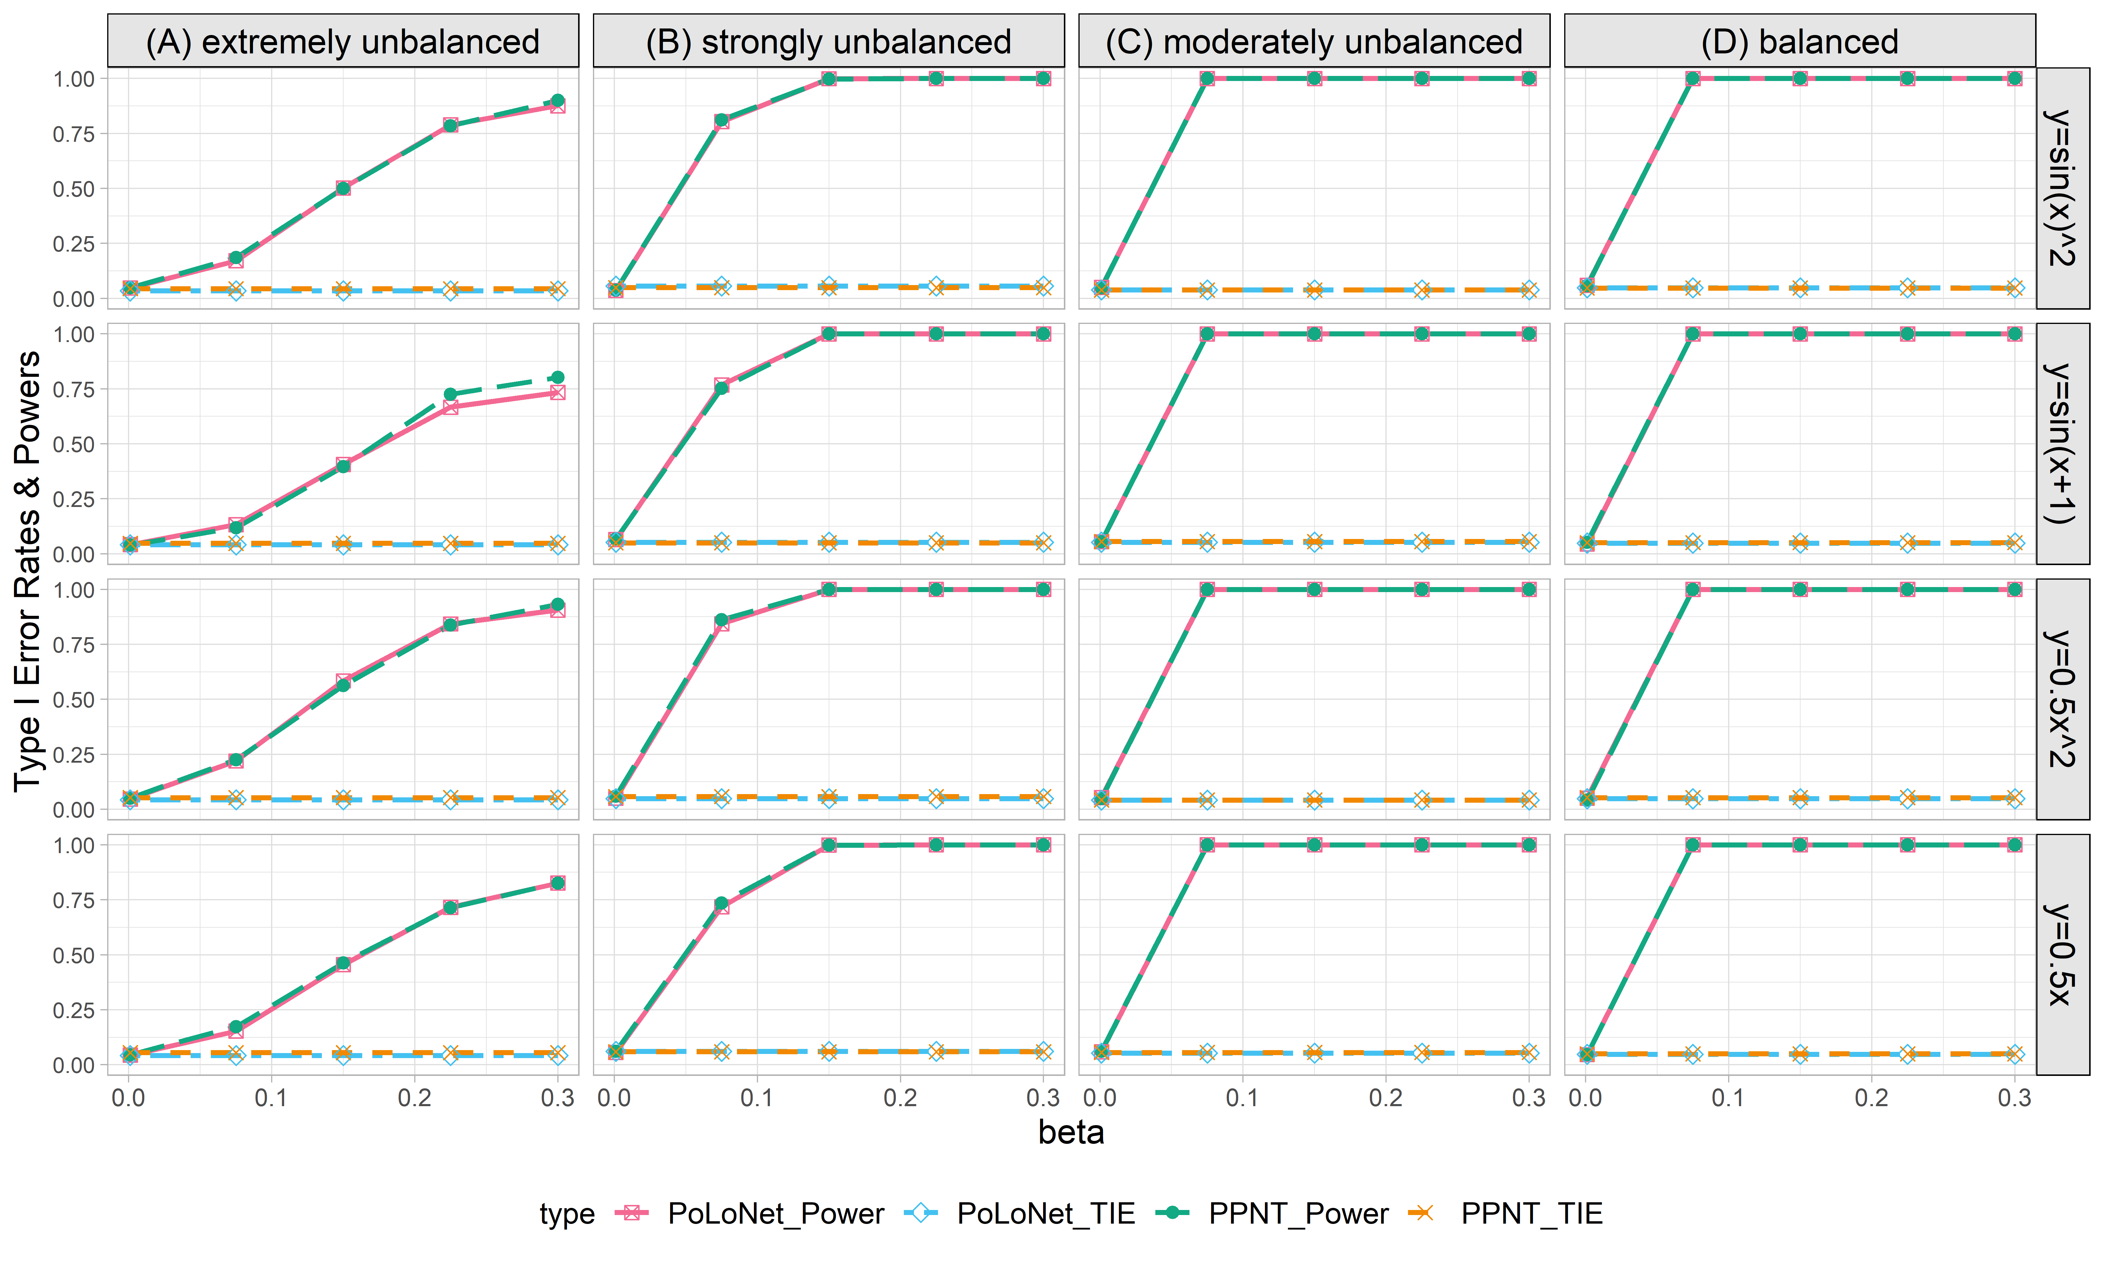

**Figure S20. Empirical type I error rates and powers for detecting the effect of the node for the binary trait under the setting that only the node has an effect (n=5000), with BSLMM as gene expression prediction model in TWAS.** The significance level is α=0.05. Simulations are conducted with 4 different between-node correlation patterns (the recombination of quadratic and sine, sine, quadratic, linear) and 5 different effect sizes (0.001, 0.075, 0.15, 0.225, 0.3). **(A)** extremely unbalanced (1:999); **(B)** strongly unbalanced (99:1); **(C)** moderately unbalanced (1:9); **(D)** balanced (1:1)).

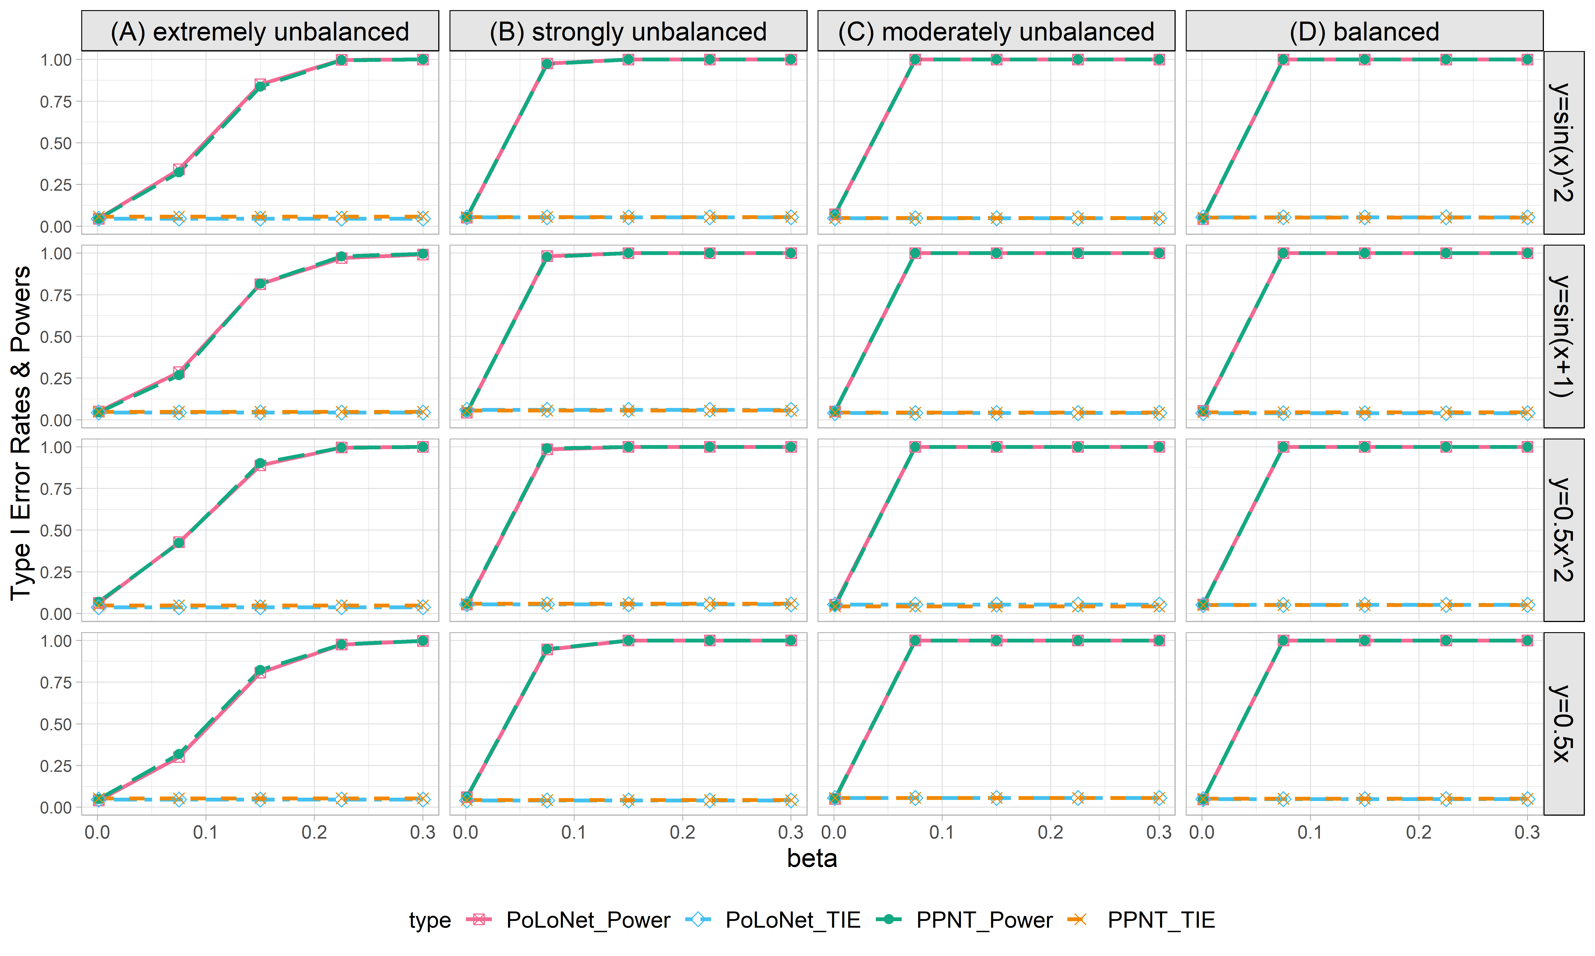

**Figure S21. Empirical type I error rates and powers for detecting the effect of the node for the binary trait under the setting that only the node has an effect (n=10000), with BSLMM as gene expression prediction model in TWAS.** The significance level is α=0.05. Simulations are conducted with 4 different between-node correlation patterns (the recombination of quadratic and sine, sine, quadratic, linear) and 5 different effect sizes (0.001, 0.075, 0.15, 0.225, 0.3). **(A)** extremely unbalanced (1:999); **(B)** strongly unbalanced (99:1); **(C)** moderately unbalanced (1:9); **(D)** balanced (1:1)).

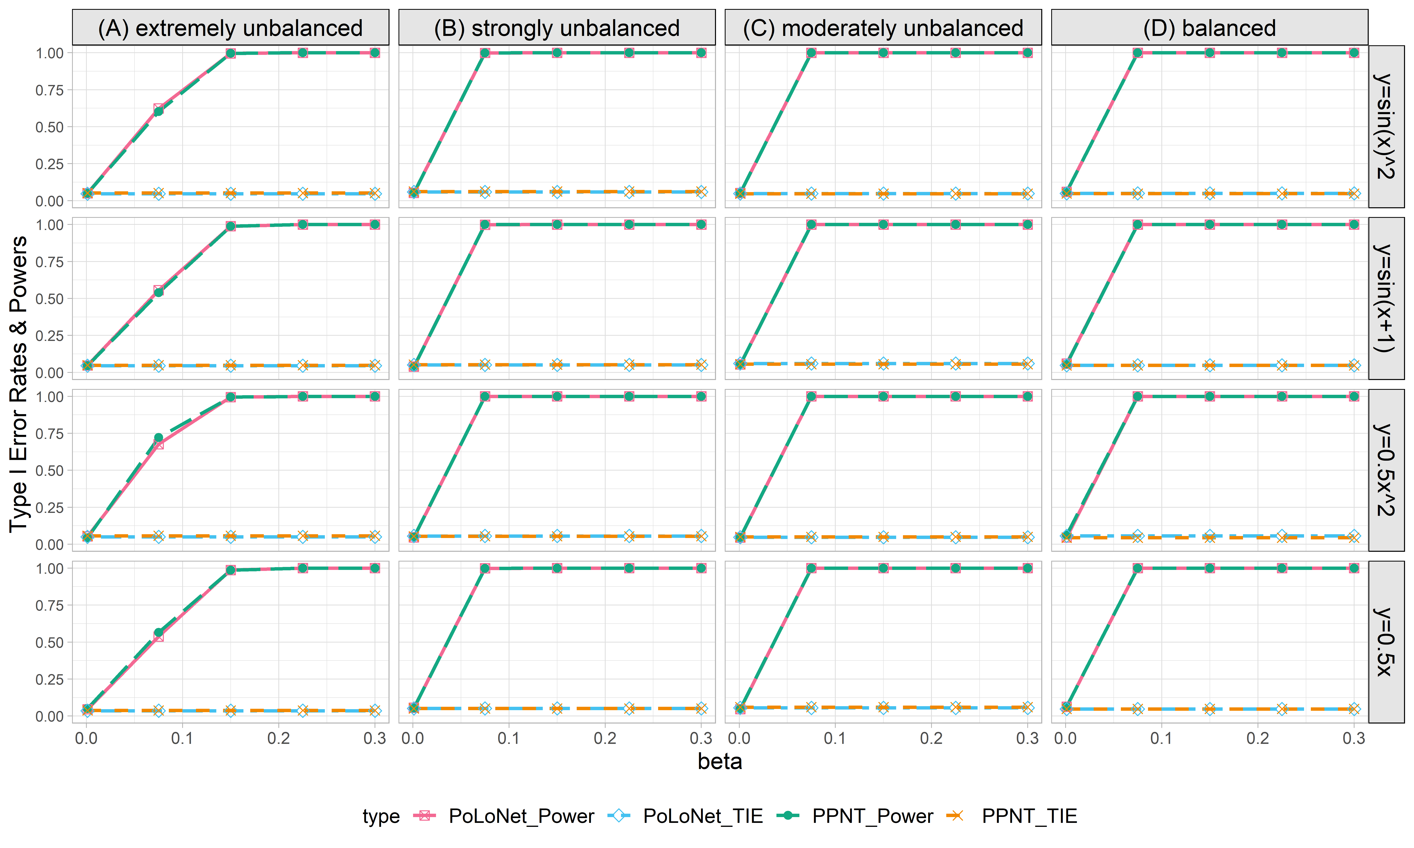

**Figure S22. Empirical type I error rates and powers for detecting the effect of the node for the binary trait under the setting that only the node has an effect (n=20000), with BSLMM as gene expression prediction model in TWAS.** The significance level is α=0.05. Simulations are conducted with 4 different between-node correlation patterns (the recombination of quadratic and sine, sine, quadratic, linear) and 5 different effect sizes (0.001, 0.075, 0.15, 0.225, 0.3). **(A)** extremely unbalanced (1:999); **(B)** strongly unbalanced (99:1); **(C)** moderately unbalanced (1:9); **(D)** balanced (1:1)).

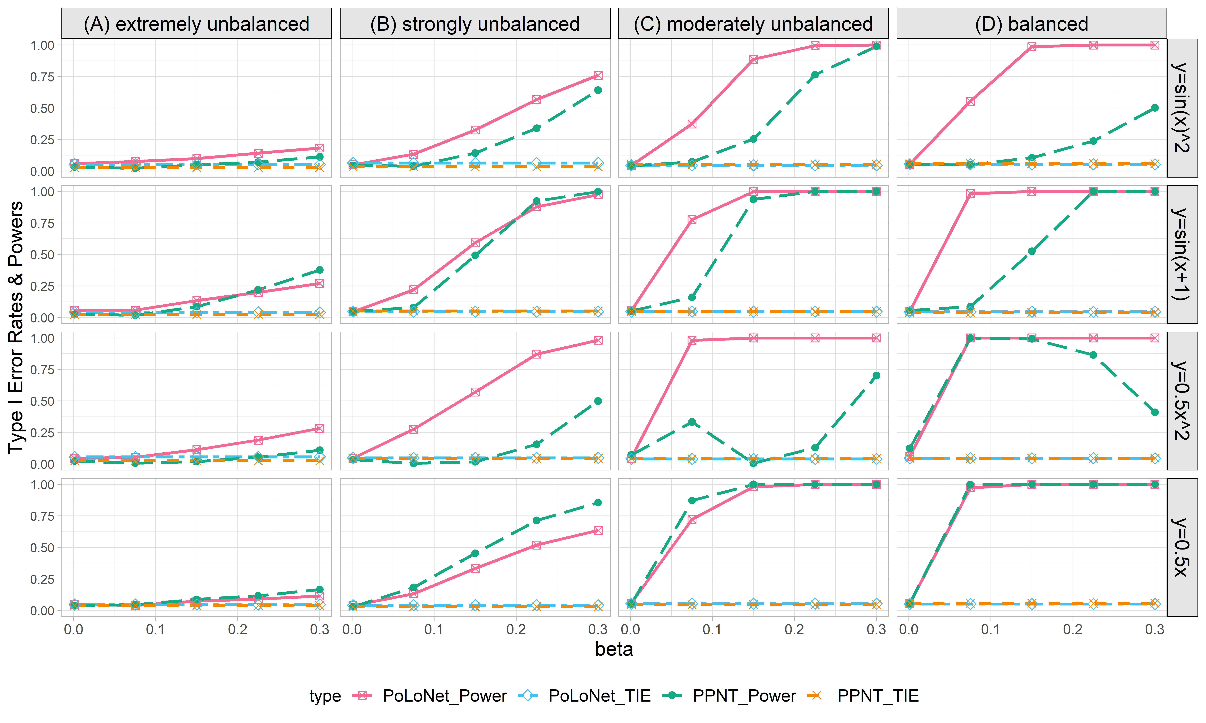

**Figure S23. Empirical type I error rates and powers for detecting the effect of the edge for the binary trait under the setting that both node and edge have effects, with the node hanging on the edge (n=5000), with BSLMM as gene expression prediction model in TWAS.** The significance level is α=0.05. Simulations are conducted with 4 different between-node correlation patterns (the recombination of quadratic and sine, sine, quadratic, linear) and 5 different effect sizes (0.001, 0.075, 0.15, 0.225, 0.3). **(A)** extremely unbalanced (1:999); **(B)** strongly unbalanced (99:1); **(C)** moderately unbalanced (1:9); **(D)** balanced (1:1)).

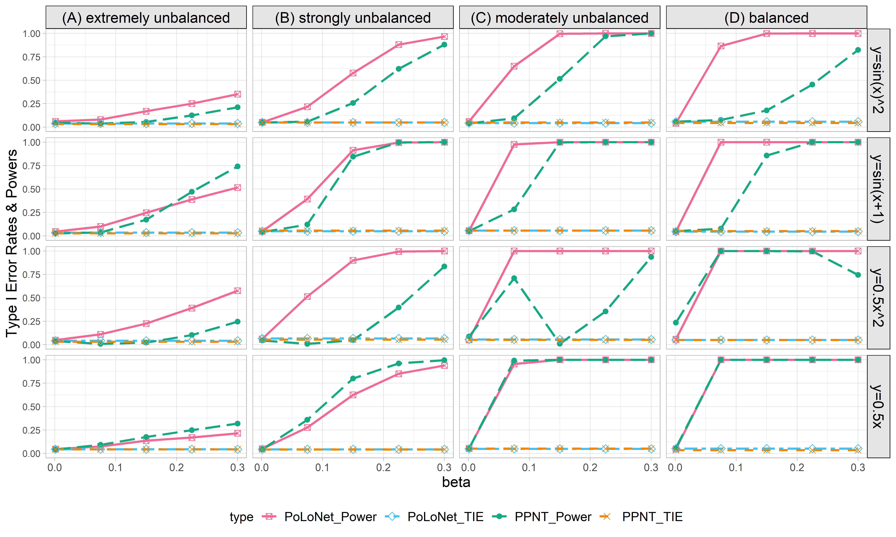

**Figure S24. Empirical type I error rates and powers for detecting the effect of the edge for the binary trait under the setting that both node and edge have effects, with the node hanging on the edge (n=10000), with BSLMM as gene expression prediction model in TWAS.** The significance level is α=0.05. Simulations are conducted with 4 different between-node correlation patterns (the recombination of quadratic and sine, sine, quadratic, linear) and 5 different effect sizes (0.001, 0.075, 0.15, 0.225, 0.3). **(A)** extremely unbalanced (1:999); **(B)** strongly unbalanced (99:1); **(C)** moderately unbalanced (1:9); **(D)** balanced (1:1)).

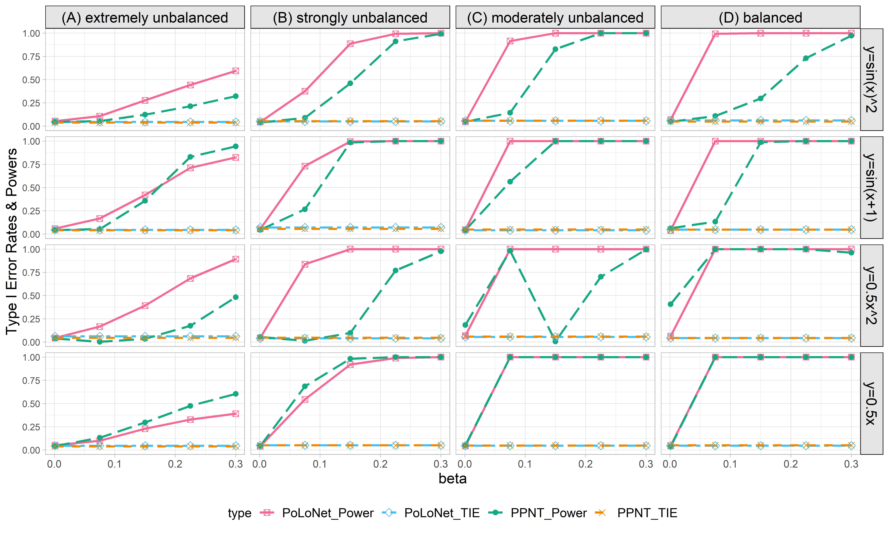

**Figure S25. Empirical type I error rates and powers for detecting the effect of the edge for the binary trait under the setting that both node and edge have effects, with the node hanging on the edge (n=20000), with BSLMM as gene expression prediction model in TWAS.** The significance level is α=0.05. Simulations are conducted with 4 different between-node correlation patterns (the recombination of quadratic and sine, sine, quadratic, linear) and 5 different effect sizes (0.001, 0.075, 0.15, 0.225, 0.3). **(A)** extremely unbalanced (1:999); **(B)** strongly unbalanced (99:1); **(C)** moderately unbalanced (1:9); **(D)** balanced (1:1)).

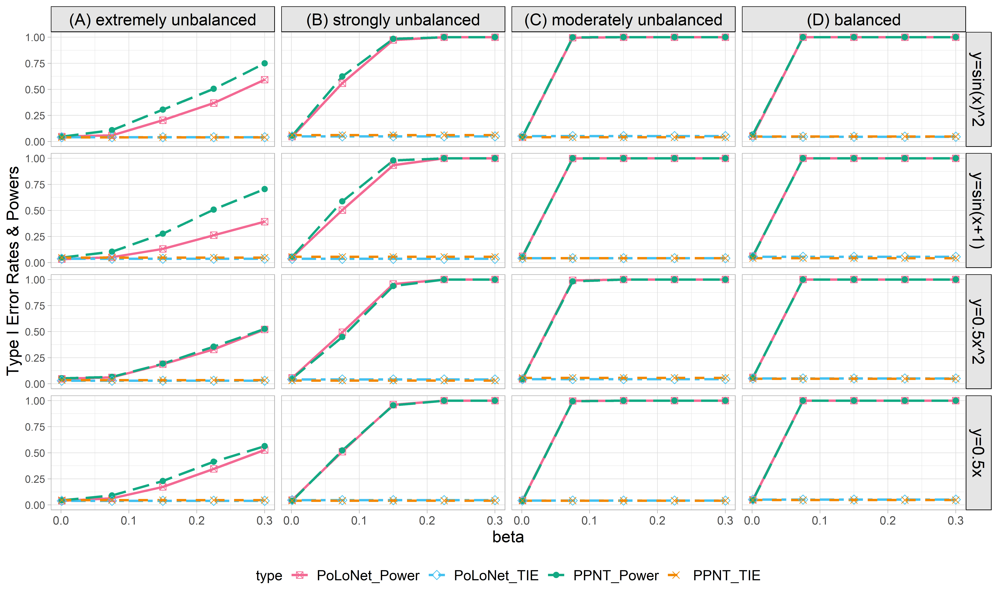

**Figure S26. Empirical type I error rates and powers for detecting the effect of the node for the binary trait under the setting that both node and edge have effects, with the node hanging on the edge (n=5000), with BSLMM as gene expression prediction model in TWAS.** The significance level is α=0.05. Simulations are conducted with 4 different between-node correlation patterns (the recombination of quadratic and sine, sine, quadratic, linear) and 5 different effect sizes (0.001, 0.075, 0.15, 0.225, 0.3). **(A)** extremely unbalanced (1:999); **(B)** strongly unbalanced (99:1); **(C)** moderately unbalanced (1:9); **(D)** balanced (1:1)).

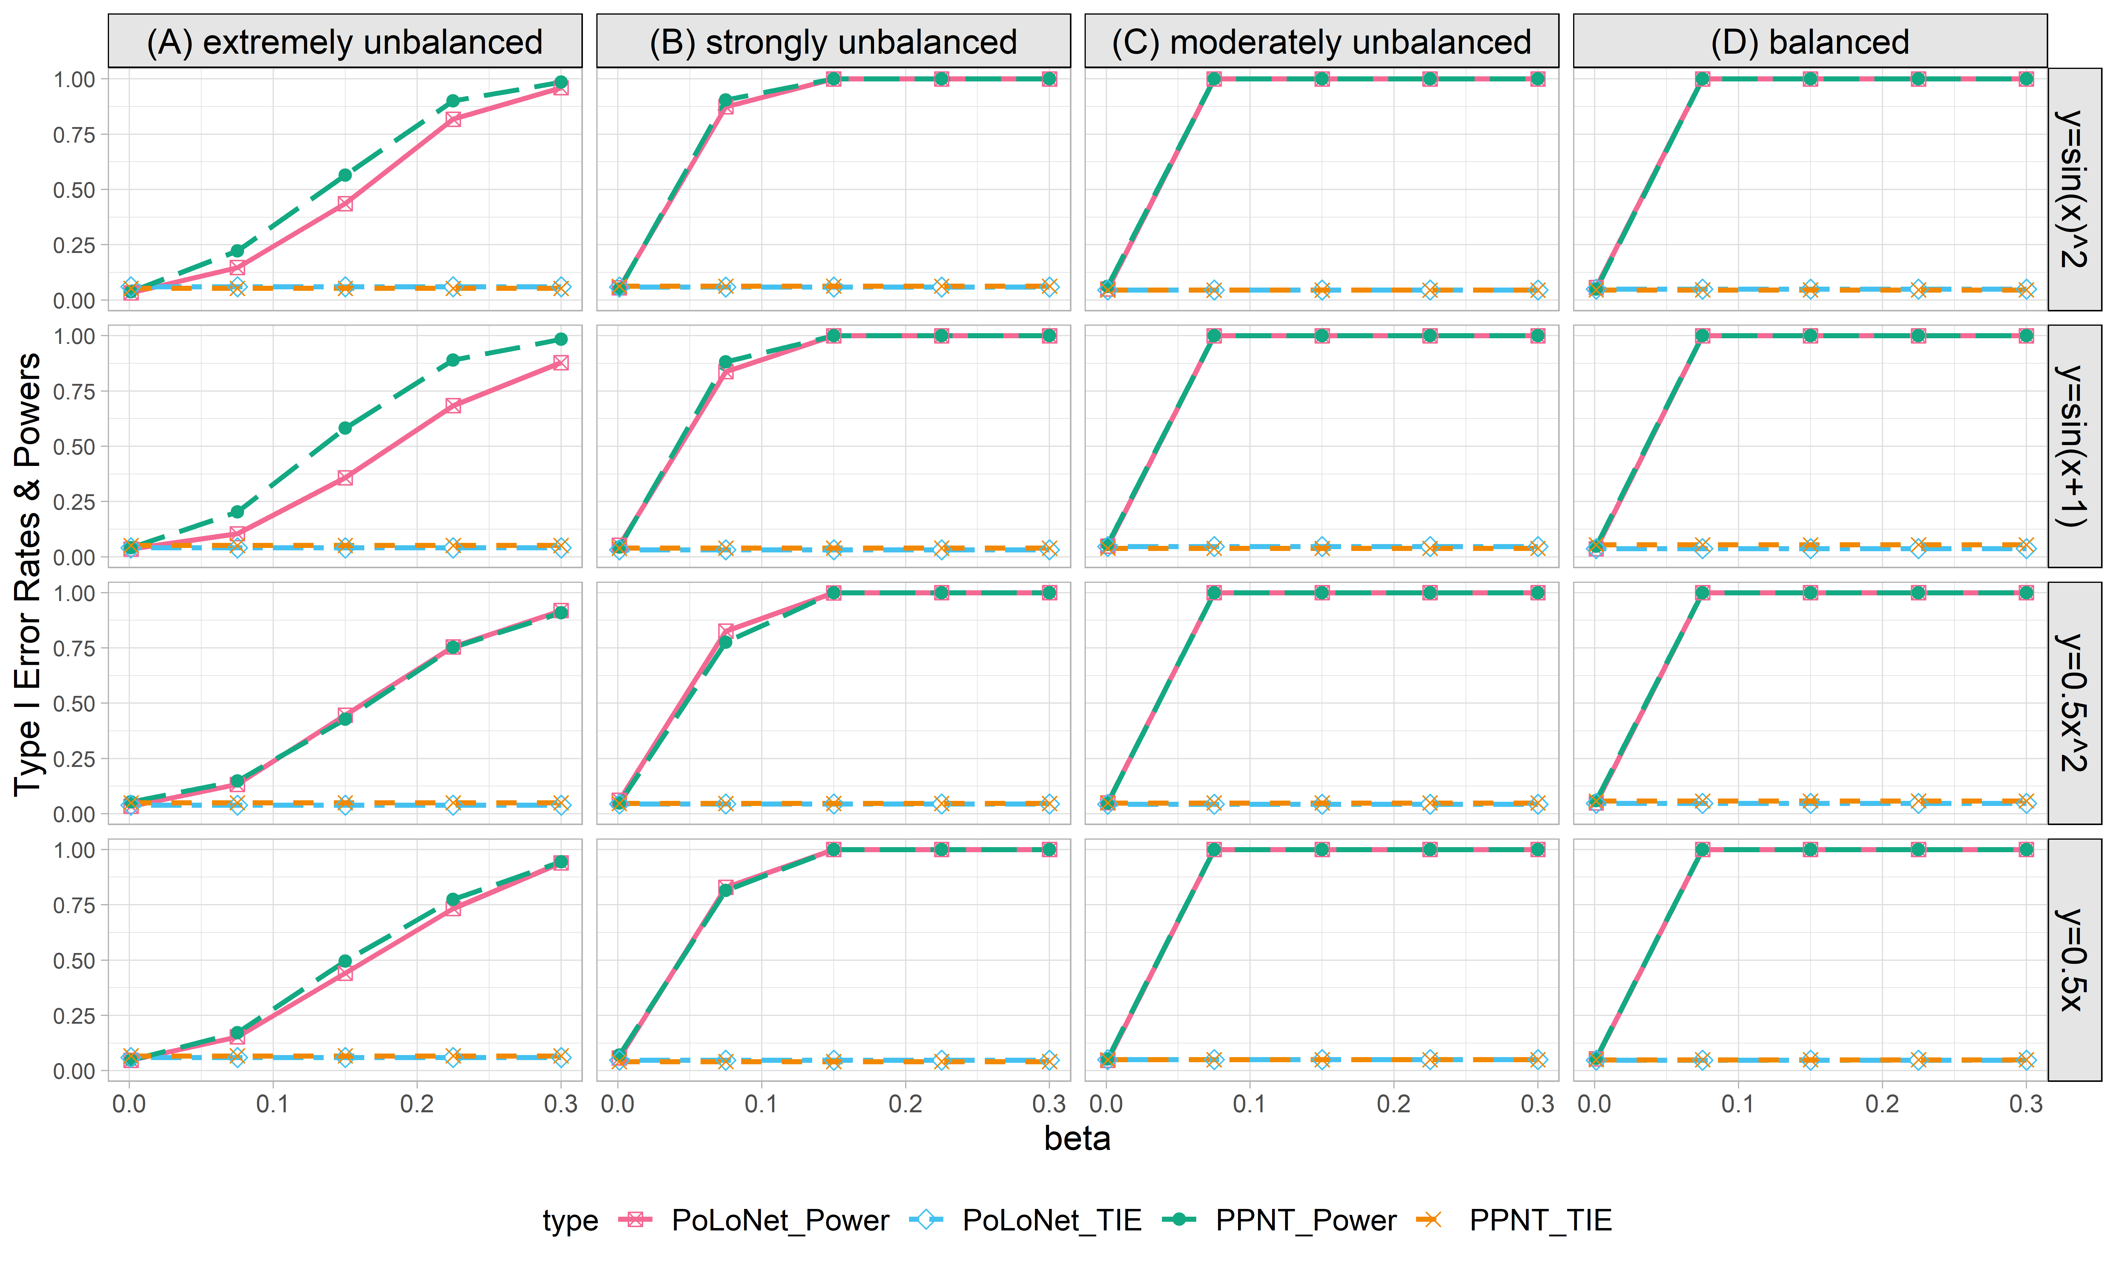

**Figure S27. Empirical type I error rates and powers for detecting the effect of the node for the binary trait under the setting that both node and edge have effects, with the node hanging on the edge (n=10000), with BSLMM as gene expression prediction model in TWAS.** The significance level is α=0.05. Simulations are conducted with 4 different between-node correlation patterns (the recombination of quadratic and sine, sine, quadratic, linear) and 5 different effect sizes (0.001, 0.075, 0.15, 0.225, 0.3). **(A)** extremely unbalanced (1:999); **(B)** strongly unbalanced (99:1); **(C)** moderately unbalanced (1:9); **(D)** balanced (1:1)).

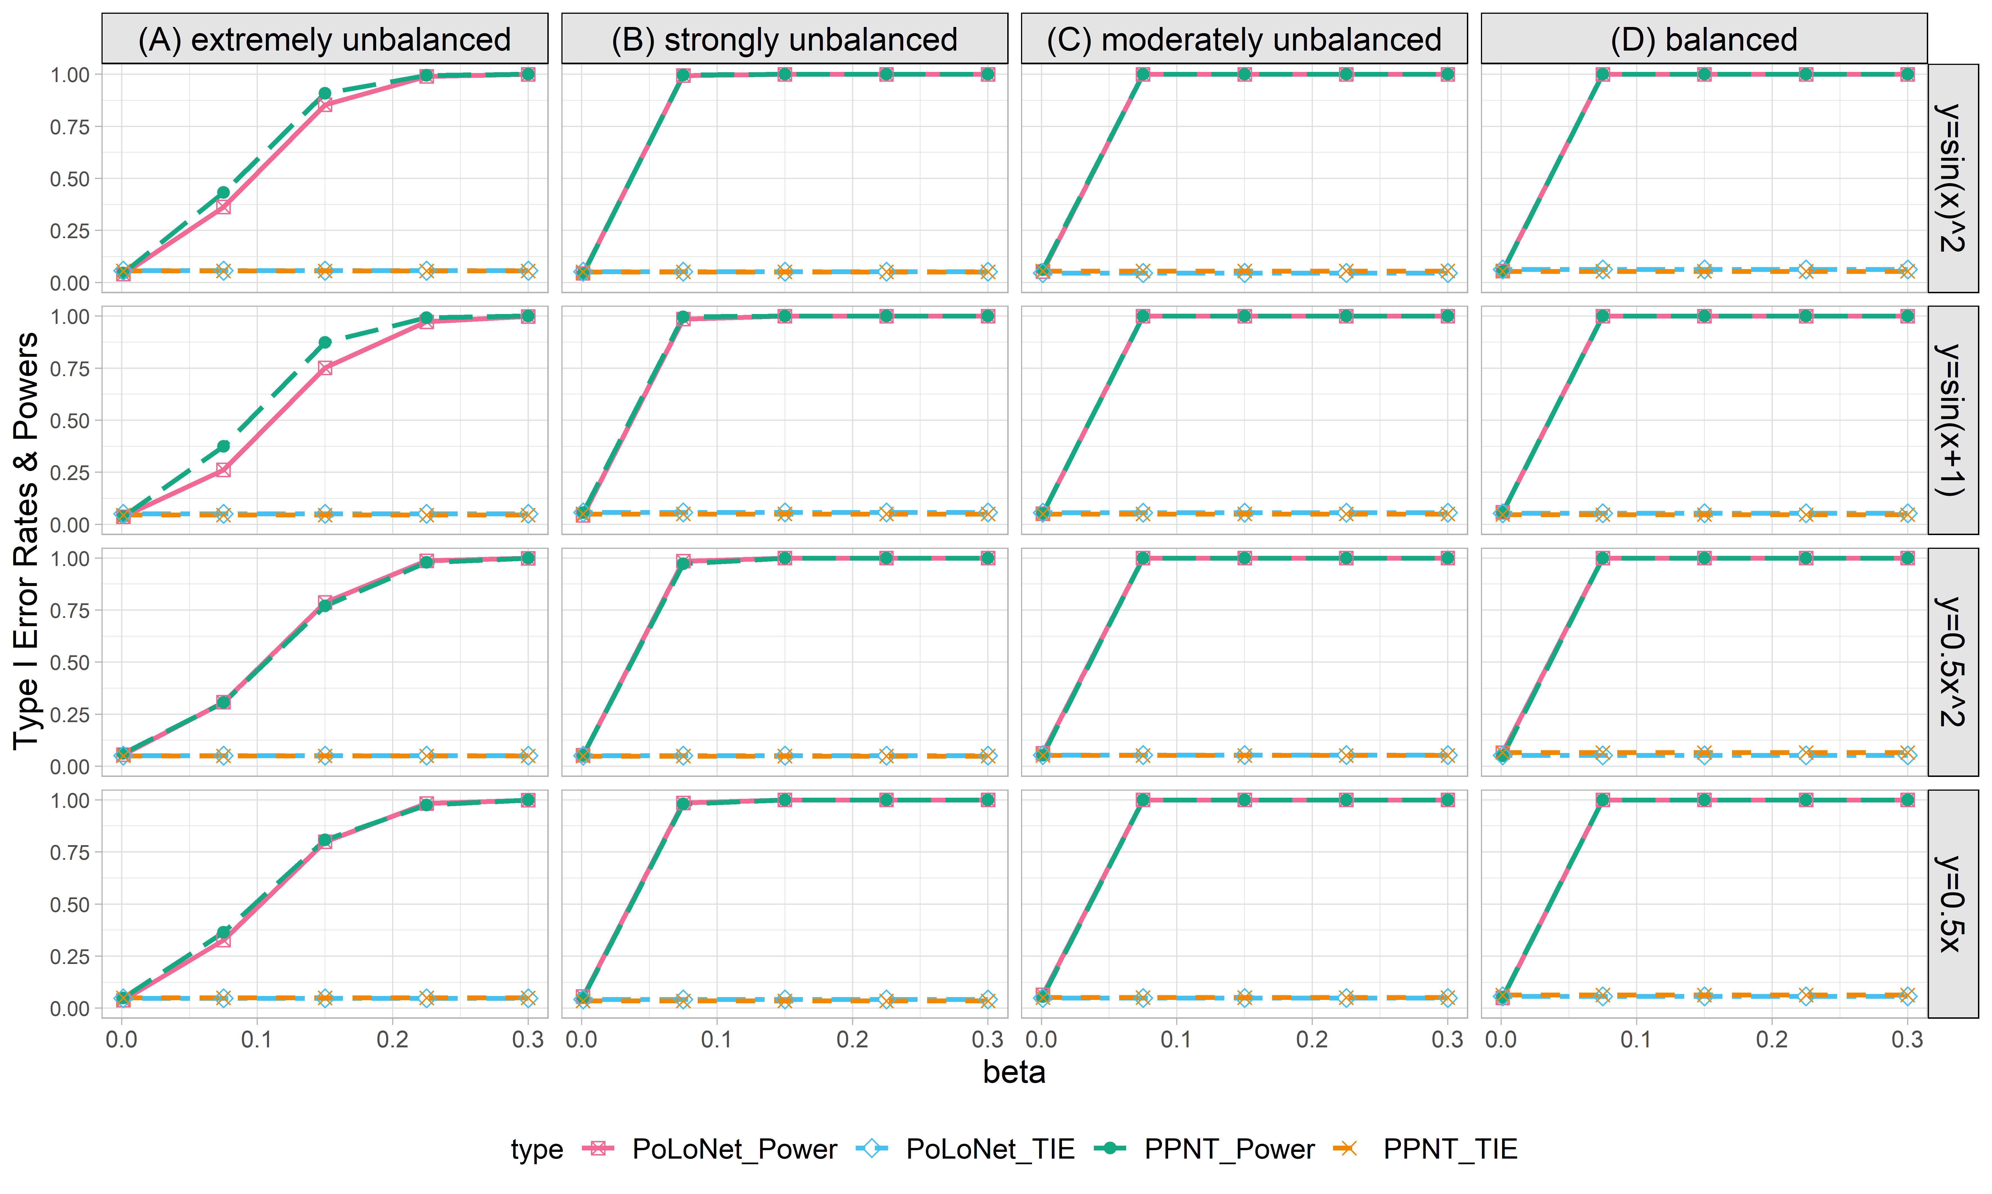

**Figure S28. Empirical type I error rates and powers for detecting the effect of the node for the binary trait under the setting that both node and edge have effects, with the node hanging on the edge (n=20000), with BSLMM as gene expression prediction model in TWAS.** The significance level is α=0.05. Simulations are conducted with 4 different between-node correlation patterns (the recombination of quadratic and sine, sine, quadratic, linear) and 5 different effect sizes (0.001, 0.075, 0.15, 0.225, 0.3). **(A)** extremely unbalanced (1:999); **(B)** strongly unbalanced (99:1); **(C)** moderately unbalanced (1:9); **(D)** balanced (1:1)).

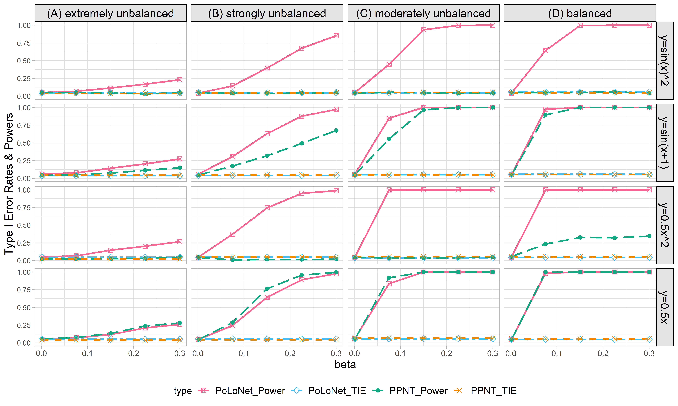

**Figure S29. Empirical type I error rates and powers for detecting the effect of the edge for the binary trait under the setting that both node and edge have effects, with the node not hanging on the edge (n=5000), with BSLMM as gene expression prediction model in TWAS.** The significance level is α=0.05. Simulations are conducted with 4 different between-node correlation patterns (the recombination of quadratic and sine, sine, quadratic, linear) and 5 different effect sizes (0.001, 0.075, 0.15, 0.225, 0.3). **(A)** extremely unbalanced (1:999); **(B)** strongly unbalanced (99:1); **(C)** moderately unbalanced (1:9); **(D)** balanced (1:1)).

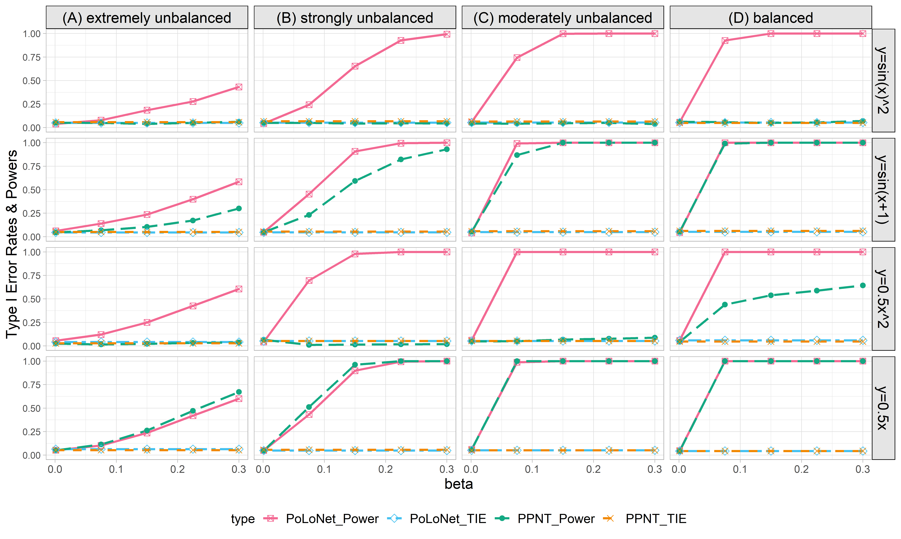

**Figure S30. Empirical type I error rates and powers for detecting the effect of the edge for the binary trait under the setting that both node and edge have effects, with the node not hanging on the edge (n=10000), with BSLMM as gene expression prediction model in TWAS.** The significance level is α=0.05. Simulations are conducted with 4 different between-node correlation patterns (the recombination of quadratic and sine, sine, quadratic, linear) and 5 different effect sizes (0.001, 0.075, 0.15, 0.225, 0.3). **(A)** extremely unbalanced (1:999); **(B)** strongly unbalanced (99:1); **(C)** moderately unbalanced (1:9); **(D)** balanced (1:1)).

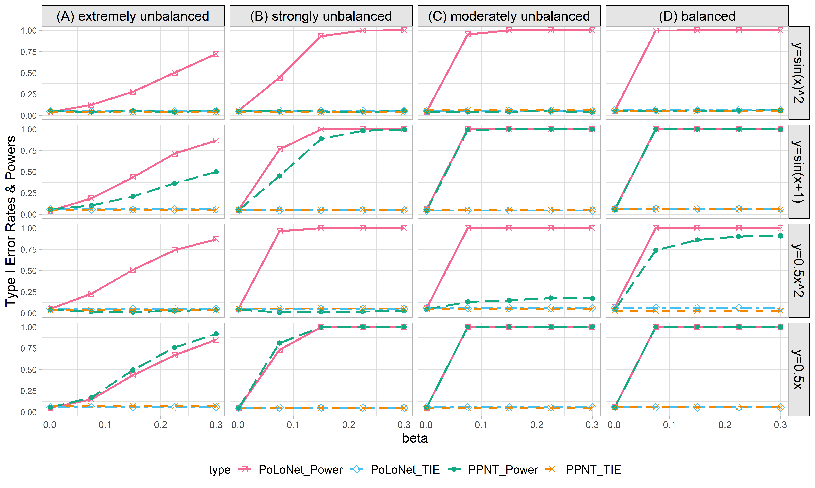

**Figure S31. Empirical type I error rates and powers for detecting the effect of the edge for the binary trait under the setting that both node and edge have effects, with the node not hanging on the edge (n=20000), with BSLMM as gene expression prediction model in TWAS.** The significance level is α=0.05. Simulations are conducted with 4 different between-node correlation patterns (the recombination of quadratic and sine, sine, quadratic, linear) and 5 different effect sizes (0.001, 0.075, 0.15, 0.225, 0.3). **(A)** extremely unbalanced (1:999); **(B)** strongly unbalanced (99:1); **(C)** moderately unbalanced (1:9); **(D)** balanced (1:1)).

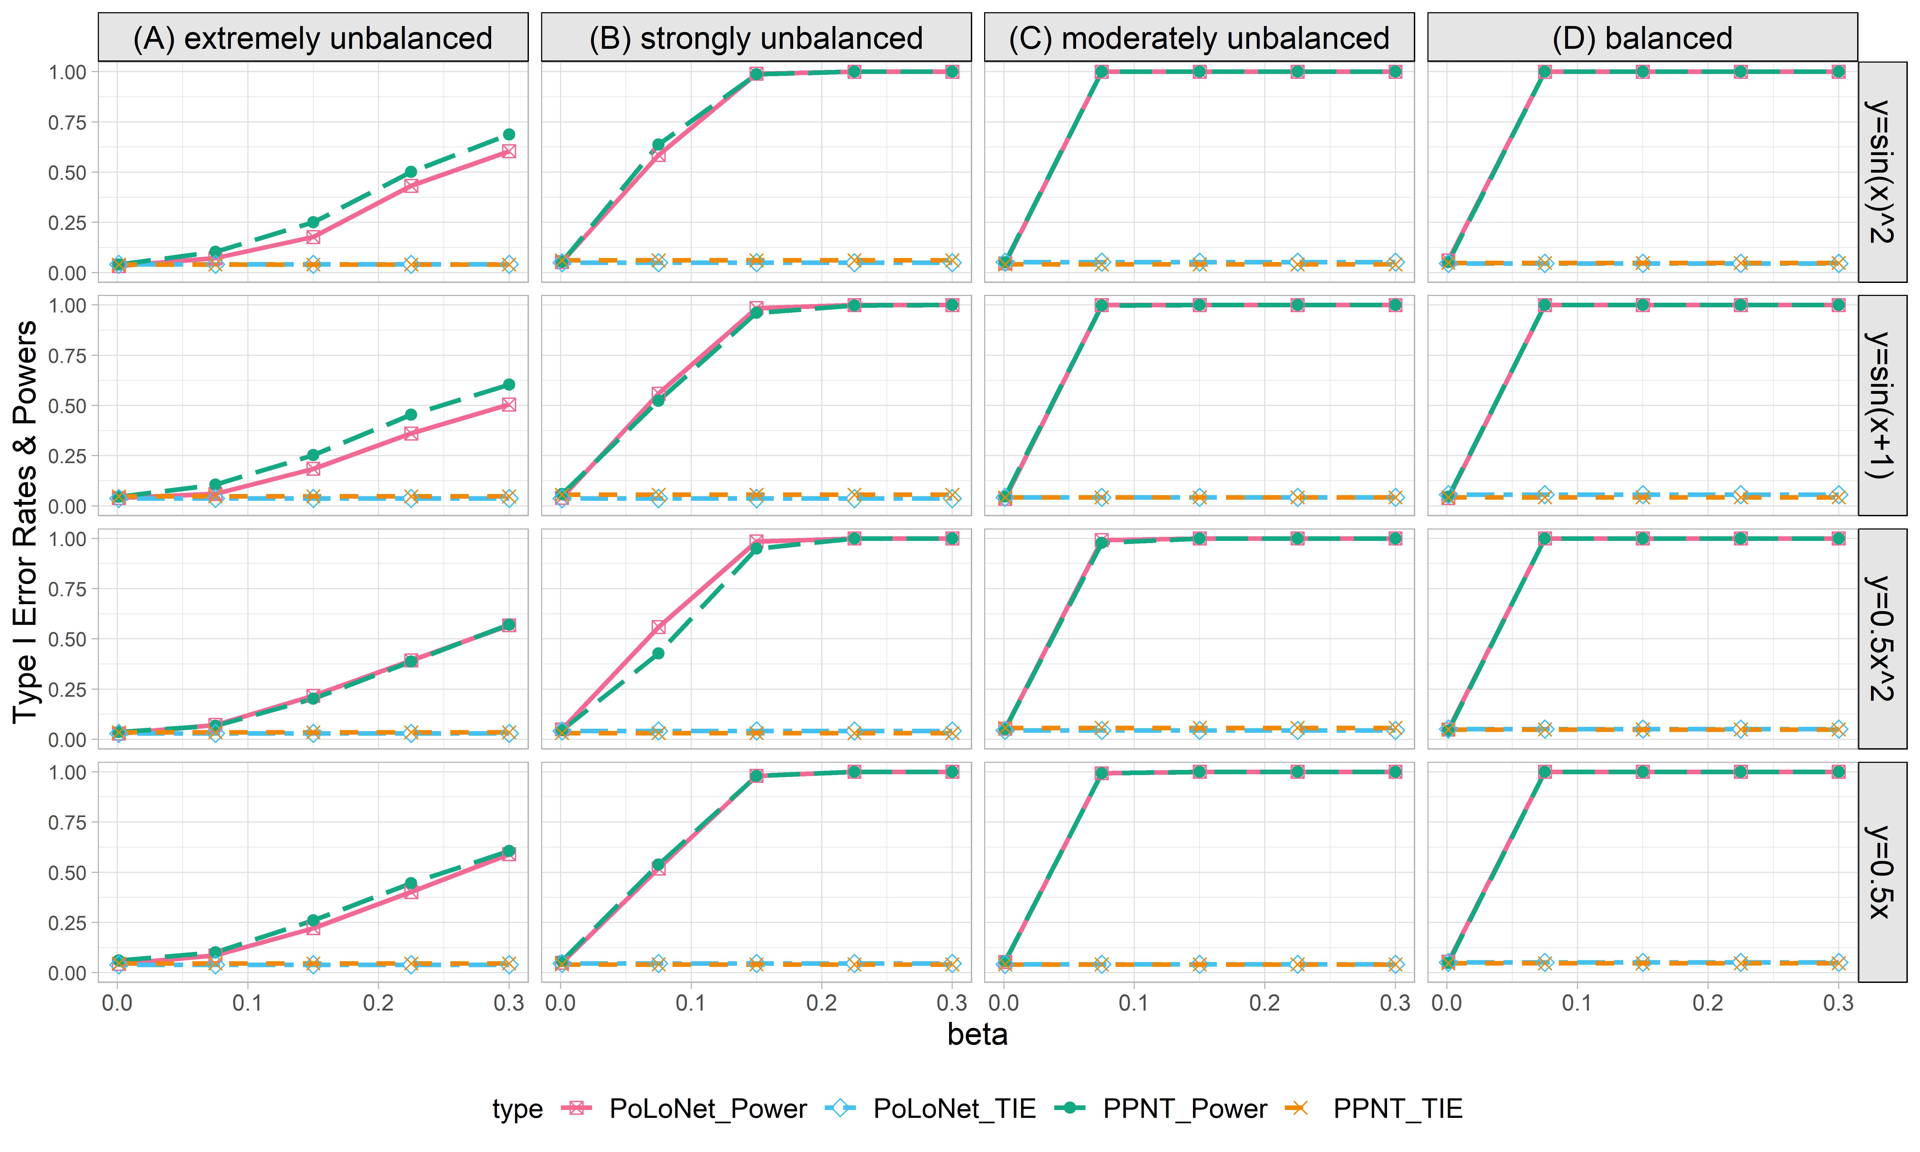

**Figure S32. Empirical type I error rates and powers for detecting the effect of the node for the binary trait under the setting that both node and edge have effects, with the node not hanging on the edge (n=5000), with BSLMM as gene expression prediction model in TWAS.** The significance level is α=0.05. Simulations are conducted with 4 different between-node correlation patterns (the recombination of quadratic and sine, sine, quadratic, linear) and 5 different effect sizes (0.001, 0.075, 0.15, 0.225, 0.3). **(A)** extremely unbalanced (1:999); **(B)** strongly unbalanced (99:1); **(C)** moderately unbalanced (1:9); **(D)** balanced (1:1)).

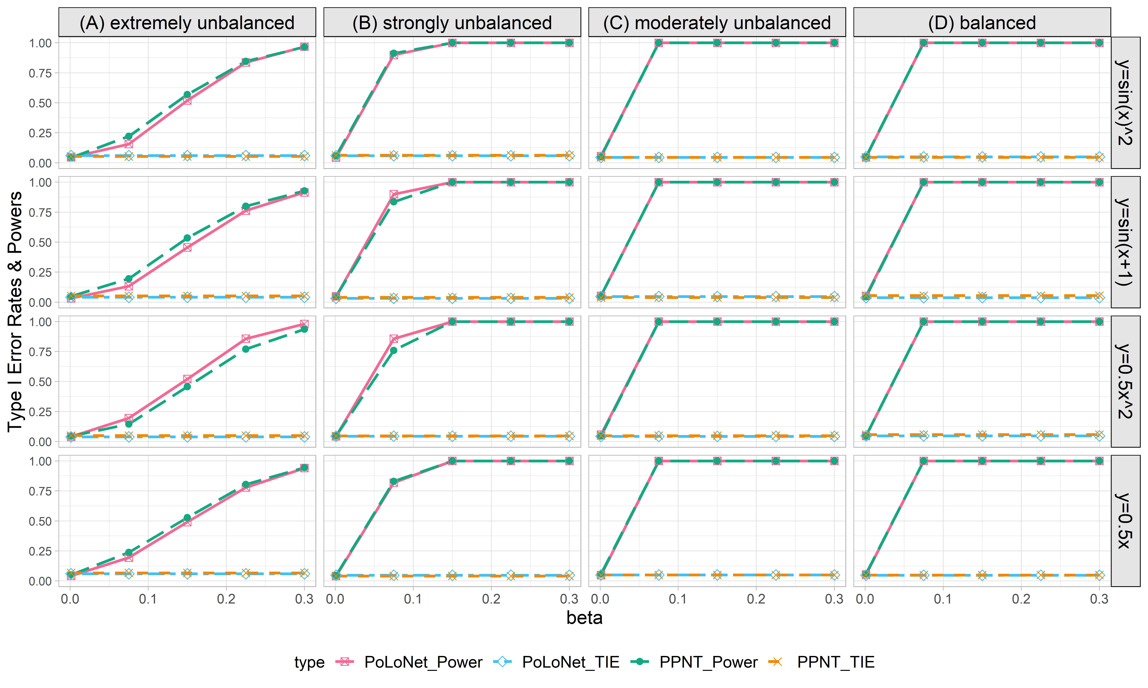

**Figure S33. Empirical type I error rates and powers for detecting the effect of the node for the binary trait under the setting that both node and edge have effects, with the node not hanging on the edge (n=10000), with BSLMM as gene expression prediction model in TWAS.** The significance level is α=0.05. Simulations are conducted with 4 different between-node correlation patterns (the recombination of quadratic and sine, sine, quadratic, linear) and 5 different effect sizes (0.001, 0.075, 0.15, 0.225, 0.3). **(A)** extremely unbalanced (1:999); **(B)** strongly unbalanced (99:1); **(C)** moderately unbalanced (1:9); **(D)** balanced (1:1)).

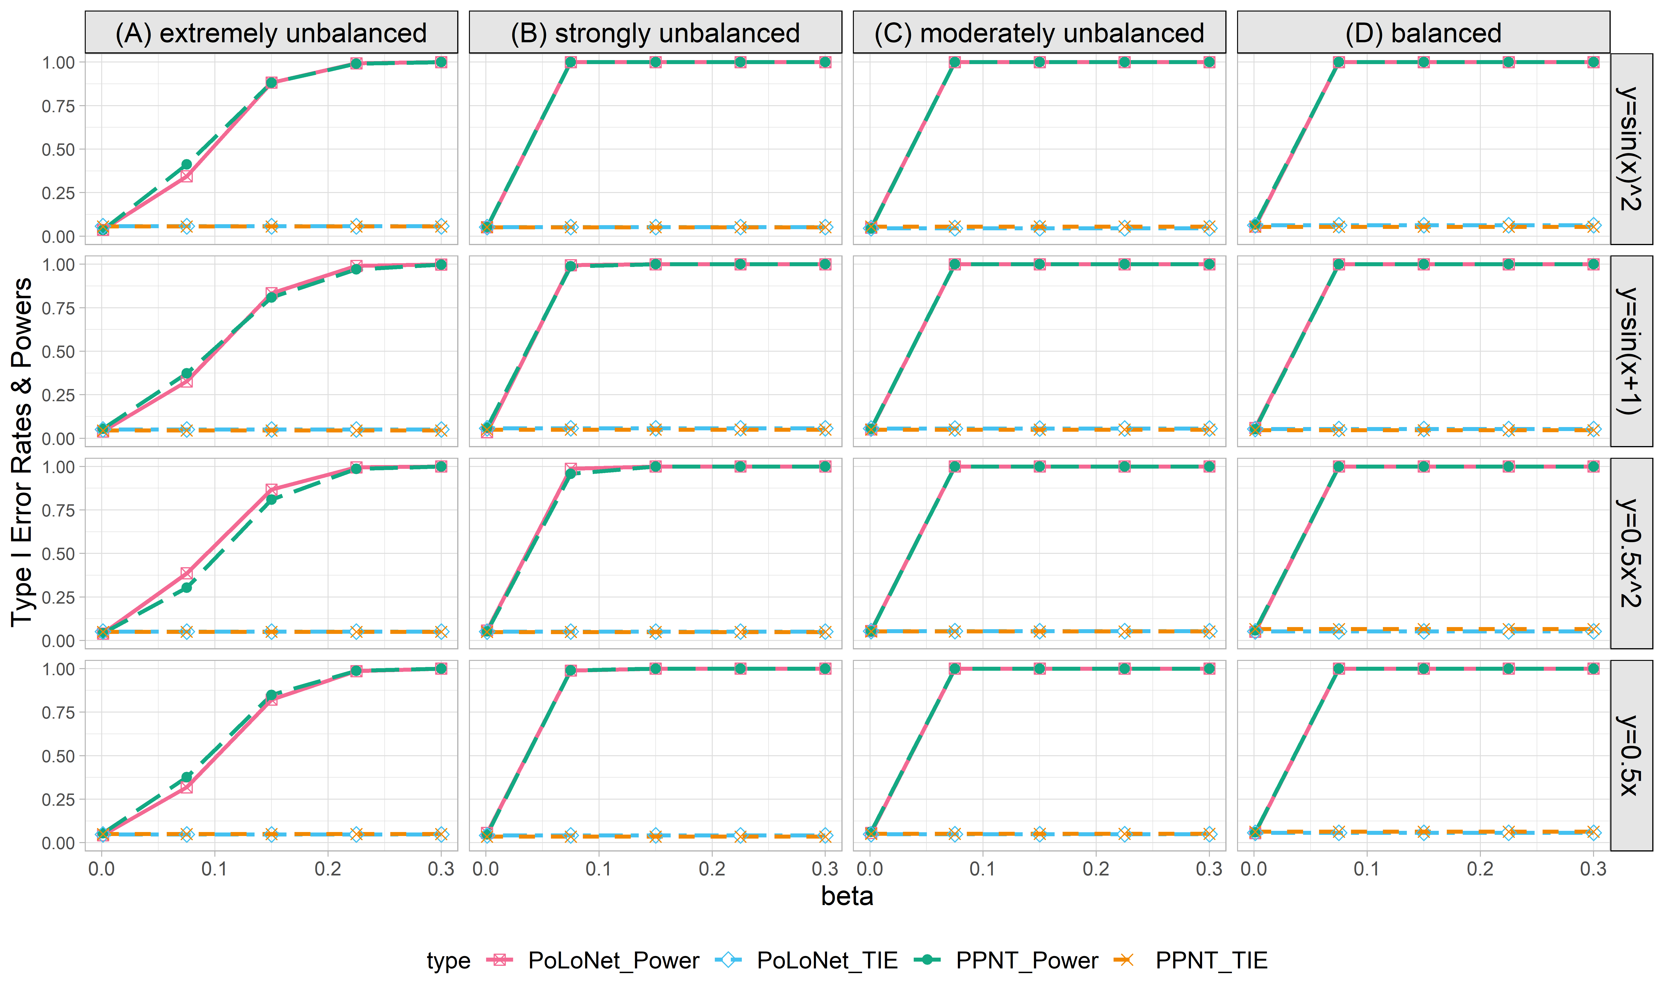

**Figure S34. Empirical type I error rates and powers for detecting the effect of the node for the binary trait under the setting that both node and edge have effects, with the node not hanging on the edge (n=20000), with BSLMM as gene expression prediction model in TWAS.** The significance level is α=0.05. Simulations are conducted with 4 different between-node correlation patterns (the recombination of quadratic and sine, sine, quadratic, linear) and 5 different effect sizes (0.001, 0.075, 0.15, 0.225, 0.3). **(A)** extremely unbalanced (1:999); **(B)** strongly unbalanced (99:1); **(C)** moderately unbalanced (1:9); **(D)** balanced (1:1)).

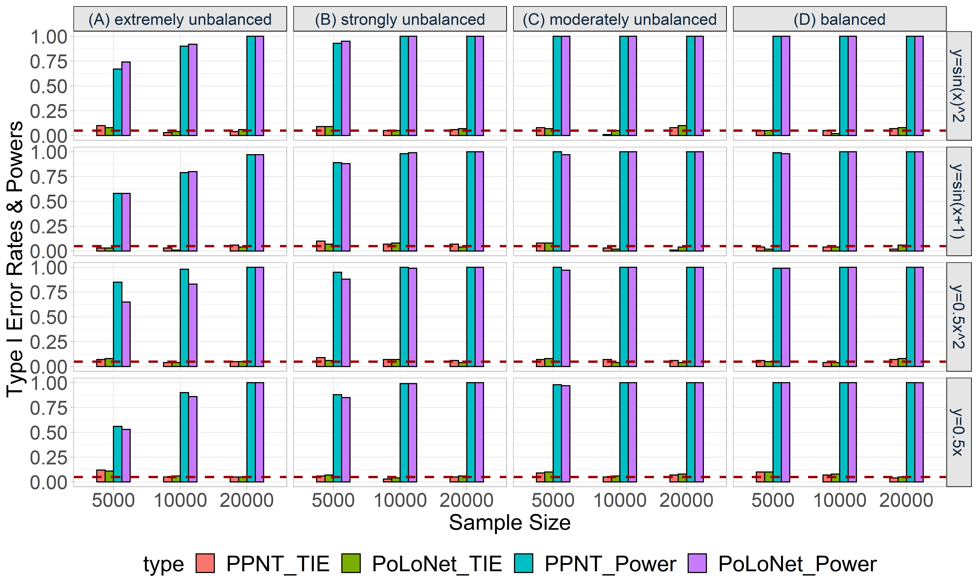

**Figure S35. Empirical type I error rates and powers for detecting the effect of the node for an ordinal trait with 4 categories under the setting that both node and edge have effects, with the node hanging on the edge.** The effect size is set to be 0.05 and DPR is used as the gene expression prediction model in TWAS.The red dotted line represents the significance level (α=0.05). Simulations are conducted with different sample sizes (5000, 10000, 20000) and 4 different between-node correlation patterns (the recombination of quadratic and sine, sine, quadratic, linear). **(A)** extremely unbalanced (100:1:1:1); **(B)** strongly unbalanced (30:1:1:1); **(C)** moderately unbalanced (10:1:1:1); **(D)** balanced (1:1:1:1).

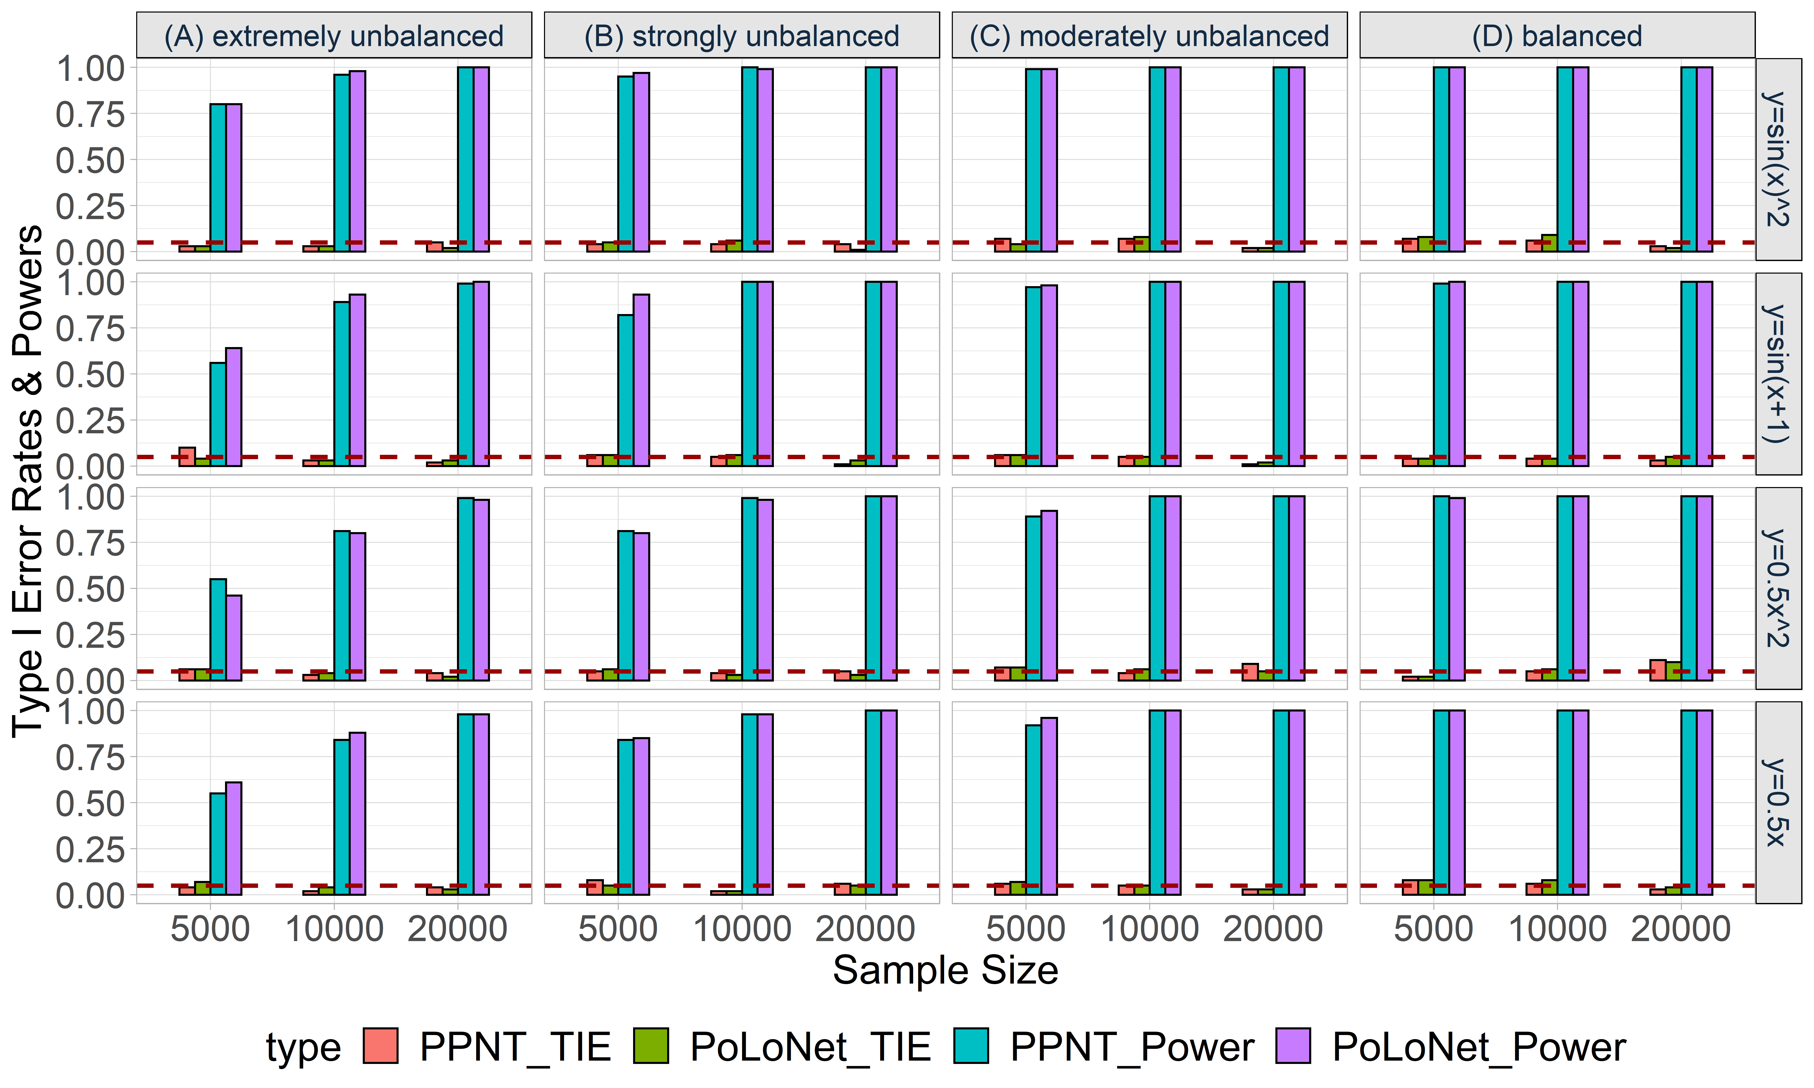

**Figure S36. Empirical type I error rates and powers for detecting the effect of the node for an ordinal trait with 4 categories under the setting that both node and edge have effects, with the node not hanging on the edge.** The effect size is set to be 0.05 and DPR is used as the gene expression prediction model in TWAS. The red dotted line represents the significance level (α=0.05). Simulations are conducted with different sample sizes (5000, 10000, 20000) and 4 different between-node correlation patterns (the recombination of quadratic and sine, sine, quadratic, linear). **(A)** extremely unbalanced (100:1:1:1); **(B)** strongly unbalanced (30:1:1:1); **(C)** moderately unbalanced (10:1:1:1); **(D)** balanced (1:1:1:1).

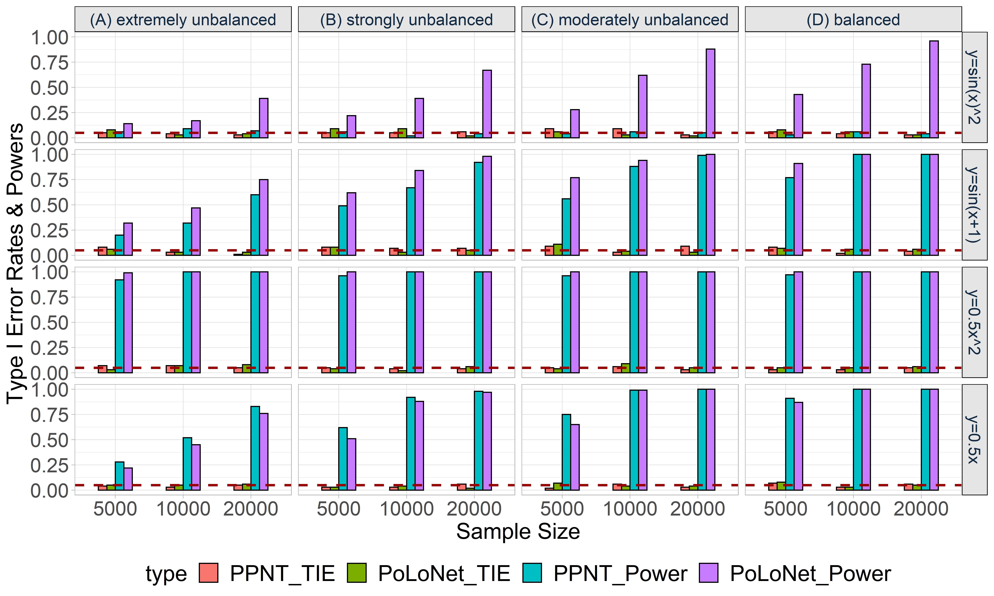

**Figure S37. Empirical type I error rates and powers for detecting the effect of the edge for an ordinal trait with 4 categories under the setting that both node and edge have effects, with the node hanging on the edge.** The effect size is set to be 0.05 and DPR is used as the gene expression prediction model in TWAS. The red dotted line represents the significance level (α=0.05). Simulations are conducted with different sample sizes (5000, 10000, 20000) and 4 different between-node correlation patterns (the recombination of quadratic and sine, sine, quadratic, linear). **(A)** extremely unbalanced (100:1:1:1); **(B)** strongly unbalanced (30:1:1:1); **(C)** moderately unbalanced (10:1:1:1); **(D)** balanced (1:1:1:1).

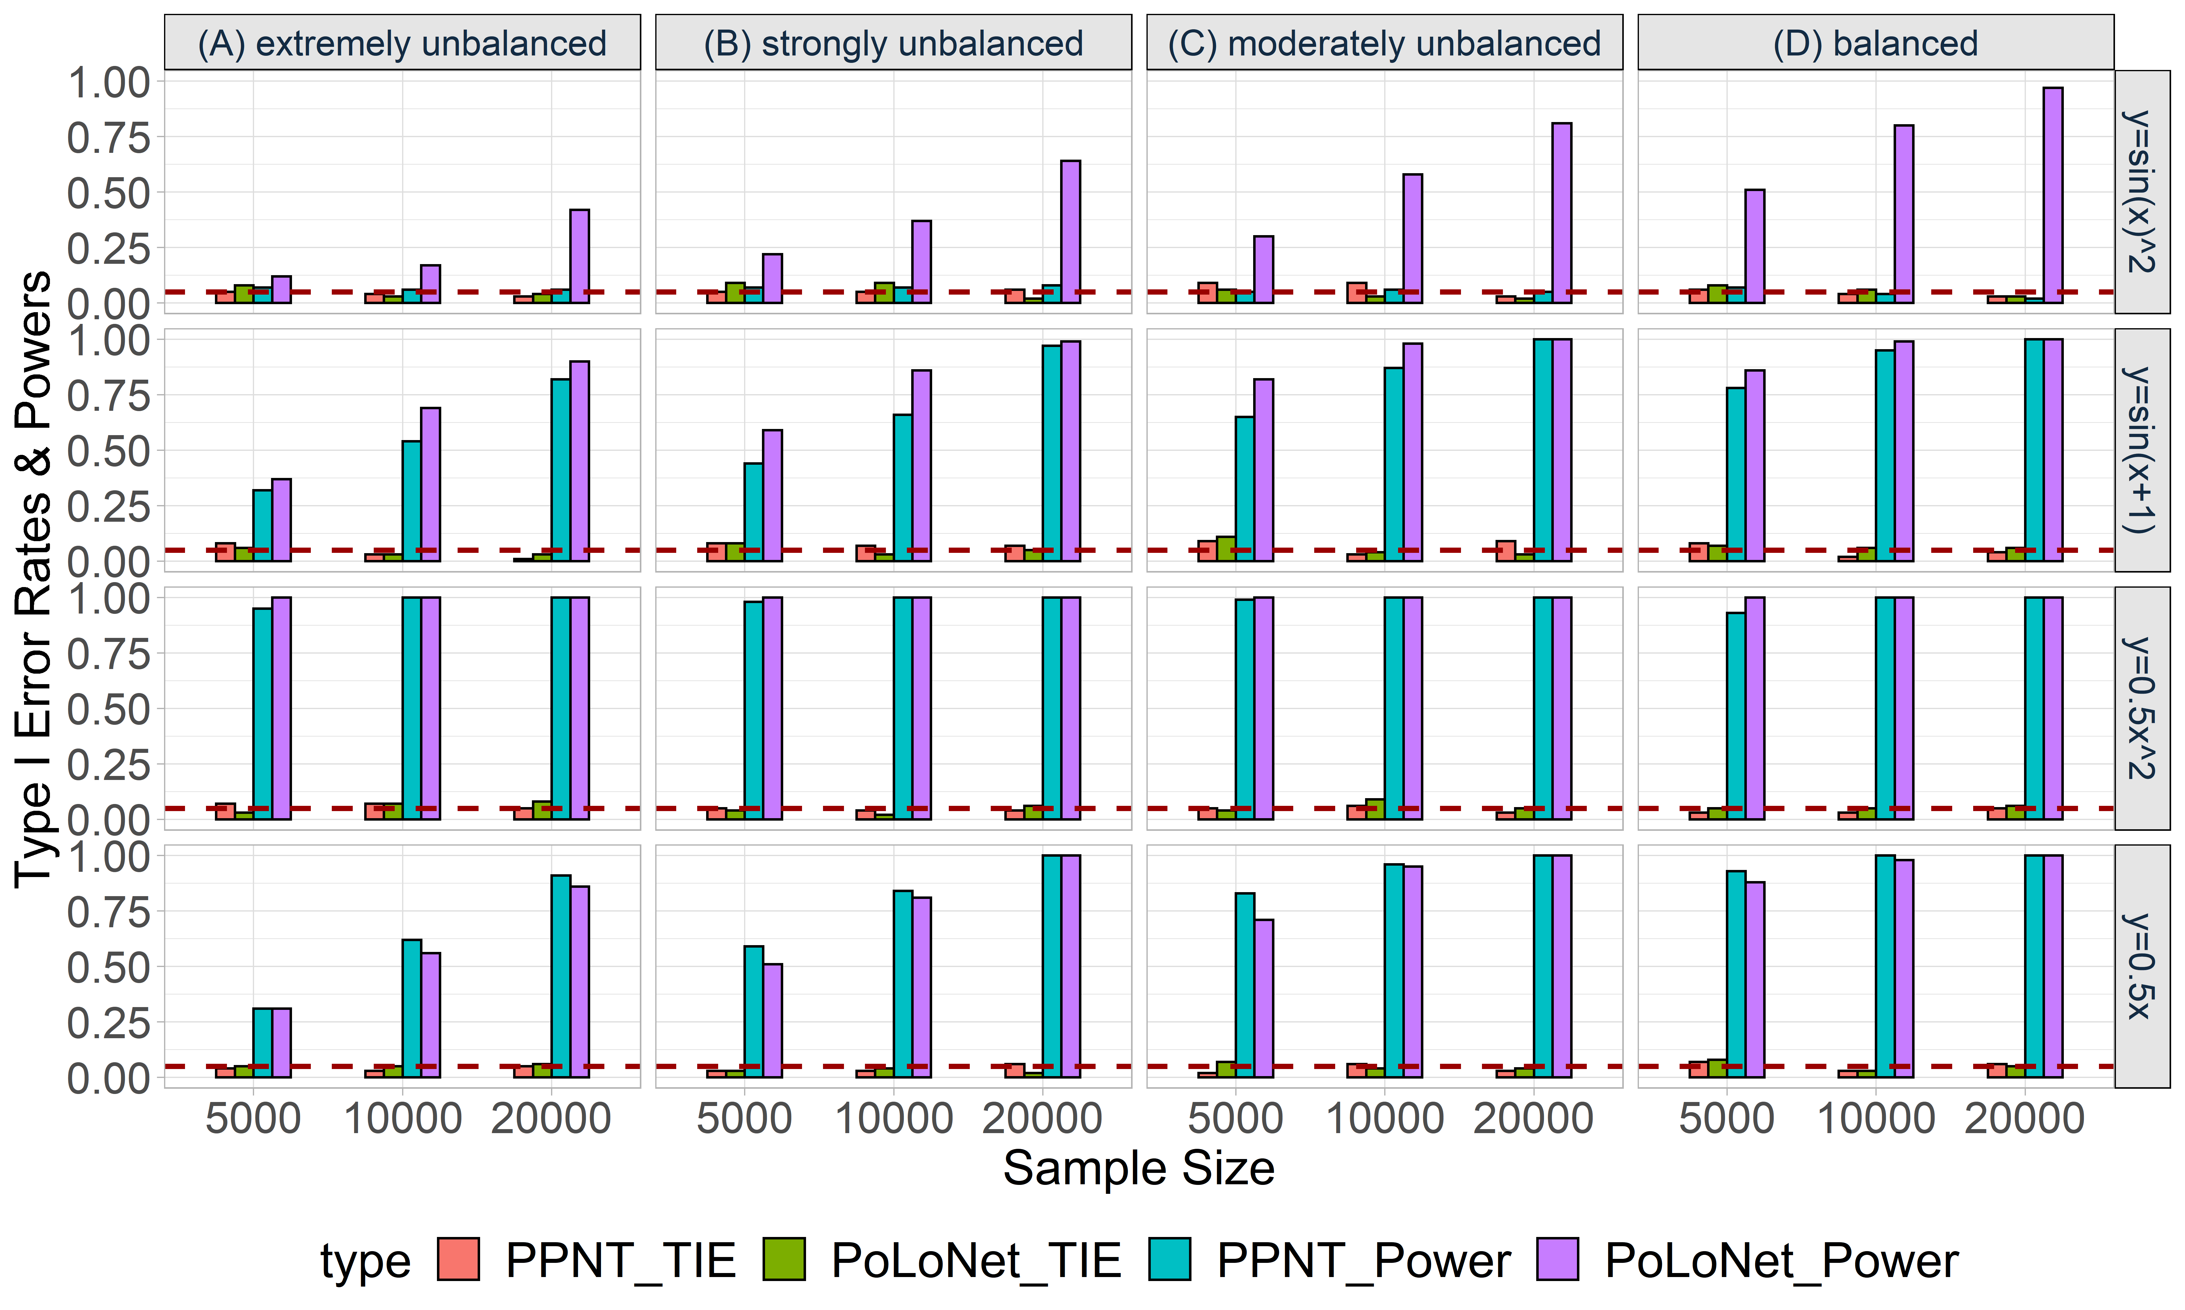

**Figure S38. Empirical type I error rates and powers for detecting the effect of the edge for an ordinal trait with 4 categories under the setting that both node and edge have effects, with the node not hanging on the edge.** The effect size is set to be 0.05 and DPR is used as the gene expression prediction model in TWAS. The red dotted line represents the significance level (α=0.05). Simulations are conducted with different sample sizes (5000, 10000, 20000) and 4 different between-node correlation patterns (the recombination of quadratic and sine, sine, quadratic, linear). **(A)** extremely unbalanced (100:1:1:1); **(B)** strongly unbalanced (30:1:1:1); **(C)** moderately unbalanced (10:1:1:1); **(D)** balanced (1:1:1:1).

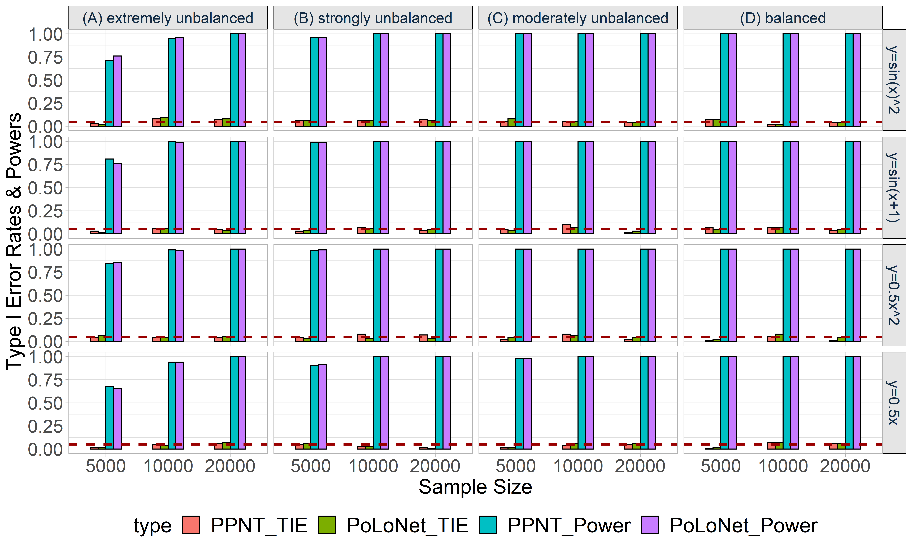

**Figure S39. Empirical type I error rates and powers for detecting the effect of the node for an ordinal trait with 4 categories under the setting that only the node has an effect. The effect size is set to be 0.05 and BSLMM is used as the gene expression prediction model in TWAS.** The red dotted line represents the significance level (α=0.05). Simulations are conducted with different sample sizes (5000, 10000, 20000) and 4 different between-node correlation patterns (the recombination of quadratic and sine, sine, quadratic, linear). **(A)** extremely unbalanced (100:1:1:1); **(B)** strongly unbalanced (30:1:1:1); **(C)** moderately unbalanced (10:1:1:1); **(D)** balanced (1:1:1:1).

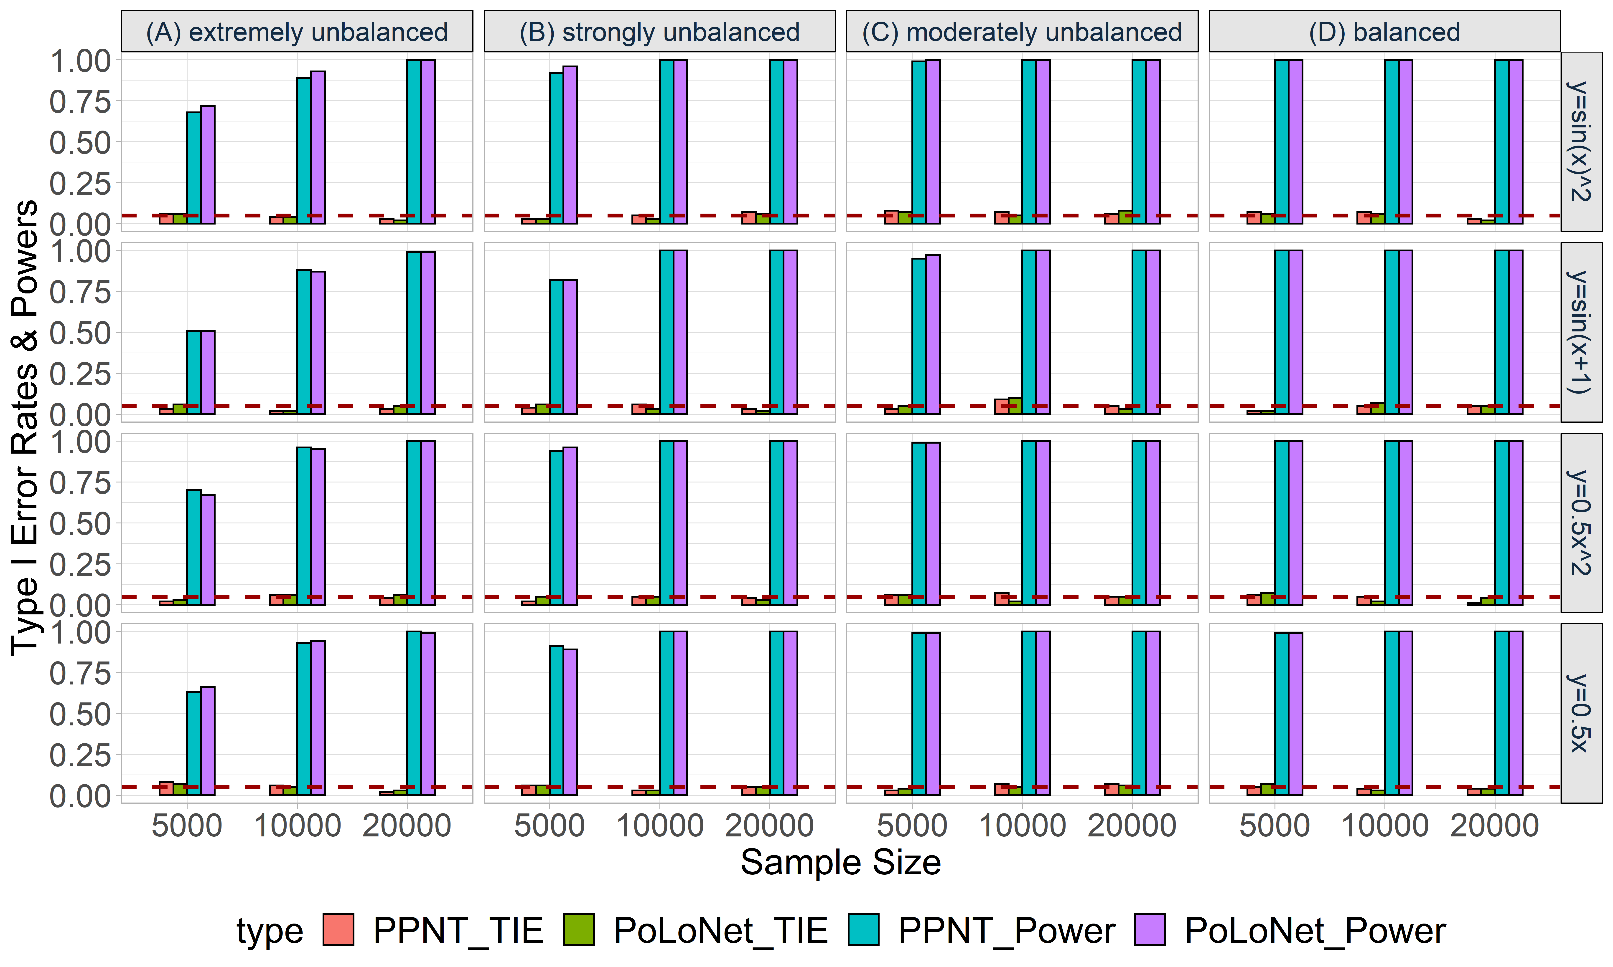

**Figure S40. Empirical type I error rates and powers for detecting the effect of the node for an ordinal trait with 4 categories under the setting that both node and edge have effects, with the node hanging on the edge.** The effect size is set to be 0.05 and BSLMM is used as the gene expression prediction model in TWAS. The red dotted line represents the significance level (α=0.05). Simulations are conducted with different sample sizes (5000, 10000, 20000) and 4 different between-node correlation patterns (the recombination of quadratic and sine, sine, quadratic, linear). **(A)** extremely unbalanced (100:1:1:1); **(B)** strongly unbalanced (30:1:1:1); **(C)** moderately unbalanced (10:1:1:1); **(D)** balanced (1:1:1:1).

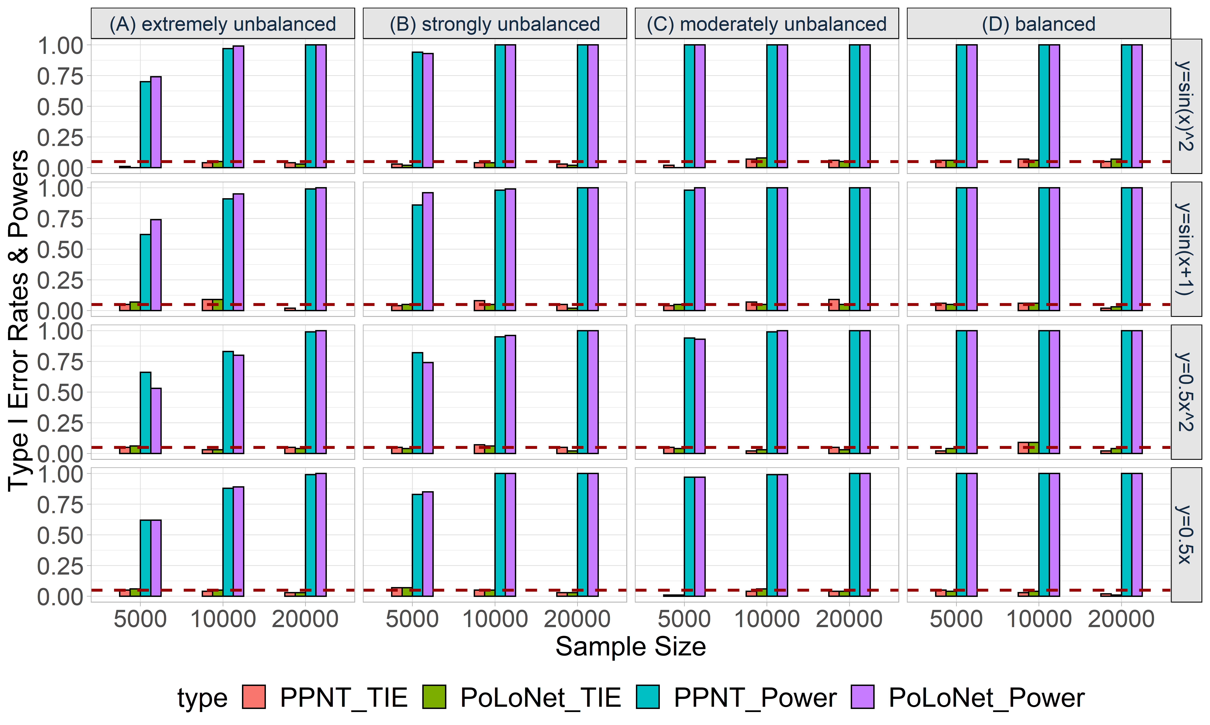

**Figure S41. Empirical type I error rates and powers for detecting the effect of the node for an ordinal trait with 4 categories under the setting that both node and edge have effects, with the node not hanging on the edge.** The effect size is set to be 0.05 and BSLMM is used as the gene expression prediction model in TWAS. The red dotted line represents the significance level (α=0.05). Simulations are conducted with different sample sizes (5000, 10000, 20000) and 4 different between-node correlation patterns (the recombination of quadratic and sine, sine, quadratic, linear). **(A)** extremely unbalanced (100:1:1:1); **(B)** strongly unbalanced (30:1:1:1); **(C)** moderately unbalanced (10:1:1:1); **(D)** balanced (1:1:1:1).

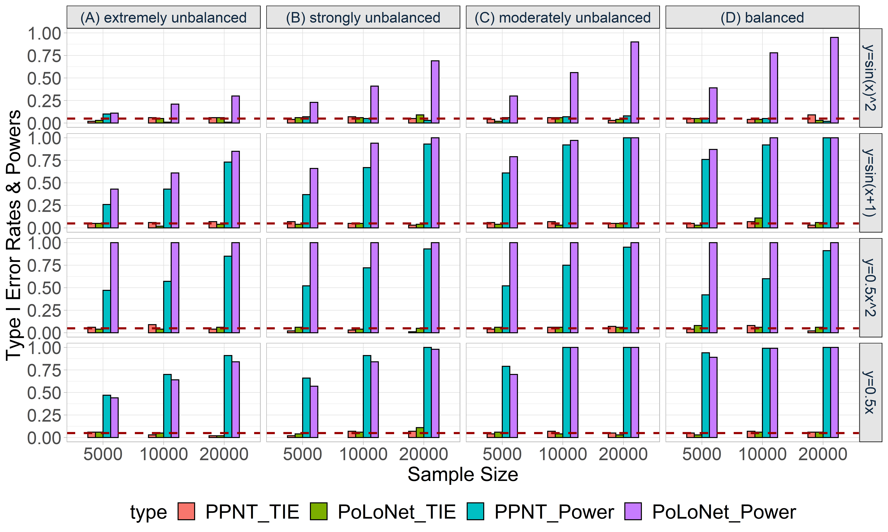

**Figure S42. Empirical type I error rates and powers for detecting the effect of the edge for an ordinal trait with 4 categories under the setting that only the edge has an effect.** The effect size is set to be 0.05 and BSLMM is used as the gene expression prediction model in TWAS. The red dotted line represents the significance level (α=0.05). Simulations are conducted with different sample sizes (5000, 10000, 20000) and 4 different between-node correlation patterns (the recombination of quadratic and sine, sine, quadratic, linear). **(A)** extremely unbalanced (100:1:1:1); **(B)** strongly unbalanced (30:1:1:1); **(C)** moderately unbalanced (10:1:1:1); **(D)** balanced (1:1:1:1).

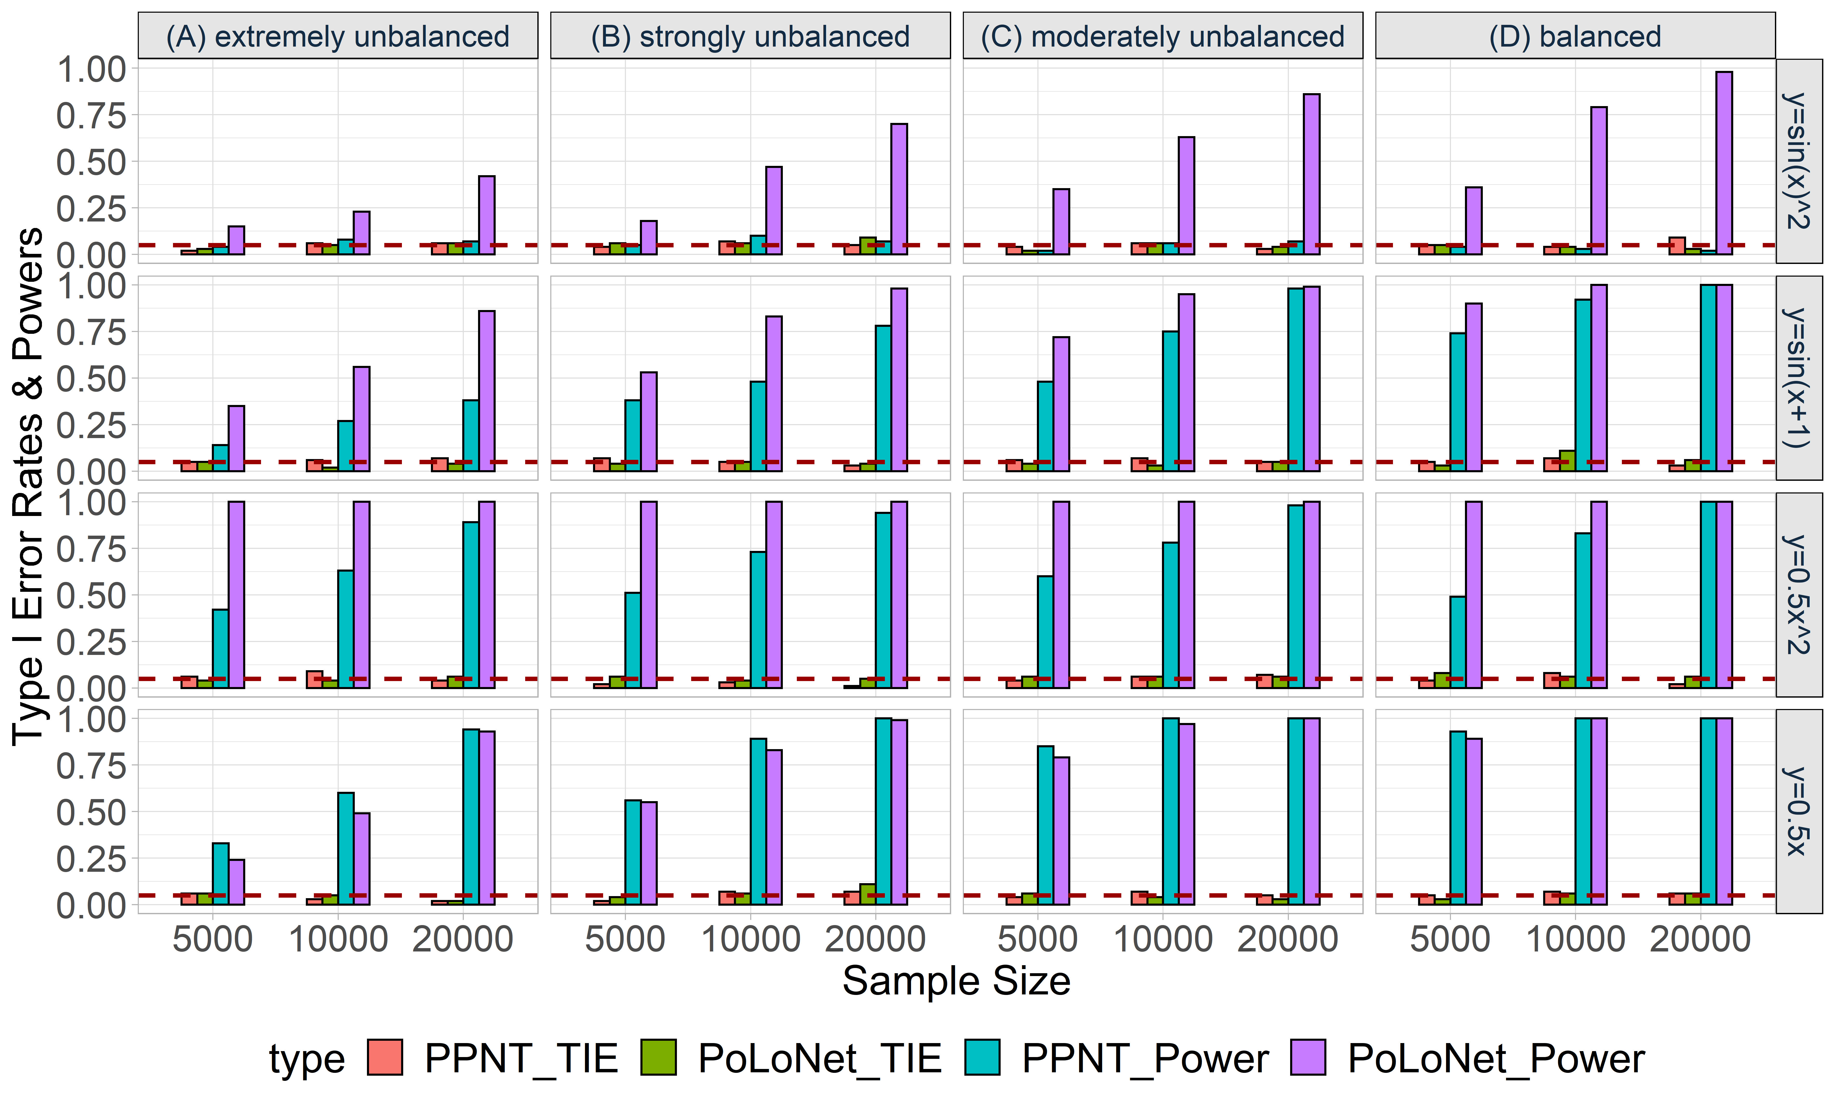

**Figure S43. Empirical type I error rates and powers for detecting the effect of the edge for an ordinal trait with 4 categories under the setting that** **both node and edge have effects, with the node hanging on the edge.** The effect size is set to be 0.05 and BSLMM is used as the gene expression prediction model in TWAS. The red dotted line represents the significance level (α=0.05). Simulations are conducted with different sample sizes (5000, 10000, 20000) and 4 different between-node correlation patterns (the recombination of quadratic and sine, sine, quadratic, linear). **(A)** extremely unbalanced (100:1:1:1); **(B)** strongly unbalanced (30:1:1:1); **(C)** moderately unbalanced (10:1:1:1); **(D)** balanced (1:1:1:1).

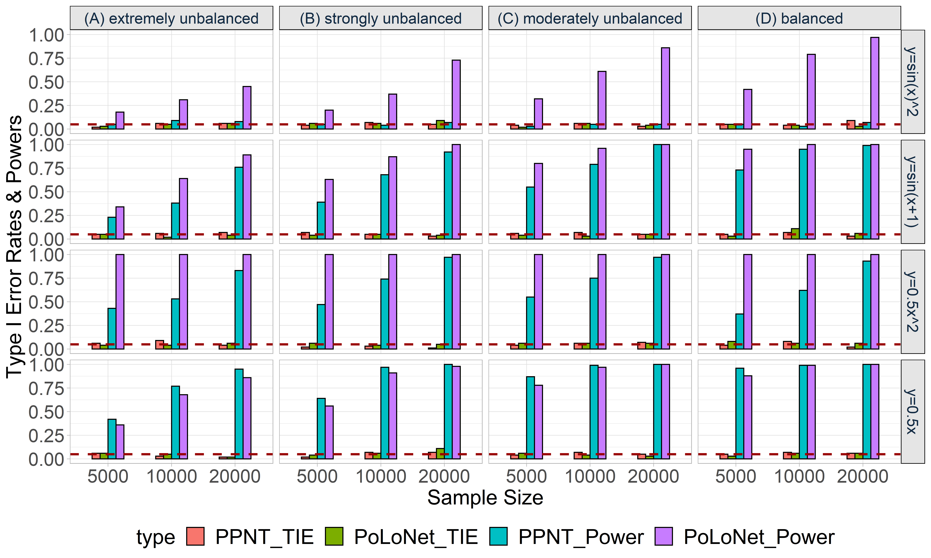

**Figure S44. Empirical type I error rates and powers for detecting the effect of the edge for an ordinal trait with 4 categories under the setting that** **both node and edge have effects, with the node not hanging on the edge.** The effect size is set to be 0.05 and BSLMM is used as the gene expression prediction model in TWAS. The red dotted line represents the significance level (α=0.05). Simulations are conducted with different sample sizes (5000, 10000, 20000) and 4 different between-node correlation patterns (the recombination of quadratic and sine, sine, quadratic, linear). **(A)** extremely unbalanced (100:1:1:1); **(B)** strongly unbalanced (30:1:1:1); **(C)** moderately unbalanced (10:1:1:1); **(D)** balanced (1:1:1:1).

To further alleviate the influence of pre-specified effecting node or edge, we have conducted additional simulations in which the effecting nodes and edges were randomly selected. All the results are consistent with that when pre-specifying the effecting node and edge.

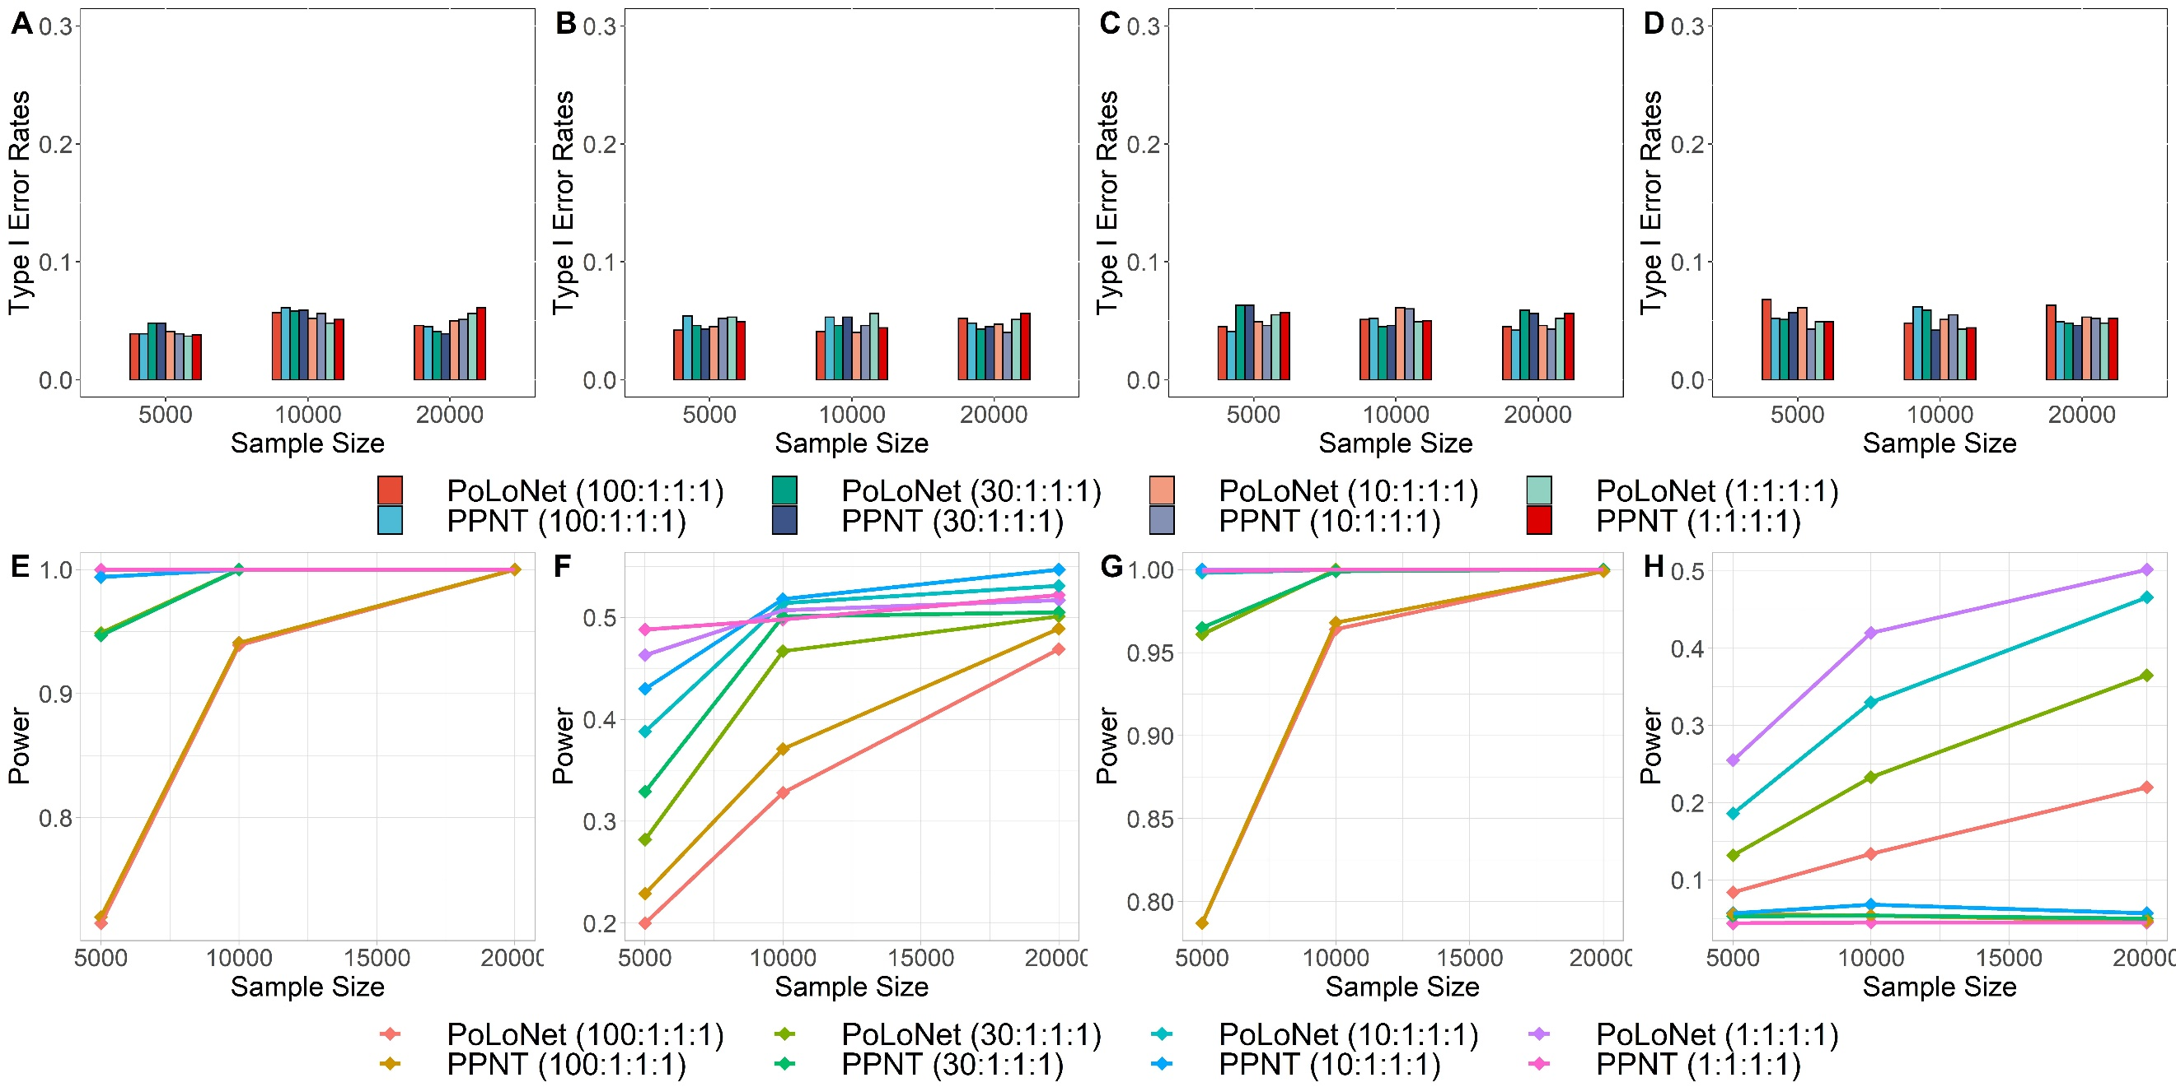

**Figure S45. Empirical type I error rates and power of PoLoNet and PPNT when the effecting nodes and edges are randomly selected.** Empirical type I error rates or power (y-axis) at a significance level 0.05 is plotted against different sample size (x-axis). The effect size is set to be 0.05 and DPR is used as the gene expression prediction model in TWAS. We considered four ratios across different categories (extremely unbalanced (100:1:1:1), strongly unbalanced (30:1:1:1)**,** moderately unbalanced (10:1:1:1) and balanced (1:1:1:1)). Empirical type I error rates when between-node relationship is linear are displayed for detecting the effects of node **(A)** and edge (**B**). Empirical type I error rates when between-node relationship is nonlinear (the recombination of quadratic and sine) are displayed for detecting the effects of node (**C**) and edge (**D**). Power when between-node relationship is linear is displayed for detecting the effects of node (**E**) and edge (**F**). Power when between-node relationship is nonlinear (the recombination of quadratic and sine) is displayed for detecting the effects of node (**G**) and edge (**H**).

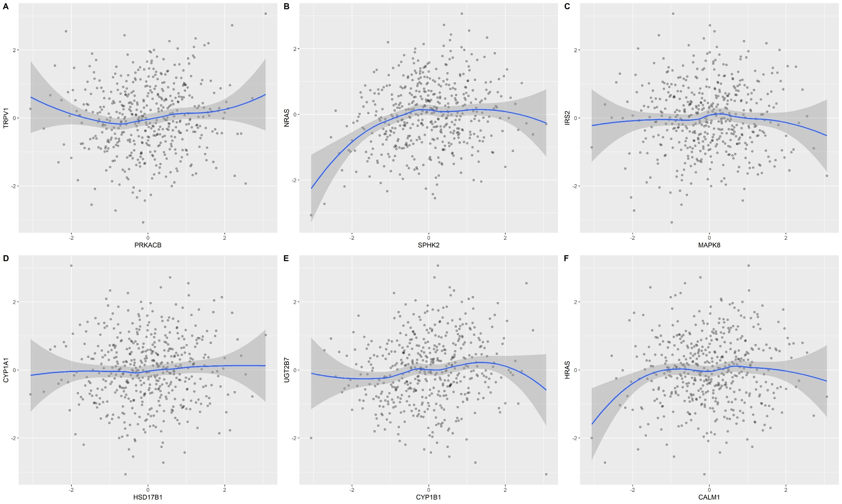

**Figure S46. Scatter plots. (A)** Scatter plot of PRKACB-TRPV1 identified by PoLoNet in blood pressure for binary phenotype. **(B)** Scatter plot of SPHK2-NRAS identified by PoLoNet in blood pressure for ordinal categorical phenotype. **(C)** Scatter plot of MAPK8-IRS2 identified by PoLoNet and PPNT in blood pressure. **(D)** Scatter plot of HSD17B1-CYP1A1 identified by PPNT in blood pressure for binary phenotype. **(E)** Scatter plot of CYP1B1-UGT2B7 identified by PPNT in blood pressure for ordinal categorical phenotype. **(F)** Scatter plot of CALM1-HRAS identified by PoLoNet in Bipolar and major depression status for ordinal categorical phenotype.

We have conducted additional simulations to compare the performance of PoLoNet with linear regression model for binary phenotypes under sample size 10,000. We have considered four case-control ratios (extremely unbalanced (1:999), strongly unbalanced (1:99), moderately unbalanced (1:9) and balanced (1:1)), three effect sizes (0.075, 0.15, 0.225) and two between-node relationships (linear as well as the recombination of quadratic and sine relationship). It can be shown that the type I error rates of both PoLoNet and the linear regression model for binary phenotype are close to the nominal level 0.05 (**Figure S47**). As expected, the power of both methods increases with effect sizes, however, the power of linear regression model for binary phenotype remains lower than that of PoLoNet (**Figure S48**), especially when case-control ratio is unbalanced. These results illustrated that it would lead to power loss if regarding the binary or ordinal categorical phenotype as a quantitative trait.

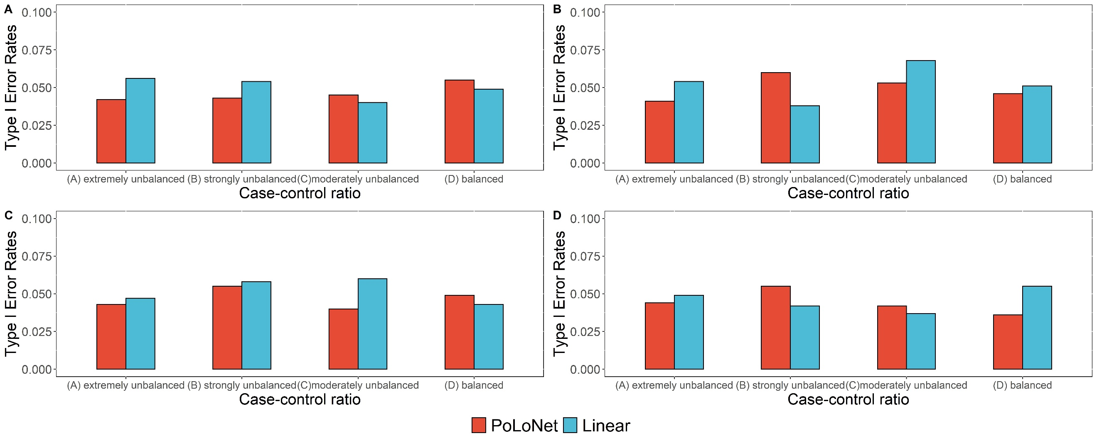

**Figure S47. Empirical type I error rates of PoLoNet and linear model for binary phenotype.** Type I error rates (y-axis) at a significance level 0.05 is plotted against different case-control ratios (x-axis). (**A**) The test for the effect of node and (**B**) edge in linear relationship. (**C**) The test for the effect of node and (**D**) edge in nonlinear (the recombination of quadratic and sine) relationship.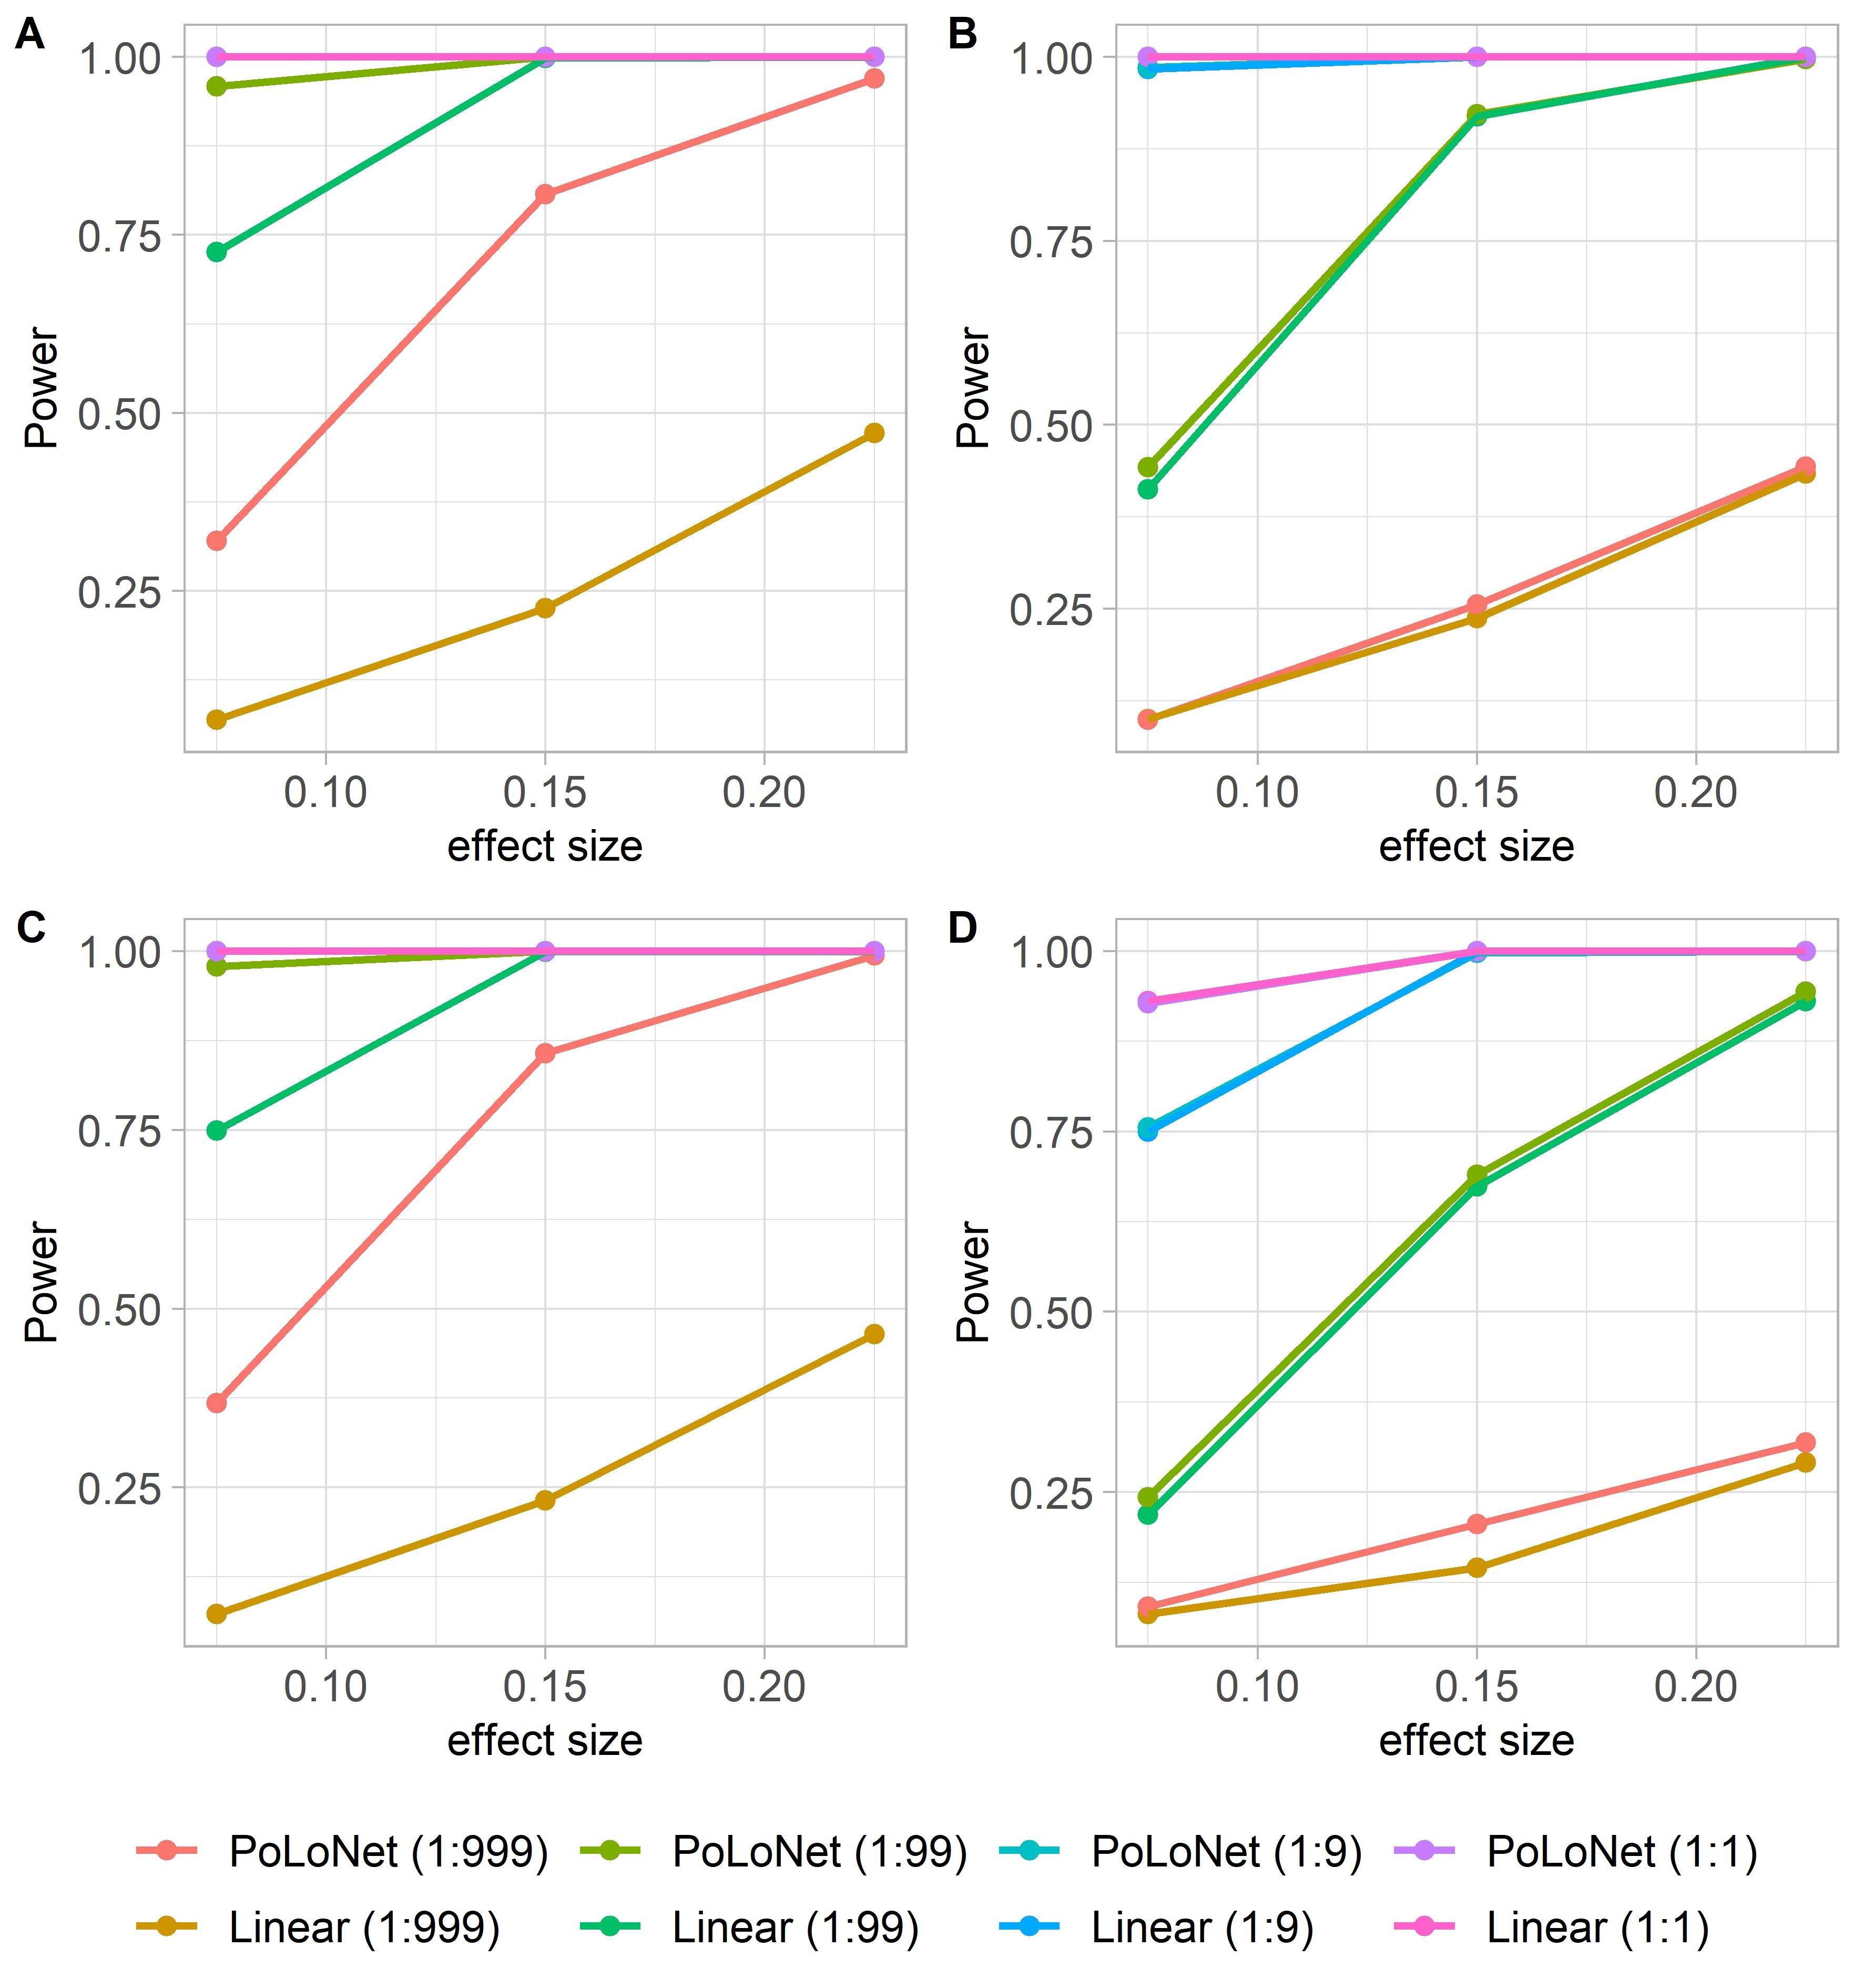

**Figure S48. Power of PoLoNet and linear regression model for binary phenotype.** Power (y-axis) at a significance level 0.05 is plotted against different effect size (x-axis). We considered four ratios across different categories (extremely unbalanced (1:999), strongly unbalanced (1:99), moderately unbalanced (1:9) and balanced (1:1)) for linear regression model and PoLoNet. (**A**) The test for the effect of node and (**B**) edge in linear relationship. (**C**) The test for the effect of node and (**D**) edge in nonlinear (the recombination of quadratic and sine) relationship.

we have performed additional simulations to compare PoLoNet with TIGAR, to further illustrate the power gain of PoLoNet for network regression of TWAS. Note that PoLoNet effectively accounts for the network structure and is able to simultaneously identify the trait-related whole network, the nodes as well as the edges, it is expected that PoLoNet should have similar performance with TIGAR if only focusing on the node test. Similar as the simulations in the previous manuscript, based on the pathway of Alzheimer disease from KEGG (including 12 nodes and 13 edges), we randomly selected various GWAS sample sizes (5000, 10000 and 20000), and considered three effect sizes (0.075, 0.15 and 0.225) as well as two types of between-node relationship (linear as well as the recombination of quadratic and sine relationship). We set the case-control ratio to be extremely unbalanced (1:999). All the results are summarized in the newly added Figure S48 in the revised manuscript. As expected, the power of both methods increases as the effect size increases. PoLoNet has the comparable power with TIGAR in testing the effect of nodes. However, PoLoNet shows the power advantage over TIGAR when testing the whole network. The power gain of PoLoNet compared with TIGAR is more likely resulted from the gene-gene interaction. 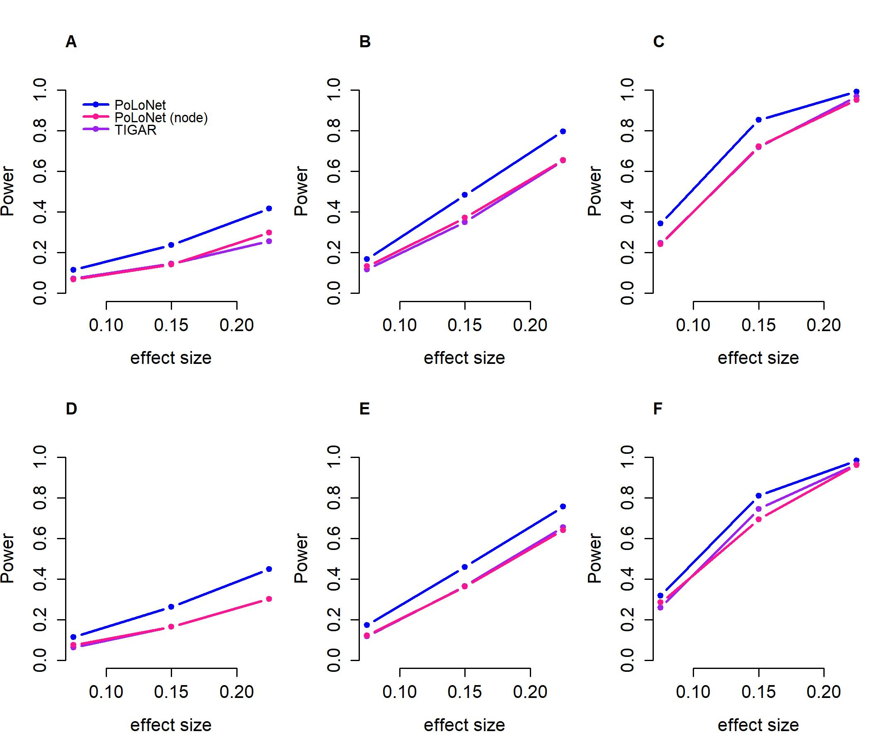

**Figure S49. Power of both PoLoNet and TIGAR under an extremely unbalanced case-control ratio.** Power (y-axis) at a significance level 0.05 is plotted against different effect size (x-axis). The power with linear between-node correlation are shown under sample size 5000 (**A**), 10000 (**B**) and 20000 (**C**). The power with nonlinear between-node correlation (the recombination of quadratic and sine relationship) are shown under sample size 5000 (**D**), 10000 (**E**) and 20000 (**F**).

We have carried out additional simulations to evaluate the performance of PoLoNet in a reduced network and investigate its robustness when some data are unavailable. Briefly, we simulated data based on the pathway of Alzheimer disease involving 12 nodes and 13 edges, while we fit the PoLoNet model in a reduced network with some proportions (15% and 30%) of genes being randomly selected for dropout. We simulated ordinal categorical phenotypes with effect size 0 for type I error rate and 0.05 for power under three GWAS sample sizes (5000, 10000 and 20000), set the relationship among network nodes to be linear or nonlinear (the recombination of quadratic and sine) and considered totally four ratios across different categories. For better comparison, we also fit PoLoNet with the full data, which can be regarded as the gold standard in this setting. The results illustrated that PoLoNetwith several genes unavailable still have calibrated type I error rate (**Figure S50**) and have comparable power with that using the full data (**Figure S51**), indicating PoLoNet is robust for the reduced network when some genes are unavailable.

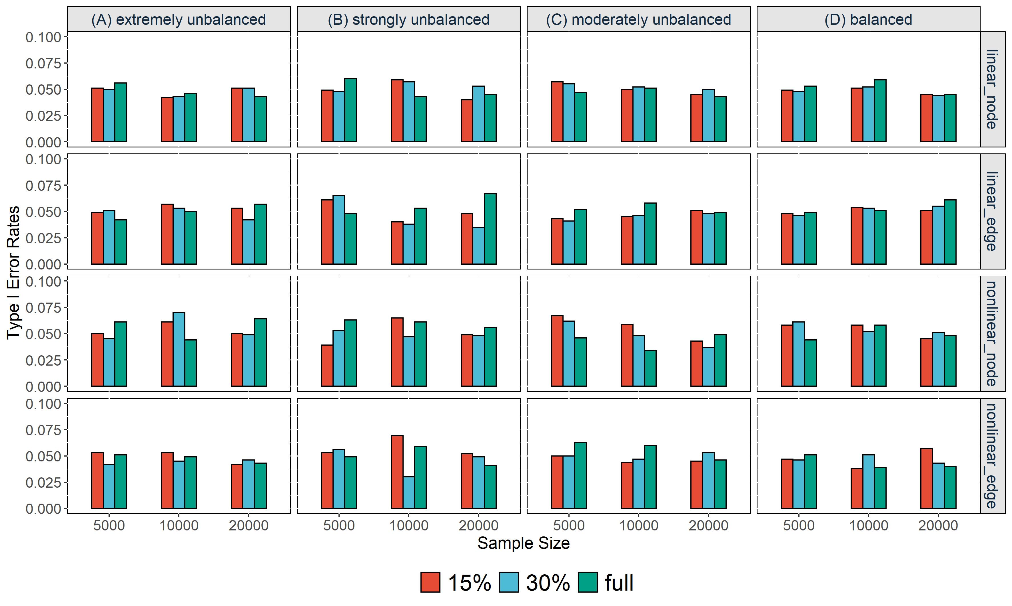

**Figure S50. Type I error rates of PoLoNet in a reduced gene network with some genes being unavailable.** Type I error rates (y-axis) at a significance level 0.05 is plotted against different sample size (x-axis). The proportion of “15%” and “30%” represent 15% and 30% genes are unavailable in network, “full” means all the genes are available. Various settings are displayed from top to bottom, including the type I error rates for detecting the effects of node and edge in linear relationship as well as detecting the effects of node and edge in nonlinear (the recombination of quadratic and sine relationship) relationship. Different ratios across different categories are listed from left to right, including (**A**) extremely unbalanced (100:1:1:1), (**B**) strongly unbalanced (30:1:1:1), (**C**) moderately unbalanced (10:1:1:1) and (**D**) balanced (1:1:1:1).

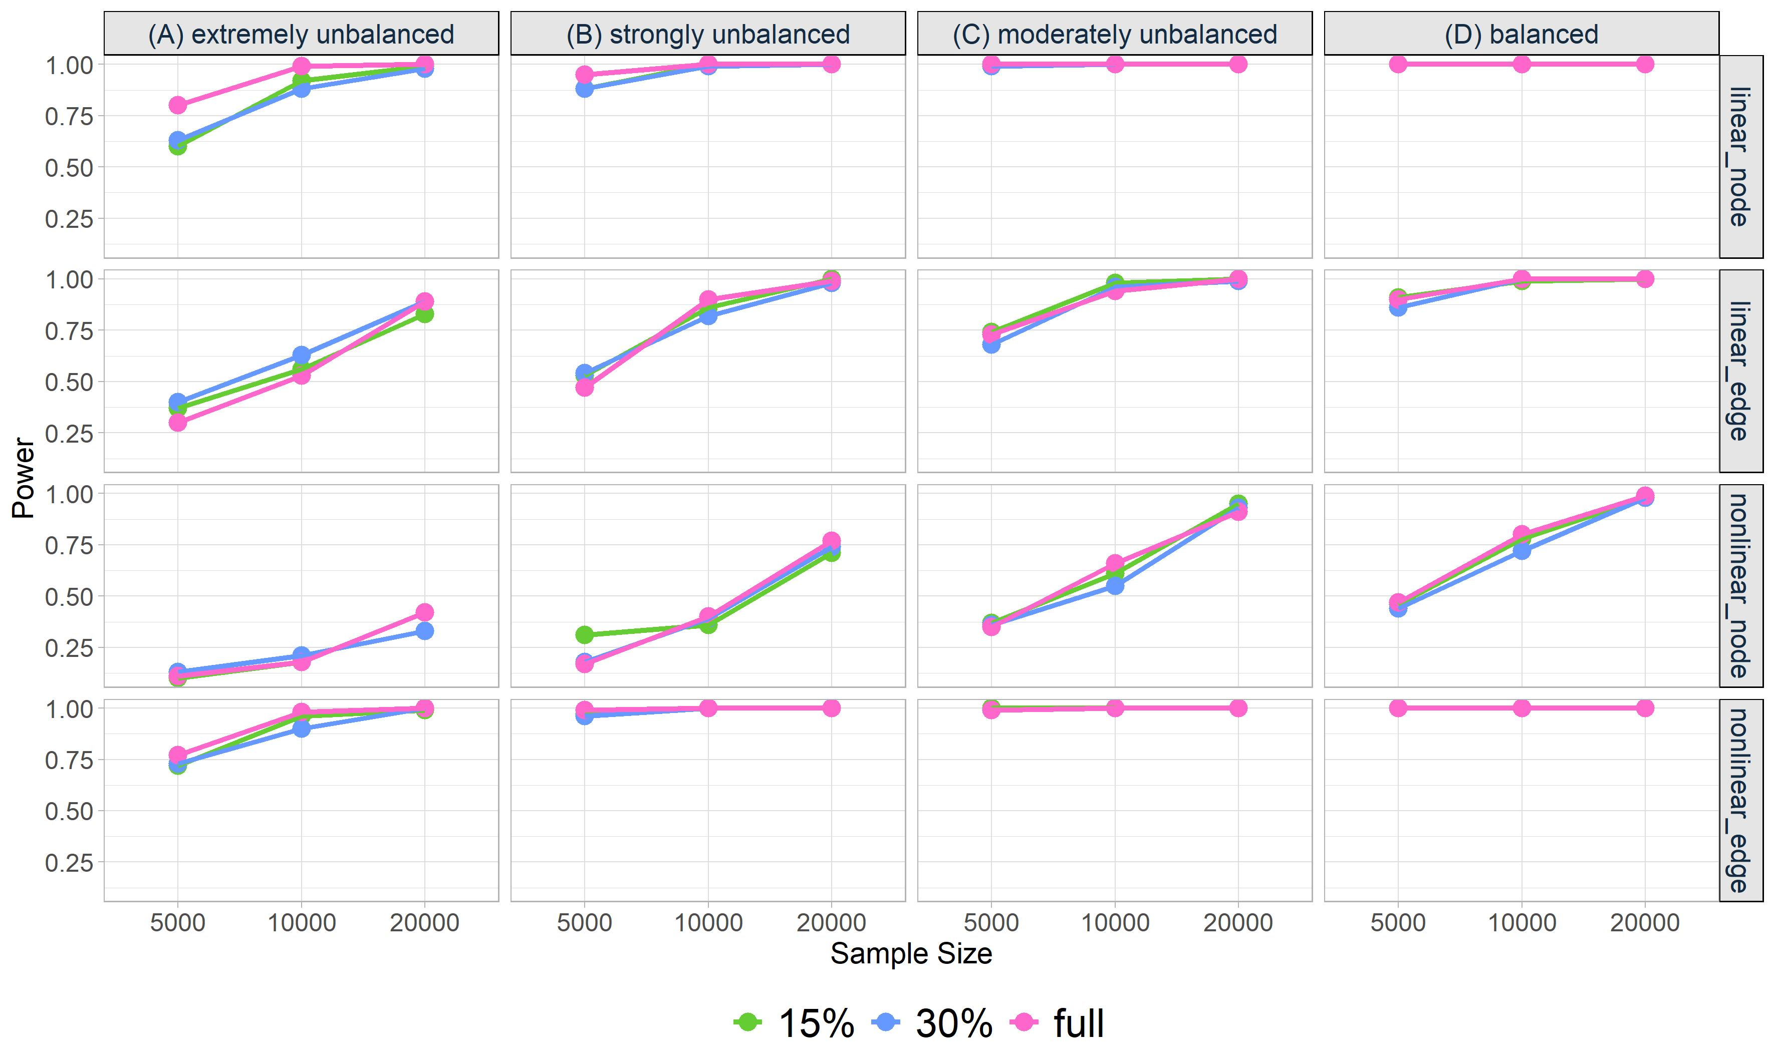

**Figure S51. Power of PoLoNet for detecting in a reduced gene network with some being unavailable.** Power (y-axis) at a significance level 0.05 is plotted against different sample size (x-axis). The proportions of “15%” and “30%” represent 15% and 30% genes are unavailable in network, “full” means the genes are all available. Various settings are displayed from top to bottom, including the power for detecting the effect of node and the effect of edge in linear relationship as well as detecting the effect of node and the effect of edge in nonlinear (the recombination of quadratic and sine relationship) relationship. Different ratios across different categories are listed from left to right, including (**A**) extremely unbalanced (100:1:1:1), (**B**) strongly unbalanced (30:1:1:1), (**C**) moderately unbalanced (10:1:1:1) and (**D**) balanced (1:1:1:1).

**Supplementary Tables S1-S7:**

**Table S1. phenotype heritability**

|  |  |  |  |  |  |  |
| --- | --- | --- | --- | --- | --- | --- |
| Variable | relationship | 0.001 | 0.075 | 0.15 | 0.225 | 0.3 |
| $$X_{5}$$ | all | 3.19E-06 | 0.0176623 | 0.06712584 | 0.1400203 | 0.2249248 |
| $$E_{5,10}$$ | linear | 1.18E-06 | 0.006521033 | 0.026311717 | 0.056420753 | 0.098553337 |
|  | sine | 1.59E-06 | 0.008805232 | 0.033622079 | 0.074141557 | 0.121324465 |
|  | quadratic | 1.45E-05 | 0.068262101 | 0.220910682 | 0.387144273 | 0.547317701 |
|  | combination | 4.12E-07 | 0.002280989 | 0.009043028 | 0.020457662 | 0.034555789 |
| $X_{2}$& $E_{2,6}$ | linear | 8.51E-06 | 0.046177521 | 0.157909991 | 0.305141081 | 0.443528436 |
|  | sine | 5.26E-06 | 0.02965126 | 0.104555207 | 0.211585244 | 0.318858653 |
|  | quadratic | 0.001527427 | 0.826507896 | 0.936608896 | 0.976174347 | 0.988623335 |
|  | combination | 3.47E-06 | 0.019174823 | 0.073546624 | 0.150329667 | 0.240263335 |
| $X_{2}$& $E_{5,10}$ | linear | 4.42E-06 | 0.024206164 | 0.090364271 | 0.182822576 | 0.28934625 |
|  | sine | 4.84E-06 | 0.026525934 | 0.095442318 | 0.193958976 | 0.296984451 |
|  | quadratic | 1.78E-05 | 0.083509236 | 0.260887717 | 0.445819858 | 0.599649217 |
|  | combination | 3.61E-06 | 0.01975134 | 0.075550932 | 0.154404035 | 0.245019564 |

**Table S2. gene expression heritability**

|  |  |  |  |  |  |  |
| --- | --- | --- | --- | --- | --- | --- |
| Gene | MKK7 | XBP1 | CHOP | JNK | ASK1 | ATF4 |
| heritability | 0.020328 | 0.042714 | 0.000001 | 0.000001 | 0.07602 | 0.03938 |
| standard error | 0.045946 | 0.034261 | 0.019799 | 0.022827 | 0.0494 | 0.044417 |
| Gene | eIF2 $α$ | ATF6 | IRE1 $α$ | PERK | TRAF2 | PSEN1 |
| heritability | 0.000001 | 0.042214 | 0.014638 | 0.000001 | 0.005092 | 0.000001 |
| standard error | 0.016272 | 0.043339 | 0.029527 | 0.016114 | 0.0386 | 0.022014 |

**Table S3. Classification of office blood pressure and definitions of hypertension grade**

|  |  |  |  |
| --- | --- | --- | --- |
| **Category** | **Systolic (mmHg)** |  | **Diastolic (mmHg)** |
| Optimal | <120 | and | <80 |
| Normal | 120-129 | and/or | 80-84 |
| High normal | 130-139 | and/or | 85-89 |
| Grade 1 hypertension | 140-159 | and/or | 90-99 |
| Grade 2 hypertension | 160-179 | and/or | 100-199 |
| Grade 3 hypertension | $$≥180$$ | and/or | $$≥110$$ |

**Table S4. Summary of networks**

|  |  |  |  |  |  |
| --- | --- | --- | --- | --- | --- |
| phenotype | network | KEGG | | Overlap | |
| node | edge | node | edge |
| Blood preasure | hsa04610 | 85 | 86 | 48 | 21 |
| hsa04270 | 134 | 304 | 99 | 204 |
| hsa04614 | 23 | 38 | 12 | 16 |
| hsa04924 | 69 | 73 | 47 | 50 |
| hsa04925 | 98 | 277 | 80 | 221 |
| hsa04926 | 129 | 544 | 110 | 429 |
| hsa04960 | 37 | 37 | 31 | 31 |
| hsa00140 | 61 | 888 | 31 | 164 |
| hsa00590 | 61 | 621 | 39 | 313 |
| hsa03320 | 75 | 275 | 49 | 140 |
| hsa04010 | 294 | 1969 | 239 | 1140 |
| hsa04020 | 240 | 1180 | 161 | 523 |
| hsa04064 | 104 | 191 | 83 | 141 |
| hsa04150 | 156 | 609 | 138 | 450 |
| hsa04260 | 87 | 25 | 57 | 8 |
| hsa04350 | 94 | 300 | 75 | 178 |
| hsa04370 | 59 | 158 | 53 | 127 |
| hsa04750 | 98 | 135 | 78 | 86 |
| hsa04910 | 137 | 412 | 120 | 302 |
| hsa04931 | 108 | 232 | 93 | 165 |
| hsa04933 | 100 | 300 | 86 | 257 |
| hsa05415 | 203 | 131 | 145 | 93 |
| Total |  | 2452 | 8785 | 1874 | 5059 |
| Bipolar and major depression status | hsa04020 | 240 | 1180 | 160 | 523 |
| hsa04724 | 114 | 471 | 87 | 329 |
| hsa04730 | 60 | 226 | 47 | 157 |
| hsa05017 | 143 | 183 | 115 | 103 |
| hsa04010 | 294 | 1969 | 239 | 1140 |
| hsa04140 | 141 | 411 | 124 | 319 |
| hsa04141 | 171 | 86 | 151 | 71 |
| hsa04720 | 67 | 339 | 53 | 206 |
| hsa04721 | 78 | 37 | 57 | 32 |
| Total |  | 1308 | 4902 | 1033 | 2880 |

**Table S5. Summary of sample sizes of ordinary categorical phenotype**

|  |  |  |  |  |  |  |  |  |
| --- | --- | --- | --- | --- | --- | --- | --- | --- |
| phenotype | network | Sample size | 0 | 1 | 2 | 3 | 4 | 5 |
| Blood pressure | hsa00140 | 294247 | 38043 | 47315 | 57907 | 98349 | 41348 | 11285 |
| hsa00590 | 295421 | 38236 | 47600 | 57978 | 98761 | 41442 | 11404 |
| hsa03320 | 283518 | 36655 | 45588 | 55774 | 94747 | 39893 | 10861 |
| hsa04010 | 218996 | 28146 | 35278 | 43013 | 73202 | 30917 | 8440 |
| hsa04020 | 244794 | 31527 | 39455 | 48206 | 81810 | 34466 | 9330 |
| hsa04064 | 266461 | 34372 | 42783 | 52375 | 89212 | 37506 | 10213 |
| hsa04150 | 246483 | 31874 | 39694 | 48361 | 82268 | 34851 | 9435 |
| hsa04260 | 283388 | 36662 | 45707 | 55667 | 94740 | 39739 | 10873 |
| hsa04270 | 268053 | 34635 | 43081 | 52734 | 89774 | 37573 | 10256 |
| hsa04350 | 276290 | 35764 | 44423 | 54317 | 92290 | 38877 | 10619 |
| hsa04370 | 287808 | 37249 | 46351 | 56500 | 96168 | 40496 | 11044 |
| hsa04610 | 289318 | 37459 | 46603 | 56814 | 96566 | 40738 | 11138 |
| hsa04614 | 308432 | 39907 | 49699 | 60608 | 103065 | 43289 | 11864 |
| hsa04750 | 273357 | 35233 | 44020 | 53790 | 91428 | 38439 | 10447 |
| hsa04910 | 256888 | 33183 | 41324 | 50528 | 85829 | 36228 | 9796 |
| hsa04924 | 287994 | 37190 | 46361 | 56727 | 96265 | 40463 | 10988 |
| hsa04925 | 274305 | 35470 | 44122 | 53929 | 91781 | 38525 | 10478 |
| hsa04926 | 259503 | 33500 | 41836 | 50949 | 86703 | 36580 | 9935 |
| hsa04931 | 268030 | 34653 | 43156 | 52702 | 89559 | 37708 | 10252 |
| hsa04933 | 267398 | 34451 | 43086 | 52586 | 89303 | 37683 | 10289 |
| hsa04960 | 298686 | 38677 | 48077 | 58711 | 99889 | 41868 | 11464 |
| hsa05415 | 243148 | 31401 | 39147 | 47845 | 81229 | 34235 | 9291 |
| Mean |  | 272387 | 35195 | 43850 | 53546 | 91043 | 38312 | 10441 |
| Bipolar and major depression status | hsa04010 | 55952 | 40326 | 3802 | 7143 | 4006 | 317 | 358 |
| hsa04020 | 62685 | 45310 | 4240 | 7914 | 4490 | 353 | 378 |
| hsa04140 | 66124 | 47759 | 4418 | 8401 | 4740 | 386 | 420 |
| hsa04141 | 62957 | 45508 | 4202 | 8007 | 4490 | 346 | 404 |
| hsa04720 | 73323 | 53003 | 4950 | 9256 | 5247 | 410 | 457 |
| hsa04721 | 72099 | 52144 | 4884 | 9075 | 5142 | 409 | 445 |
| hsa04724 | 69336 | 50135 | 4676 | 8754 | 4943 | 393 | 435 |
| hsa04730 | 74013 | 53480 | 4988 | 9326 | 5338 | 414 | 467 |
| hsa05017 | 66685 | 48241 | 4483 | 8423 | 4768 | 363 | 407 |
| Mean |  | 60317 | 43591 | 4064 | 7630 | 4316 | 339 | 377 |

Note:

|  |  |  |
| --- | --- | --- |
| category | Blood pressure | Bipolar and major depression status |
| 0 | Optimal | no bipolar or depression |
| 1 | Normal | single probable major depression episode |
| 2 | High normal | probable recurrent major depression (moderate) |
| 3 | Grade 1 hypertension | probable recurrent major depression (severe) |
| 4 | Grade 2 hypertension | bipolar II disorder |
| 5 | Grade 3 hypertension | bipolar I disorder |

**Table S6. Summary of sample sizes of binary phenotype**

|  |  |  |  |  |
| --- | --- | --- | --- | --- |
| Phenotype | network | Sample size | control | case |
| Blood pressure | hsa00140 | 294247 | 143265 | 150982 |
| hsa00590 | 295421 | 143814 | 151607 |
| hsa03320 | 283518 | 138017 | 145501 |
| hsa04010 | 218996 | 106437 | 112559 |
| hsa04020 | 244794 | 119188 | 125606 |
| hsa04064 | 266461 | 129530 | 136931 |
| hsa04150 | 246483 | 119929 | 126554 |
| hsa04260 | 283388 | 138036 | 145352 |
| hsa04270 | 268053 | 130450 | 137603 |
| hsa04350 | 276290 | 134504 | 141786 |
| hsa04370 | 287808 | 140100 | 147708 |
| hsa04610 | 289318 | 140876 | 148442 |
| hsa04614 | 308432 | 150214 | 158218 |
| hsa04750 | 273357 | 133043 | 140314 |
| hsa04910 | 256888 | 125035 | 131853 |
| hsa04924 | 287994 | 140278 | 147716 |
| hsa04925 | 274305 | 133521 | 140784 |
| hsa04926 | 259503 | 126285 | 133218 |
| hsa04931 | 268030 | 130511 | 137519 |
| hsa04933 | 267398 | 130123 | 137275 |
| hsa04960 | 298686 | 145465 | 153221 |
| hsa05415 | 243148 | 118393 | 124755 |
| Mean |  | 272387 | 132592 | 139796 |
| Bipolar and major depression status | hsa04010 | 55952 | 40326 | 15626 |
| hsa04020 | 62685 | 45310 | 17375 |
| hsa04140 | 66124 | 47759 | 18365 |
| hsa04141 | 62957 | 45508 | 17449 |
| hsa04720 | 73323 | 53003 | 20320 |
| hsa04721 | 72099 | 52144 | 19955 |
| hsa04724 | 69336 | 50135 | 19201 |
| hsa04730 | 74013 | 53480 | 20533 |
| hsa05017 | 66685 | 48241 | 18444 |
| Mean |  | 60317 | 43591 | 16727 |

**Table S7 Mean computational time (seconds) of both methods in the simulation**

|  |  |  |  |  |
| --- | --- | --- | --- | --- |
| #Sample size | PoLoNet_binary | PPNT_binary | PoLoNet_ordinal | PPNT_ordinal |
| 5000 | 5.14(0.11) | 5.07 (0.16) | 5.66(0.16) | 5.07(0.14) |
| 10000 | 5.75(0.22) | 5.65(0.18) | 5.84(0.16) | 5.68(0.20) |
| 20000 | 6.89(0.32) | 6.53(0.24) | 6.98(0.26) | 6.61(0.29) |

Computation is carried out on a single thread of an Intel Xeon E5-2697 v3 CPU. The computation time is averaged across 20 replicates, with values inside parentheses denoting the standard deviation. #Sample size denotes the number of samples included in the model. The computational times for both methods are based on balanced ratios across different categories for binary and ordinal categorical phenotype. Both methods have almost the same physical memories (less than 1GB) under various situations.